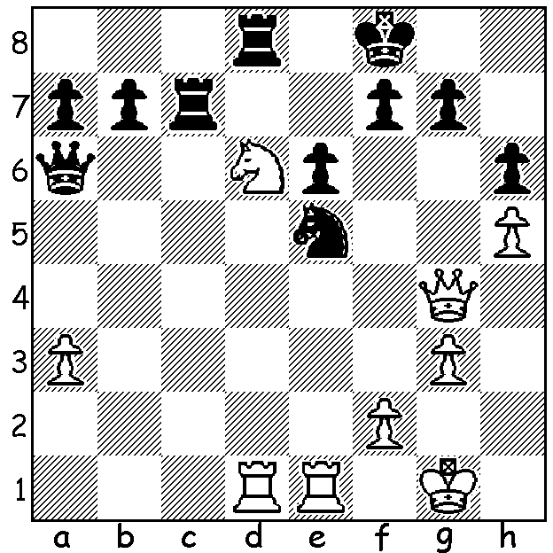

SHORT – BAREEV 1991:
White, 2 pawns down, seems in dire straits
but somehow conjures up a win:

WA players will have a rare opportunity to play against one of the greatest players of the 20th Century when British GM Nigel Short MBE gives a 30 Board Simultaneous Display on Sunday 6th March at the Rhein-Donau Club, North Lake Rd., Melville. If you are interested in playing information can be found early next week on cawa.org.au or by contacting me (0439798607). In 1993, after defeating Boris Gelfand, former World Champion Anatoly Karpov and then Jan Timman, Short qualified to play the great Gary Kasparov for the world title, a match he not surprisingly lost. Short had been a child prodigy who, like Bobby Fischer, achieved little at school and left at a relatively early age. However at the age of only 10 Short had defeated the great Viktor Korchnoi in a simul and had qualified to compete in the British Championship when only 11. At 14 he became the youngest British champion and then the youngest ever IM. In the 1980 Junior World Championship he was second to Kasparov. He has represented England with distinction in 15 Olympiads and has won a multitude of tournaments, the most recent being the 2015 South African Open. He is also a prodigious chess columnist and an outstanding coach. An original thinker, Short is prepared to play obscure openings and defences. He is also a brilliant attacking player (“I like to go for the king because mate ends the game. This is sometimes forgotten in modern chess. All this concern about pawn structures – forget it. Checkmate is checkmate.”). Here is a fine example of his original and attacking play against one of the giants of chess, Viktor Korchnoi, (and this time not a simul):
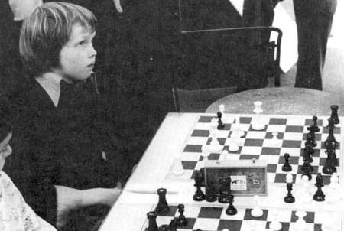
NIGEL SHORT – VIKTOR KORCHNOI
Belgrade 1987
Giuoco Piano
1.e4 e5 2.Nf3 Nc6
3.Bc4 Bc5 4.c3 Nf6
5.b4 Bb6 6.d3 a6
7.0-0 0-0 8.Nbd2 d5
9.exd Nxd5 10.Qb3 Nf4 Short in simul v Smyslov,
11.d4 Be6(a) 12.dxe Nxe5 world champion 1957.
13.Nxe5 Qg5 14.g3 Ne2+
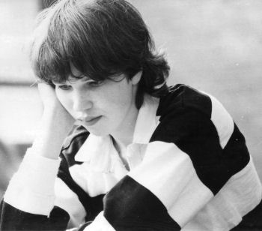
15.Bxe2!(b) Bxb3 16.Ndf3 Qf6
17.axb3 Rae8 18.Bf4 h6
19.Bc4 g5 20.Ng4 Qxc3
21.Nxh6+ Kg7 22.Nxg5! Qxb4(c)
23.Nhxf7 Bd4 24.Rad1 Qc3
25.Rd3 Qb2 26.Bc1 Bxf2+
27.Kg2 Qa1 & Black resigns(d)

a) Korchnoi has prepared a tactical variation but his calculation
is faulty; 11…exd was necessary when White could gain Short aged 15
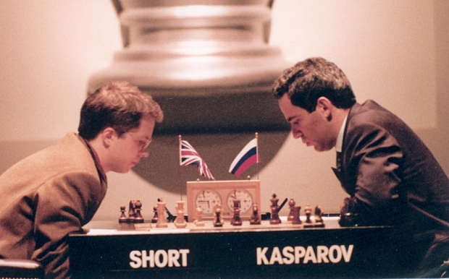
attacking opportunities with 12.Ne4 (12…Ne6 13.Bb2
dxc 14.Qxc3).
b) Short has seen further, realising his three active minor
pieces will be more than a match for the opposing queen.
c) Not 22…Kxh6?? 23.Ne4+ winning the queen.
d) as 28.Ne6+! Rxe6 29.Bh6+.

SOLUTION: 1.Nf5!! & Black resigns (1…Nxg4 2.Rxd8# or
1…Rxd1 2.Qxg7+ Ke8 3.Qg8+ Kd7 4.Rxd1+ Nd3 – 4…Kc6
5.Rd6+ - 5.Qxf7+ Kd8 6.Qf8+ Kd7 7.Qe7+ Kc6 8.Qxe6+
winning or 1…exf5 2.Rxd8+ Ke7 3.Qd4 winning).

Short v Kasparov, World Championship 1993

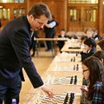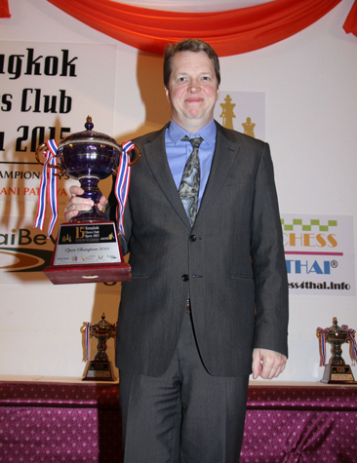

Short giving simul to schoolchildren Winner in Bangkok 2015

