NIGEL SHORT – Natalia Zhukova 2006: White is a piece down and is threatened with further loss of rook and bishop. However he has everything under control and pulls off a sensational win:
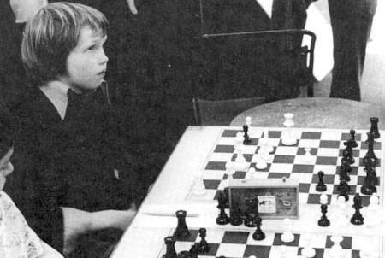
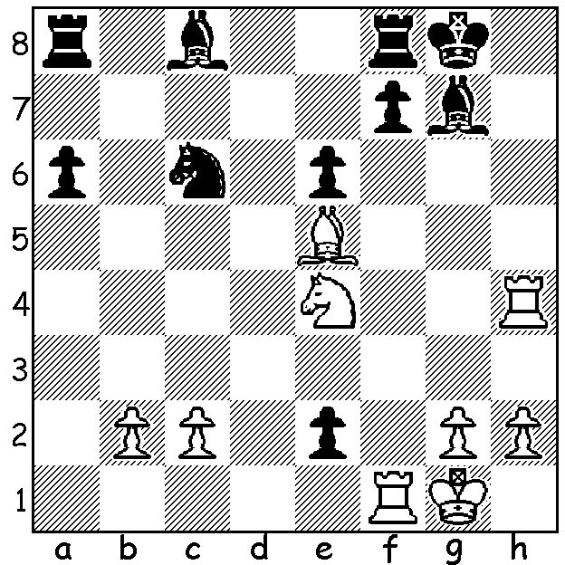 Short in simul v Smyslov, world champion 1957.

Fifteen of WA’s top players have already enrolled to play Nigel Short in a Simultaneous Display on Sunday March 6, at the Rhein-Donau Club, Melville, starting at 1pm. However there are still places available so if you wish to compete or attend the one hour lecture and watch play check out details at cawa.org.au or contact me 0439798607.
In a biography of Short by Raymond Keene Short is reported to have said, “I like to go for the king because mate ends the game. … All this concern about pawn structure – forget it. Checkmate is checkmate.” See how this master of attack creates a brilliant sacrificial attack leading to a spectacular king hunt:
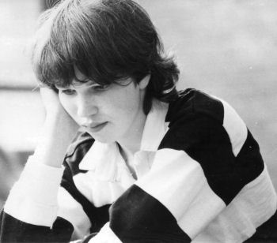
NIGEL SHORT – LJUBOMIR LJUBOJEVIC
Amsterdam 1988
Sicilian, Richter-Rauzer Attack
1.e4 c5 2.Nf3 d6
3.d4 cxd 4.Nxd4 Nf6
5.Nc3 Nc6 6.Bg5 e6
7.Qd2 a6 8.0-0-0 h6
9.Be3 Bd7 10.f4 b5
11.Bd3 Be7 12.Kb1 b4 Short aged 15
13.Nce2 0-0 14.h3 Qc7
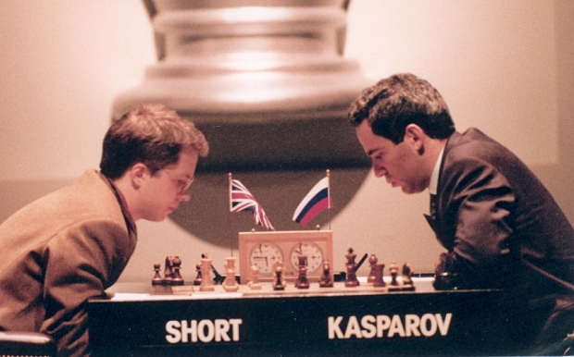
15.g4 Qb7 16.Ng3 Nxd4
17,Bxd4 Bc6 18.Rhe1 Rfe8(a)
19.g5 hxg 20.fxg Nd7
21.Bxg7!! Kxg7 22.Nh5+ Kg5(b)
23.e5+! Kxh5 24.Qf4 Bxg5
25.Qxf7+ Kh4 26.Qh7+ Kg3
27.Qh5 Kh2 28.Qxg5(c) Rg8
29.Rd2+ Bg2 30.Qf4+ Rg3
31.Be4 Qxe4 32.Qxe4 resigns

a) Too slow – necessary was 18…Nd7.
b) If the king retreats 23.g6! will secure the win.
c) Even quicker was 28.Qe2+. Short v Kasparov, World Championship 1993

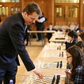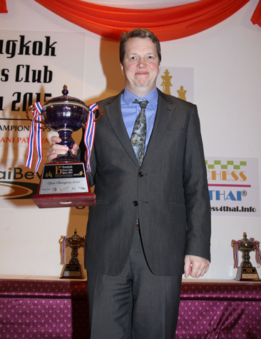

Short giving simul to schoolchildren Winner in Bangkok 2015

WA GRAND PRIX 2016: Two GP events start this month with the first being the Southern Suburbs Open (7 Rd Swiss) which starts on Tuesday 16 February at 7.30pm at Leeming Primary and the second, also at Leeming, the Perth Open played over the weekend of 20 & 21 Feb, start 10.30. Details cawa.org.au or enquire 0407421084.

SOLUTION: 1.Nf6+!! Bxf6 2.Bxf6 exf1=Q+ 3.Kxf1 & 4.Rh8#.

