NIGEL SHORT –YE JIANGCHUAN 2004:
White wins in 5 moves:
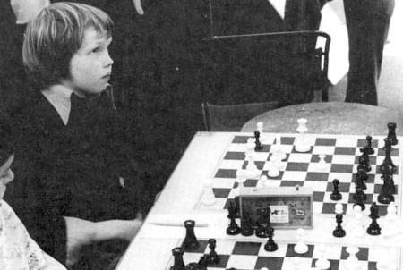
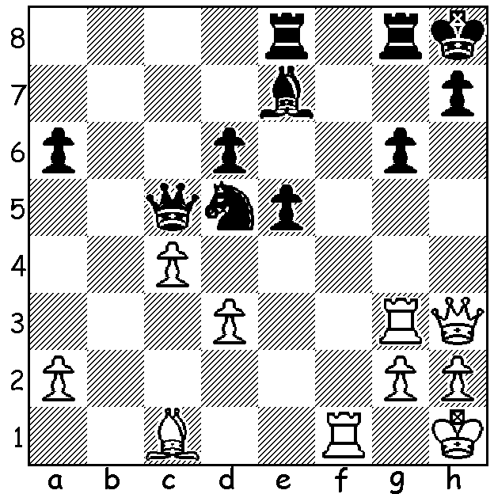
.

Short in simul v Smyslov,
world champion 1957

British GM Nigel Short, who challenged Gary Kasparov for the world title in 1993, will take on 30 players simultaneously from WA on Sunday March 6 (details cawa.org.au or phone/text 0439798607). Among those 30 will be WA’s leading two players Tristan Boyd and Yita Choong, Australian Reserves champion Patrick Gong and university student Adam Kelly, who over 2015 developed into one of the state’s top players. Here is one of his games from 2016 Australian Reserves Championship where he scored 7/11 with his opponent being the Australian Under 14 champion:

ADAM KELLY – BOBBY YU
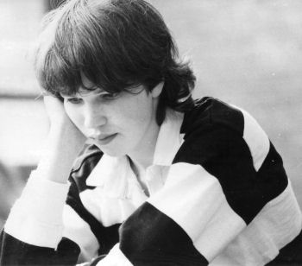
2016 Australian Championship Reserves, Rd 3
Queens Pawn, Grunfeld Defence
1.d4 Nf6 2.c4 g6
3.Nc3 d5 4.Nf3 Bg7
5.Bg5 Ne4 6.Bh4 Nxc3
7.bxc3 c5 8.e3 Nc6
9.Be2 cxd 10.cxd 0-0
11.0-0 Bf5 12.Qb3 Na5
13.Qb4 Re8 14.cxd Qxd5
15.Bb5 Nc6(a) 16.Bxc6 Qxc6 Short aged 15
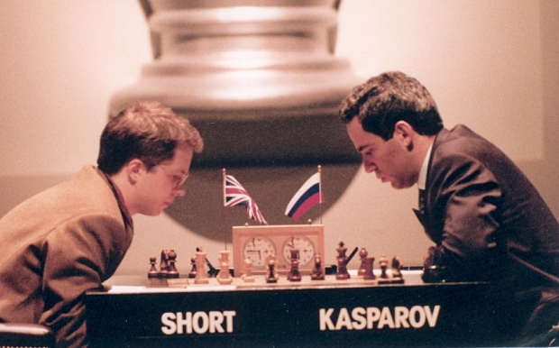
17.Bxe7 Be4(b) 18.Rfc1 Qd7
19.Bd6 a5 20.Qa3 Bxf3
21.gxf3 Qh3 22.Bg3 h5
23.Qb3!(c) Re7 24.Qd5 h4
25.Bc7 Rae8 26.Bxa5(d) Rd7!
27.Qg5 Qxf3 28.Qg2(e) Qf5
29.Rc5 Qxc5!? 30.dxc5 Bxa1(f)
31.Qf1 Bg7 32.Qb5 Ree7
33.Kg2 Rd5 34.Qb4 Ree5
35.Qxb7 Rxc5 36.Bd8 Rc4
37.Qb3 Rec5 38.a4 Rg4+
39.Kf3 Rg1 40 Bxh4 Ra1
41.Bd8 Bc3 42.h4!(g) Rf5+
43.Kg2 Rc1 44.Qb8 Kh7 Short v Kasparov, World Championship 1993
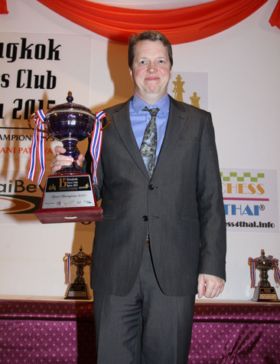
45.Qa7 Be1 46.f4 Rc2+
47.Kf3 Rf2+ 48.Ke4 Rh2
49.Bc7 Rd2(h) 50.Be5 Kh6
51.a5 f6 52.Qa8(i) Kh5
53.Qh8+ Kg4 54.Bxf6 Rxa5
55.Qh6 Ra4+ 56.Bd4 Ra6
57.Qg5+ Kh3 58.h5 gxh
59.Qxh5+ Kg2 60.Qf3+ Kh2
61.Bc3 Ra4+ 62.Kf5 Rd5+
63.Qxd5 & wins (j)

a) Or 15…Rec8! when Black has active play for the pawn after 16.Qxa5 a6
17.a4 axb5 18.Qxb5. White could reply 16.Bxe7.
b) 17…a5 with …b5 or 17…Rac8 are stronger. Winner in Bangkok 2015
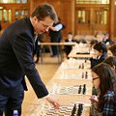
c) So if 23…h4 24.Rc7! driving back Black’s queen.
d) The bishop is better on the h2-b8 diagonal giving protection to the king.
26.Qxb7 was playable as the pin is not dangerous.
e) A wise choice: if 28.Qxh4 not 28…Re4? 29.Rc8+ Bf8 30.Qh6 but 28…Rd5
29.Bc7 Bf6 30.Qf4 Rg5+ 31.Kf1 Qh3+ 32.Ke2 Rf5 looks dangerous.
f) Will the rooks be too strong for the queen or will White’s queenside majority
tip the scales in White’s favour?
g) With Black concerned with the a pawn White decides to open up the kingside.
h) With the passed a pawn such a menace Black cannot waste time on
49…R/Bx h4 (50.Be5).
i) If now 52…Rxe5+ 53.fxe5 f5+ 54.Kf3 Rf2+ 55.Kg3 and Black gains nothing
from the discovered check.
j) Notes based on those supplied by Adam.
Giving simul to schoolchildren
WANTED FOR SHORT’S LECTURE ON MARCH 6 PROJECTOR & SCREEN. Can you help (0439798607)?

PERTH OPEN (WA GP) tomorrow & Sunday 10.30am at Leeming Primary. Details cawa.org.au & phone/text entry to Andrew on 0407421084.

Nigel Short will be playing in the Begonia Open in Ballarat, Victoria, 12 – 14 March. The field will also include ex-Australian champions Darryl Johansen and Max Illingworth. Details and entry begoniaopen.com

SOLUTION: Black’s …Nxd5 allows the stunning 1.Qxh7+!! Kxh7 2.Rh3+ Kg7 3.Bh6+ Kh8 4.Bf8+ Bh4 5.Rxh4# (a well-known mating combination)

