NAKAMURA – BELLIN (Gibraltar 2016) White gains a winning advantage in 4 moves:

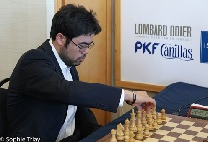
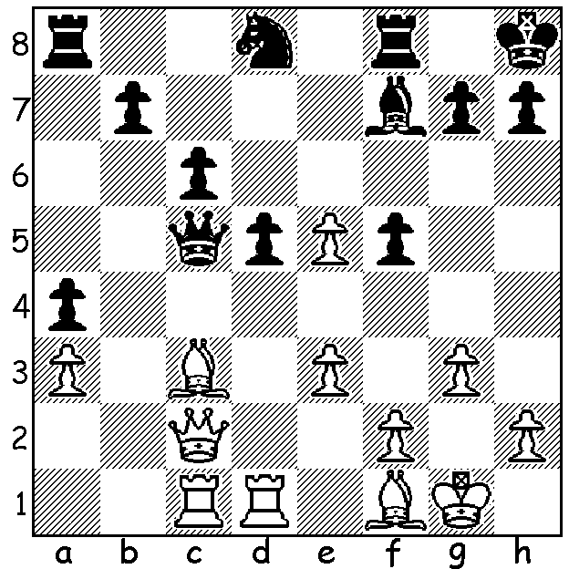

With Nigel Short’s 30 Board Simultaneous at the Rhein-Donnau Club only nine days away I looked up Nigel’s most recent tournament, the Tradewise Gibraltar Chess Festival, played 26 Jan to 4 Feb, hoping to find an example of his sparkling play. Nigel had won the first two Festivals in 2003 and 2004 and was winner again in 2012. This time he finished =24th among the 257 entrants with 6.5/10. Of his games the most memorable, a brilliant sacrificial mate, was unfortunately for Nigel a loss:

Nigel Short – Dronavalli Harika
2016 Tradewise Gibraltar Chess Festival
French, Tarrasch
1.e4 e6 2.d4 d5
3.Nd2 Be7 4.e5 c5

5.Qg4 Kf8 6.dxc h5
7.Qe2 Bxc5 8.Nb3 b6
9.Nh3 Qc7 10.Bf4 Ne7
11.0-0-0 Ng6 12.Kb1 Nc6
13.Re1 a5 14.Nxc5 bxc5(a)
15.Qe3 c4 16.Qc5+ Kg8
17.Bc1 a4 18.f4 Nge7
19.Ng5 Nf5 20.Rd1 Ra5
21.Qf2 Rb5 22.c3 Qa5
23.Qc2 Rb8 24.Ka1 Ba6
25.Nf3 Qb5 26.g3 a3! A happy Dronavalli Harika
27.bxa Qa5 28.Bh3 Bb5
29.Rxd5(b) Ba4!(c) 30.Qd2 Qxd5!
31.Qxd5 Bc2! Resigns(d)

a) Despite his imprisoned KR Black has the better game with attacking prospects on the queenside.
b) This promising exchange offer looks promising (29…exd5 30.Bxf5)
c) Now if 30.Rxa5 Bxc2 wins the rook.
d) Threatening mate and protecting the f5 knight.

Winner at Gibraltar was top US player Hikaru Nakamura who also won in 2015. He had to defeat France’s number 1 Maxime Vachier-Lagrave in a play-off which after 4 draws was won by Nakamura (Black) in an Armageddon finish. Nakamura’s prize was £20,000 while the top women’s player, Anna Muzychuk (7/10) won £15,000. Here’s Nakamura’s win against Anna’s sister Mariya, the current Women’s World champion:
Hikaru Nakamura – Mariya Muzychuk
2016 Tradewise Gibraltar Chess Festival
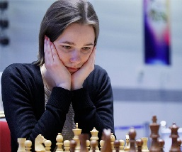
Queens Gambit, Sem-Slav
1.Nf3 d5 2.d4 Nf6
3.c4 c6 4.Nc3 e6
5.e3 Nbd7 6.Qc2 Bd6
7.g4 h6 8.Rg1 e5
9.Bd2 e4 10.Nh4 g6
11.h3 a6 12.0-0-0 b5
13.c5 Bh2 14.Rh1 Bc7
15.f3 a5 16.fxe b4
17.Nxd5! cxd5 18.exd5 Bg3
19.Nf3 0-0 20.Rg1 Qc7
21.Bc4 Ba6? 22.d6! Bxd6
23.Qxg6+ Kh8 24.Qxh6+ Nh7
25.Ng5 Ndf6 26.Rdf1 resign Women’s World champion Mariya Muzychuk
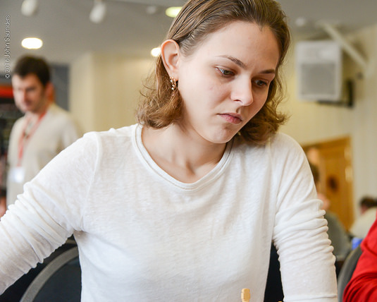
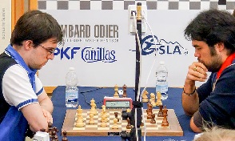

Vachier-Lagrave v Nakamura in Play-Off Top scoring female Anna Muzychuk
A popular match at Gibraltar was ‘The Battle of the Sexes’ in which a team of men played a team of women on a giant board with each player making a move in turn. The women won the first but lost the 2nd & 3rd.


The women celebrating their Game 1 win Men seeking revenge in Game 2
(team captain Short on left with Nakamura 2nd left)

SOLUTION: 1.e6! (clearance sacrifice) 1..Nxe6 (defending Q) 2.Bxg7+! (discovered attack on Q) 2…Kxg7 3.Qb2+! Kg8 4.Rxc5 Nxc5 and White’s Q proved too strong for Black’s R & N.

