Nigel Short – Kindermann (2012):
White wins quickly:
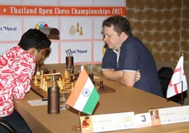
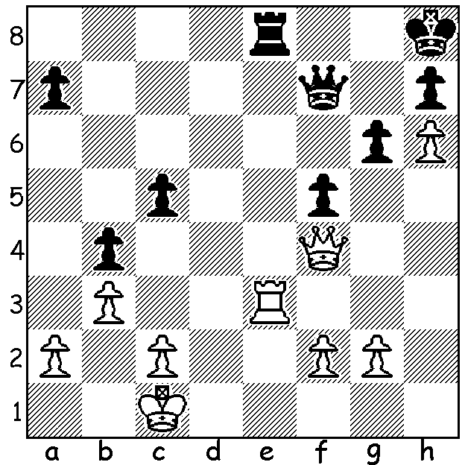
Short at 2015 Thailand Open which he won

With the Nigel Short Lecture and 30 Board Simultaneous Display at the Rhein-Donnau Club only two days away it will be interesting to compare his result after all the games have finished with that of the world champion Magnus Carlsen who recently took on 70 opponents in Hamburg. The significance of 70 was the 70th anniversary of the German Newspaper Die Ziet. The 1400 applicants proved the interest generated in the event and there was a competition to guess the final score with many tipping 70 - 0. After six hours of play the final score was 68 – 2 in favour of Carlsen (+67 =2 -1) with the only winner being Jens-Erik Rudolpe, a historical chess author with a FIDE rating of 1981. Former WA champion Stuart Byrne who has played Nigel Short, citing Short’s skill in Rapidplay and Blitz chess, believes he will win all games but I am of the opinion he will lose one or two games and draw at least two. What is your prediction of the result? While all 30 places have been filled there are opportunities to attend Nigel’s lecture at 1pm and watch the games ($10) or just watch the games at 2pm (gold coin collection). Contact me on 0439798607 for details.

Magnus Carlsen – Jens-Erik Rudolpe
2016 Die Ziet Simul, Hamburg
Kings Indian Defence
1.c4 g6 2.Nc3 Bg7
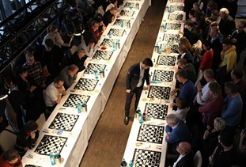
3.d4 d6 4.e4 e5
5.d5 a5 6.Bd3 Na6
7.Nge2 Nf6 8.Bg5 h6
9.Bh4 0-0 10.f3 Nc5
11.Bc2 Bd7 12.0-0 Qe8
13.Kh1 Nh7 14.b3 f5
15.a3 b6 16.b4 Nb7
17.Qd2 f4 18.Bf2 g5
19.Nb5 Bxb5 20.cxb5 h5
21.Nc3 g4 22.Qe2 Qg6
23.Rfc1 Nf6 24.Bd1 Bh6
25.Be1 Rf7 26.Ra2 Rg7
27.Rac2 Kh8 28.Qf1 Rag8
29.Bh4 Bg5 30.Bf2 g3
31.Be1 gxh 32.Na4 Ne8
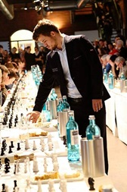
33.Nb2 axb 34.axb h4
35.Nd3 Bd8 36.Kxh2 Rh7
37.Nf2 Nf6 38.Nh3 Nh5
39.Ra1 Ng3 40.Qd3 Bf6
41.Ra7 Nd8 42.Raxc7 Rxc7
43.Rxc7 Nf5! 44.Rc2 Ne3
45.Ra2 Nxg2 46.Qe2 Ne3
47.Bb3 Nf7 48.Qf2 Qh5
49.Qe2 Rg2+ 50.Qxg2 Nxg2
51.Kxg2 Ng5 52.Ng1 h3+
53.Kh1 Qg6 54.Rh2 Nxf3
55.Nxf3 Qxe4 56.Rxh3 Kg7
57.Kg1 Qe3+ White resigns

The LOFTUS CENTRE Allegro (15 min) Championship (cnr Vincent & Loftus St., N Perth) will be played Sunday March 13 starting 10.30am. Entry by Friday 11 March to muller@iinet.net.au or 0419950619 (entry $20 but late entries – up to 10.00am Sunday – incur $10 extra charge). Membership of CAWA is NOT REQUIRED.

SOLUTION: 1.Qc7 resigns (1…Qxc7 2.Rxe8# or 1…Qf8 2.Rxe8 Qxe8 3.Qg7#)

