Nigel Short – Mezioud (2013):
White wins quickly:

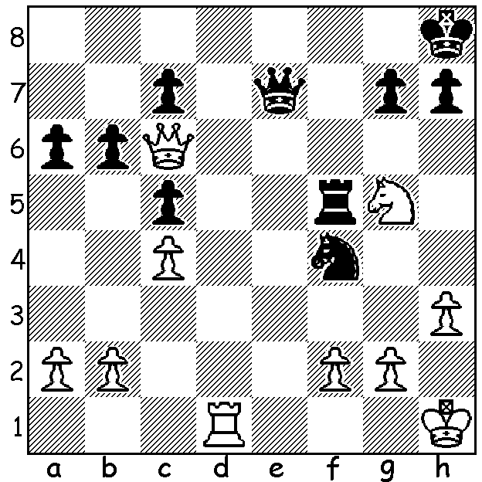
Short deep in thought at WA Simul

The Nigel Short lecture at the Rhen-Donau Club was attended by about 100 chess enthusiasts who saw Nigel present two of his recent games in which he employed the Open Defence in the Ruy Lopez (1.e4 e5 2.Nf3 Nc6 3.Bb5 a6 4.Ba4 5.Nxe4). He then took on 31 opponents in a Simultaneous Display lasting over four hours. While he won 25 games, five locals held him to a draw, WA top player Tristan Boyd, university student Adam Kelly, Tom Donaldson (who has not been competing for a couple of years), Southern Suburbs organiser Andrew Hardegen and Edik Gilmetdinov, easily the last to finish, who coolly held a two rook v two rook and one pawn ending. Nigel was forced to tip over his king to only one player, 16 year old Chisholm College schoolboy Patrick Gong, the current Australian Reserves Champion and 2015 Australian Under 16 champion. Nigel has certainly enjoyed his five-day stay in Perth, taking a walking tour of the city, watching a day’s play at the WACCA and going on a Swan River lunch/wine tour, and has expressed a wish to visit WA again in the near future.

NIGEL SHORT - PATRICK GONG
2016 Simultaneous, Perth
Benoni Defence
1.d4 Nf6 2.Nf3 c5 3.d5 e6
4.Nc3 exd 5.Nxd5 Nxd5 6.Qxd5 Nc6
7.c3 d6 8.Ng5 Qf6 9.g3 h6
10.Ne4 Qe6 11.Qxe6 Bxe6 12.Bg2 a5
13.f4 d5 14.Nf2 f5(a) 15.0-0 Be7
16.Rd1 Rd8 17.Be3 0-0 18.Nd3 b6
19.Bf2 Bf6 20.Rd2 a4(b) 21.a3 Na5
22.Rc2 Rfe8 23.Bf3 g6 24.h4 h5
25.Re1 Kf7 26.e3 Bc8 27.Rd2 Re7
28.Rdd1 Bb7 29.Kg2 Nc4 30.Re2 Rde8
31.Rde1 Ke6 32.Kg1 Kd6 33.Nc1 Bc6
34.Kg2 Nxb2! 35.Rxb2 Bxc3 36.Ree2 Bxb2
37.Rxb2 b5 38.Nd3(c) Rxe3! 39.Bxe3 Rxe3
40.Ne5(d) Rxa3 41.Nxg6 b4 42.Ne5 b3
43.Rb1(e) c4 44.Rd1 Kc5(f) 45.Nxc6 Kxc6
46.Rxd5 Kb6 47.Rxf5 c3 48.Rf6+ Ka5
49.Be4 c2 50.Rc6 Ra1! 51.Bxc2 Ra2
White resigns
a) In permanently preventing e4, this ensures domination of the centre and the cramping of White’s position.
b) Fixing White’s queenside pawns, establishing a knight outpost on c4 and leaving b2 vulnerable.
c) This attempt to establish a knight on e5 is met by a winning exchange sacrifice resulting in Black creating a juggernaut of four united passed pawns.
d) If 40.Rd2 c4 41.Ne5 Rxa3 42.Nxc6 Kxc6 43.Bxd5+ (43.Rxd5? Rxf3!) 43…Kc5 and the pawns cannot be stopped.
e) Black threatened 43…Ra2.
f) Not 44…Bb7? 45.Nxc4+.

The LOFTUS CENTRE Allegro (15 min) Championship (cnr Vincent & Loftus St., N Perth) will be played Sunday March 13 starting 10.30am. Entry today to muller@iinet.net.au or 0419950619 (entry $20 but late entries – up to 10.00am Sunday – incur $10 extra charge). Membership of CAWA is NOT REQUIRED.

SOLUTION: 1.Qe4! (another back row mating sacrifice) resigns (1…Qxe4 2.Rd8+ or 1…Qf8 2.Qxf5! Qxf5 3.Rd8+ or 1…Qxg5 2.Qe8+)

Some of the many pictures taken by Joe Klimzcak


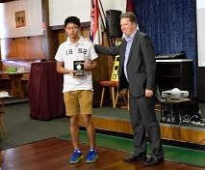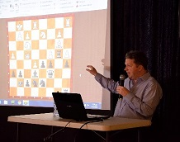

Patrick Gong receiving Nigel demonstrating The attentive audience
Australian Reserves plaque one of his games

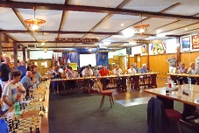
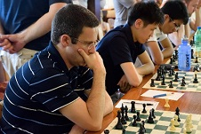
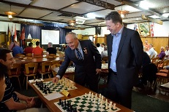

Mayor Russell Aubrey makes Play in progress WA’s top boards, Tristan Boyd
the first move for Nigel Yita Chong and Patrick Gong

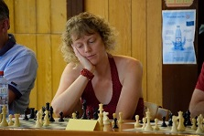
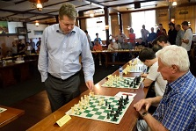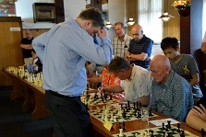

Nigel in play against two multi times WA Champions And against multi times WA Womens
Wolfgang Leonhardt and David Ellis Champion Natalie Maris

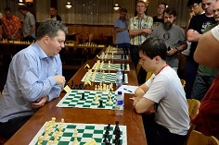

Last player to finish, Edik Gilmetdinov
holds out to draw

