SHORT – ZELIGALKO 2004: White has a mating attack (7 moves):

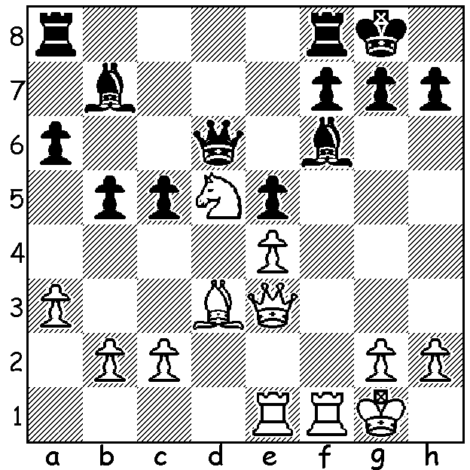

After his six day visit to Perth Nigel Short travelled to Ballarat, Victoria, to play in the Begonia Open (147 players). With three local GMs competing, Zhong-Yuan Zhao, Darryl Johansen and Max Illingworth, as well as many other leading Australian players, he was sure to face stiff opposition. He finished with 6/7 (+5 =2) but had to share top place with last year’s winner Kanan Izzat and Australian champion Bobby Cheng.
Perhaps the most interesting of Nigel Short’s Perth simultaneous games on March 6 at the Rhine-Donau Club was the following:

NIGEL SHORT – ADAM KELLY
2016 Perth Simultaneous
Torre Attack
1.d4 Nf6 2.Nf3 e6
3.Bg5 h6 4.Bh4 c5
5.e3 b6 6.Bd3 Bb7
7.O-O Be7 8.Nbd2 O-O
9.c3 d5 10.Ne5 Nbd7
11.f4 Ne8 12.Bxe7 Qxe7
13.Qa4(a) Ndf6 14.Qa3?(b) Qc7
15.Rac1 Nd6 16.b4 c4
17.Bb1 a5! 18.g4 axb4
19.Qxb4 Ra5 20.Qb2 Rfa8
21.h4 Rb5 22.Qa1(c) h5!
23.g5 Nfe4 24.Nxe4 dxe4
25.Kf2(d) g6 26.Rc2 Ra3
27.Rh1 Bd5 28.Rcc1 Kf8
29.Rc2 Ke7 30.Re2 Qa7
31.Kg3 Qa5 32.Rc1 Rbb3!
33.Rec2 Nb5(e) 34.axb3(f) Rxa1
35.bxc4 Na3?(g) 36.cxd5 Qxd5?(h)
37.c4 Qb7 38.Rb2 Rxb1
39.Rcxb1 Nxb1 40.Rxb1 Qa6
41.c5 Qe2 42.Rxb6 Qxe3+
43.Kg2 Qe2+ 44.Kg3 Qe3+
45.Kg2 Qe2+ 46.Kg3 e3
47.Rb7+ Ke8 48.Rb8+ Ke7(i)

a) Preventing Black from carrying out his plan of …f6 & …e5
b) With a superior Stonewall set-up (no bad bishop) White’s queen is wanted on the kingside to assist in an attack against Black’s king.
c) A terrible square for the queen.
d) White can only mark time while Black seeks to improve his position.
e) 33…Nf5+ first is good.
f) White desperately tries for a swindle
g) Played too hastily (by now Short was coming around much more quickly with more than half the games finished), missing 36.cxd5 Nxc2? or Rxb1? 37.Nc6+: instead retreating the bishop would have been much much better.
h) 36… Qa6 or …Qb5 would be better.
i) In this complex position a draw was agreed. Black believed he had to concede a perpetual but there’s still considerable play: 49.Rb7+ Kf8! (49…Kd8 50.Nxf7+ Kc8 51.Nd6+ Kd8 52.Rb8+ Ke7 – 52…Kc7?? 53.Rc8# - 53.Rb7+ draw) 50.Rxf7+ Ke8 51.c6 when 51…Qc2 fails to 52.c7 e2 53.Kf2! & Black must seek a perpetual with 53…Qc1 54.Kxe2 or 53…e8=Q+: a better try would be 51…Qf2+ 52.Kh3 Qc2 53.c7 e2 54.Rd7 Qxc7 (not 54…e8=Q 55.Rd8+ Ke7 56.Rd7+ perpetual) 55.Rxc7 e1=Q when Black can continue striving for a win. (Thanks to Adam for providing me with his many thoughts on the game)

SOLUTION: 1.Rxf6! gxf6 2.Qh6 Bxd5 3.exd5 (now the bishop joins the attack) 3…Rfd8 (now a well-known mating sequence) 4.Bxh7+ Kh8 5.Bg6+ Kg8 6.Qh7+ Kf8 7.Qf7#.

