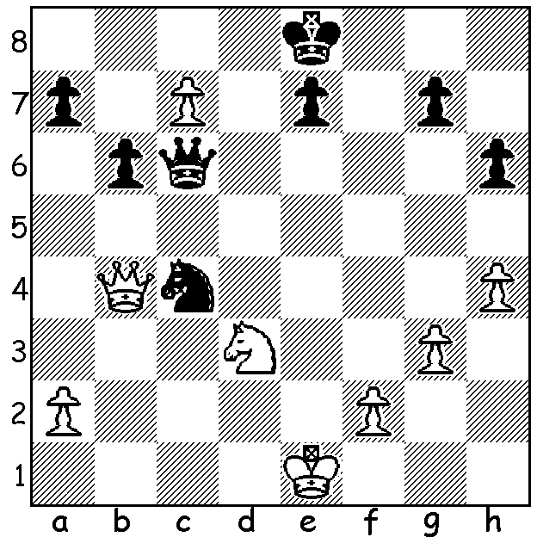

A delightful little problem I saw recently
on chessvibes featuring deflection sacrifices:
White to play and win (5 or 6 moves):

As I reported in my previous article, after his six day visit to Perth, Nigel Short travelled to Ballarat, Victoria, to play in the Begonia Open (147 players). With three local GMs competing, Zhong-Yuan Zhao, Darryl Johansen and Max Illingworth, as well as many other leading Australian players, he was sure to face stiff opposition. He finished with 6/7 (+5 =2) but had to share top place with last year’s winner Kanan Izzat and Bobby Cheng. Nineteen year old IM Kanan Izzat from Azerbaijan is studying aerospace engineering in Melbourne and came first in the Australian Championship this year while Bobby Cheng, also 19, a former World Under 12 champion, is the current Australian champion after being runner-up to the ineligible Izzat.

NIGEL SHORT – KANAN IZZAT
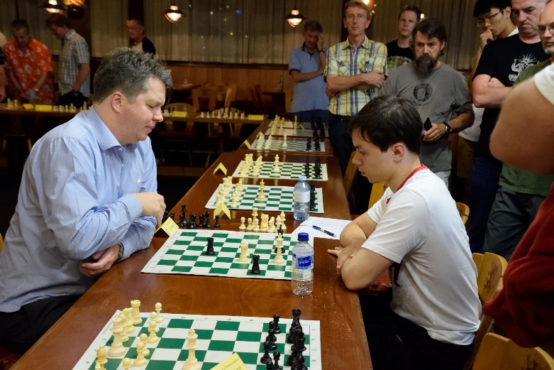
2016 Begonia Open, Bellarat
Caro-Kann Advance
1.e4 c6 2.d4 d5
3.e5 c5 4.c3 Nc6
5.Ne2 Bg4 6.Be3 e6
7.a3 Nge7 8.f3 Bf5
9.b4 cxd 10.cxd Nc8(a)
11.g4 Bg6 12.Bg2 Nb6
13.0-0 Nc4 14.Bf2 Bxb1
15.Qxb1(b) Nd2 16.Qd3 Nxf1
17.Rxf1 Be7 18.f4 Bh4(c)
19.Be3 Qe7 20.Bd2(d) a6
21.Kh1 Na7 22.Ng1 Qd8(e)
23.g5 h6 24.Qh3 hxg Nigel Short v Edik Gilmetdinov
25.fxg Qc7 26.Nf3(f) Qc2 unable to clinch win in last Simul game
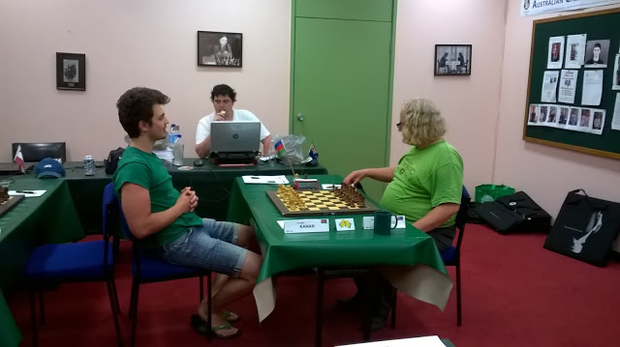
27.Be1 Rc8 28.Nxh4 Nb5(g)
29.g6! Nxd4 30.gxf7+ Kd7
31.Qg4! g5 32.Qxd4! gxh4
33.Bxd5! resigns

a) 10…h5 to slow White on the kingside was an
excellent alternative.
b) Better than 15.Rxb1 Nxa3.
c) Better seems 18…a6 & 19…Rc8.
d) Planning 21.b5 / 22.Bb4.
e) 22…g5 is necessary to safeguard the bishop.
f) 26.g6! is clearly winning – 26…0-0-0 27.gxf7 Qd7
28.f8=Q Rdxf8 29.Rxf8+ Rxf8 30.Qxh4.
g) 28…g6 is necessary. Kanan Izzat v Daryl Johansen in 2015
Australian Masters

And now a win against a young Aussie star, 25 year old Junta Ikeda, a former Japanese champion:
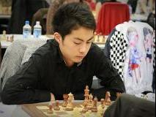
NIGEL SHORT – JUNTA IKEDA
2016 Begonia Open, Ballarat
Sicilian, Sneider Variation
1.e4 c5 2.Nf3 e6
3.b3 b6 4.Bb2 Bb7
5.Nc3 a6 6.d4 cxd
7.Nxd4 Qc7 8.Qd2 Nf6
9.f3 Nc6 10.Nxc6 Bxc6
11.0-0-0 Be7 12.Kb1 0-0
13.Bd3 b5 14.g4 d6
15.h4 Rfd8 16.Qg2 b4 Junta Ikeda (top) & Bobby Cheng
17.Ne2 e5 18.Ng3 Bb5
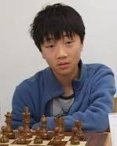
19.g5 Nd7 20.Nf5 Nc4
21.h5 Bf8 22.f4 Bxd3
23.cxd3 a5 24.fxe a4
25.Nh6+! Kh8 26.g6! Be8
27.gxf Bxf7 28.exd6 Rxd6
29.Nf5 Bxb3 30.h6! Bxa2+
31.Ka1 resigns

The GUFELD CUP (WA GP) this weekend, Sat 2rd & Sun
3rd at Leeming Primary starting 10.30 each day. Please get
entry in today. Details cawa.org.au and enquiry & entry to
g-dunlop64@bigpond.com or 93686412 (AH).

The WA JUNIOR CHAMPIONSHIPS will take place 11 – 14 April. Check details on cawa.org.au

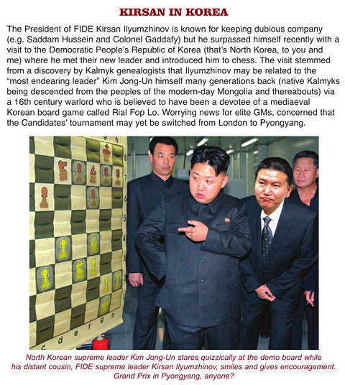
I’ve read a report of a visit by FIDE
President Kirsan Ilyumzhinov to
Pyongyang where he met Supreme
Leader Kim Jong-Un. Ilyumzhinov
hopes fostering an interest in the game
in North Korean can be a means of
building bridges between the secluded
country and the rest of the world.
More next week.

SOLUTION: 1.Qa4! Qxa4 2.c8=Q+ Kf7 3.Qc4+! (an echo) 3…Qxc4 4.Ne5+ / 5.Nxc4 and White is a piece up. (Black can play 1…b5 but this only delays the sequence one move after 2.Qxb5!).

