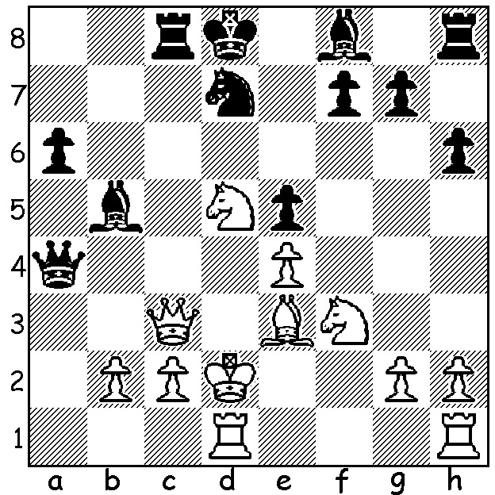

Continuing with combinations from
the women's world champion:
Hou Yifan – Prasad Arun 2008:
White to play and win
(4 moves – look for a pseudo queen sac):

The final round of the recent Candidates Tournament brought together the two possible winners, tied leaders Sergey Karjakin and Fabiano Caruana. With a draw ensuring Karjakin top spot on countback, Caruana chose the Sicilian (1.e4 c5), a fighting double-edged defence which had been neglected throughout the tournament in favour of 1...e5. A tense game ensued:

Sergey Karjakin - Fabiano Caruana
2016 Candidates, Rd 16
Sicilian, Richter-Rauzer Attack
1.e4 c5 2.Nf3 Nc6
3.d4 cxd 4.Nxd4 Nf6
5.Nc3 d6 6.Bg5 e6
7.Qd2 a6 8.0-0-0 Bd7
9.f4(a) h6 10.Bh4 b5(b)
11.Bxf6 gxf6(c) 12.f5 Qb6
13.fxe fxe 14.Nxc6 Qxc6
15.Bd3 h5 16.Kb1 b4
17.Ne2 Qc5 18.Rhf1 Bh6
19.Qe1 a5 20.b3 Rg8
21.g3 Ke7 22.Bc4 Be3!
23.Rf3 Rg4 24.Qf1 Rf8
25.Nf4 Bxf4 26.Rxf4 a4
27.bxa! Bxa4 28.Qd3 Bc6
29.Bb3 Rg5 30.e5!(d) Rxe5(e)
31.Rc4 Rd5 32.Qe2 Qb6(f)
33.Rh4 Re5 34.Qd3 Bg2
35.Rd4 d5 36.Qd2 Re4?(g)
37.Rxd5! exd5 38.Qxd5 Qc7
39.Qf5! Rf7 40.Bxf7 Qe5
41.Rd7+ Kf8 42.Rd8+ resigns(h)

a) 9.f3 Be7 10.g4 is the other popular continuation.
b) 10...Nxe4 11.Qe1 Nf6 12.Nf5 Qa5 13.Nxd6+ Bxd6 14.Rxd6 & White is clearly better.
c) If 11...Qxf6 12.e5! Dxe 13.Ndxb5! Qd8 14.Nd6+ Bxd6 15.Qxd6 exf 16.Ne4! With a clear advantage.
d) Necessary before Black consolidates with ...Re5 ...Rg8 ...Rg4.
e) If 30...dxe? 31.Rc4 Qd5 32.Qh7+ wins or 30...fxe? 31.Qh7+ Ke8 32.Rxf8+ Kxf8 33.Rf1+ or 30.Qxe5 31.Rc4 or Rxb4.
f) Better 32...Rxd1+ 33.Qxd1 Qd5 34.Qc1 Qh1 forcing the queen exchange.
g) 36...Be4 37.Rxb4 Qc6 would leave both sides with chances.
h) 42.Rxf7 43.Qh7+ Ke6 44.Re8+.

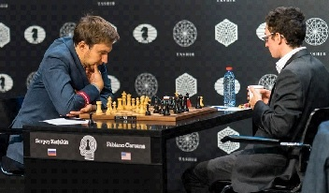
Karjakin (White) in final game v Caruana

FINAL SCORES: Karjakin 8.5/14, Caruana, Viswanarhan Anand 7.5, Anish Giri (14 draws!), Peter Svidler, Levon Aronian & Hikaru Nakamura 7, Veselin Topalov 4.5. Karjakin now qualifies to play defending champion Magnus Carlsen in New York starting November 11.

NIGEL SHORT played in all 152 games in his simultaneous displays in Australia (Perth, Ballarat, Melbourne, Adelaide & Sydney) winning 137, drawing 13 and losing only 2 (one being to Perth schoolboy Patrick Gong (see game March 11). WA secured the best result with 1 win and 5 draws in 31 games.

SOLUTION: 1.Bb6+!! Nxb6 2.Nxb6! Rxc3 (2...Bb4 3.Nxa4 Bxc3+ 4.Nxc3 & White is a piece up) 3.Kxc3+ Kc7 4.Nxa4 Bxa4 5.Nxe5 & with R + p for B White wins easily.

