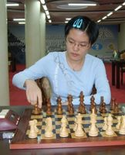
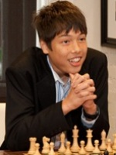
Ray Robson – Hou Yifan 2004:
Black to play and win (5 moves):

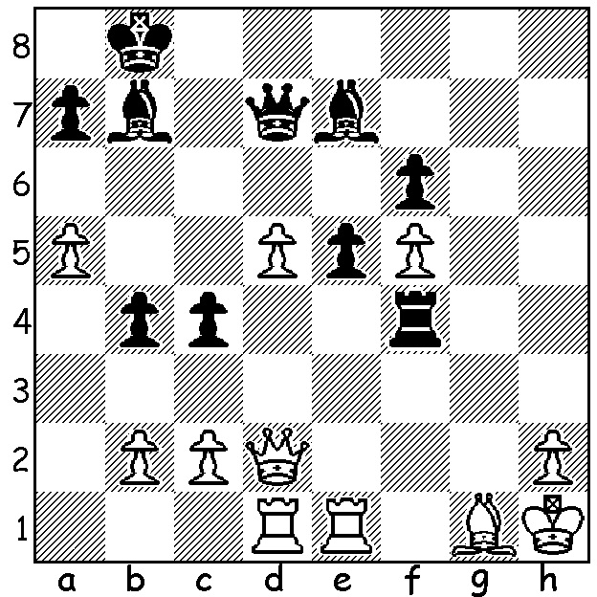

Ray Robson Hou Yifan

A rather unkind joke has circulated about the remarkable performance of Anish Giri in drawing all 14 of his games in the 2016 Candidates event to decide the next challenger to world champion Magnus Carlsen. Imagine the position White king on f7 and queen on g2 with Black’s king on h8. The eight Candidate players were asked to select the best move for White. What do you think was the move Giri chose? (answer below) Giri’s result in the Candidates might lead to the thought that he took a no risks, safety first approach to his games. This was certainly not true as can be seen from the following game against the runner up:

Anish Giri - Fabiano Caruana
2016 Candidates, Rd 9
Pseudo-Grunfeld
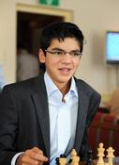
1.d4 Nf6 2.c4 g6
3.f3 d5 4.cxd Nxd5
5.e4 Nb6 6.Nc3 Bg7
7.Be3 0-0 8.Qd2 e5
9.d5 c6 10.h4 cxd
11.exd Na6(a) 12.h5 Nb4
13.hxg Bf5!(b) 14.gxh+ Kh8
15.Rd1!(c) Nc2+ 16.Kf2 Nxe3
17.Qxe3 Bd7 18.Nh3 f5
19.f4 Rc8 20.g3! Nc4!?(d)
21.Bxc4 Rxc4 22.fxe f4(e)
23.Nxf4 Qg4 24.Rd4(f) Rxd4
25.Qxd4 Bxe5 26.Qb4 Rf7
27.Nce2(g) Bg4 28.Qe4 Qf6
29.Rh4 Bf5 30.Qe3 b6
31.b3 Re7 32.Qd2 Rc7! Anish Giri
33.d6(h) Bxd6 34.Qd5 Rf7(i)
35.Kg2 Bc5 36.Rh5 Bg4
37.Rh6(j) Qxh6 38.Qxf7 Qc6+(k)

a) Usual is 11…N8d2 12.h5 Nf6 giving the king added protection.
b) Far better than recapturing as 14.
c) Now 15.Bc5 is met with 15…N4xd5 16.Bxf8 Bxf8 when the attack passes to Black.
d) If 20…e4 21.Ng5.
f) Best was 24.Ke1 (24…Bxe5 25.Ng6+! Qxg6 26.Qxe5+ winning).
g) White has stabilized his position and Black’s king will now be in danger.
h) A clearance sacrifice making d5 available.
i) Better 34…Rc8 with possibility of …Re8.
j) Still 2 pawns up, with the exchange of rooks White believes his queen and knights will engineer a winning attack.
k) Black is not tempted into offering the queen exchange with 38…Qg7? ( 39.Qe8+ Kxh7 40.Qe4+ Kg8 41.Ne6 winning). Now despite White’s continuous attempts to win Black, by resolute defence, struggled to a 96 move draw.
Giri’s suggested move in the puzzle? While the other seven players chose one of the 5 different mates in one available, Giri’s choice was 1.Qg6 draw by stalemate!

RETRACTION: At the beginning of April I reported on a meeting between FIDE President Kirsan Illyumzhinov and North Korean Supreme Leader Kim Jong-Un. You may have noticed the date of my article was April 1 and in consequence may have realized that the report was entirely fictional.

SOLUTION: 1…Rd4! Resigns - 2.Bxd4 Qxd5+ 3.Kg1 Qh1+ 4.Kf2 Qg2+ 5.Ke3 Qf3#.

