Another win by the current Womens World Champion:
Hou Yifan – Francisco Vallejo 2009:White to play & win (6 moves):

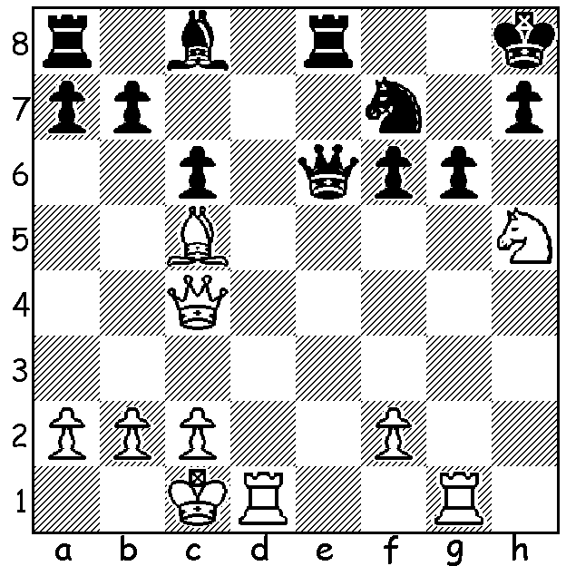

The recently completed Thai (Bangkok) Open attracted 325 players from 43 countries including 13 GMs.
Four players were in the running coming into the final round. While Bejamin Bok (Hungary) and Lidar Khairulin (Russia) could only manage a draw in their game, Paco Vallejo (Spain) defeated last year’s winner Nigel Short (UK) and Surya Ganguly (India) overcame leader Loek van Wely (Netherlands). With Vallejo and Ganguly tied with 7.5/9, the championship was decided on tie-break (sum of opponents’ scores) with the Indian taking the title by a narrow margin. Ganguly’s finish mirrored his effort last year when he beat the leader in the final round to tie for first place although then his tie-break score was less than Short’s. Twelve Australians competed in the event, the best performers being young teenager Anton Smirnov (6), Tim Reilly and Perth schoolboy Patrick Gong (5).

Francisco Vallejo Pons – Wyn Zaw Htun
2016 Thai Open, Round 7
Sicilian, Najdorf
1.e4 c5 2.Nf3 d6
3.d4 cxd 4.Nxd4 Nf6
5.Nc3 a6 6.Bg5 e6
7.f4 Be7 8.Qf3 Qc7
9.0-0-0 Nbd7 10.g4 b5
11.Bxf6 Nxf6 12.g5 Nd7
13.f5! Nc5(a) 14.f6 gxf
15.gxf Bf8 16.Rg1 h5
17.a3 Rb8 18.Re1 Nd7?(b)
19.Nxe6! fxe6 20.f7+ Ke7?(c)
21.Rg6! Qc5 22.Rxe6+! Kxe6
23.Nd5 Nf6(d) 24.Qxf6+ Kd7
25.Qxh8 Bb7 26.Bh3+ Kc6
27.Qf6 a5 28.Qe6 Bc8
29.Qe8+ resigns

a) If 13…Bxg5+ 14.Kb1 0-0 15.fxe Nb6 16.Bh3 with a strong attack.
b) A new move aiming for e5 but a bad one as it deprives the e pawn of bishop protection.
c) Better 20…Kd8 - 21.Rg8 Rh6 22.Qg3 (threat 23.Qg7 & 23.Qg5+) 22…Ke7 23.Bh3 Bb7) and
White remains with a ferocious attack for his sacrificed piece.
d) Forced.
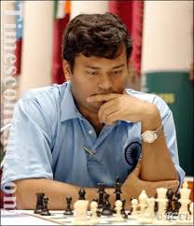
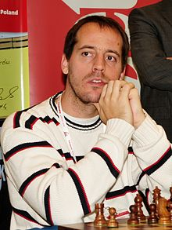

Surya Ganguly Francisco Vallejo

Results from recently played tournaments:
SOUTHERN SUBURBS OPEN: 1. Ihsan Ferozkohi 7/7, 2. Leon Taylor 5.5, 3 Andrew Hardegen 5: Under 1700 – 1.Andrey Lugovskoy 4.5: Under 1450 – 1. Jon Prunty 4.5: Junior – 1. Ignatius Yap 4.

GUFELD CUP: 1.Patrick Gong 5/6, 2.Ihsan Ferozkohi & Lorenzo Escalante 4: Under 1800 – Gary Donaldson, David Spartar & Ignatius Yap 3.

WA JUNIOR CHAMPIONSHIPS: Junior Champion - Ignatius Yap: Girls Champion – Safiyya Aljunied: Under 16 – Sri Krishna Dharmapuri: Under 14 & 12 – Pranav Senthikumar: Under 10 – Raghav Senthikumar.

SOLUTION: 1.Rge1! Qxe1 (1…Qxc4 2.Rxe8# or 1...Ne5 2.Qxe6 Bxe6 3.Nxf6 wins) 2.Qxf7!! Qxd1+ 3.Kxd1 Bg4+ 4.Kd2 Rad8+ 5.Kc3 Bxh5 6.Bd4.

