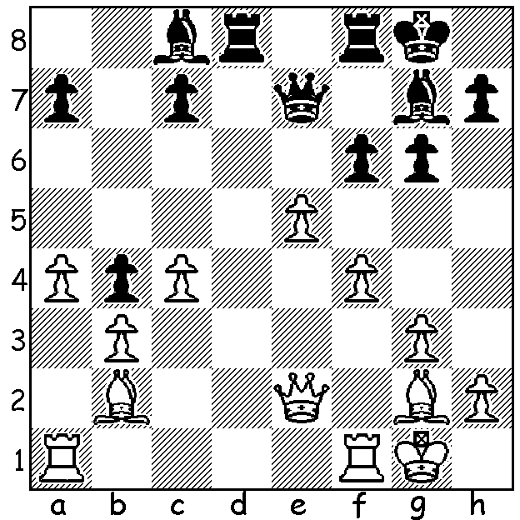

Kasparov – So (St Louis Blitz 2016):
Black's last move, ...f6 is a mistake.
Can you see why (3 moves)?

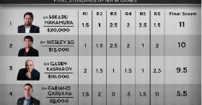
The recent St Louis Blitz, USA, brought together the three top Americans, Fabiano Caruana, Hikaru Nakamura and Wesley So together with the legendary ex- world champion Gary Kasparov who retired eleven years ago. 36 games were played over two days with a time limit of 5 minutes a player but instead of 3 or 5 second increments there was a 3 second delay in the clock restarting after each move. For Kasparov at 53 playing against much younger opponents (Nakamura 30, So 22, Caruana 23) the experience was exhausting. However his performance would rate him 13th in world Blitz rankings. There were a host of blunders interspersed with some amazing chess in the 10 minute games. Here are examples of both:

Wesley So - Hikaru Nakamura
St Louis Blitz, Day 1
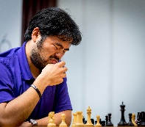
Nimzoindian Defence
1.d4 Nf6 2.c4 e6
3.Nc3 Bb4 4.e3 0-0
5.Bd3 c5 6.Nf3 d5
7.cxd cxd 8.exd Nxd5
9.0-0 Nc6 10.Bc2 Be7
11.Qd3 g6 12.a3 Nxc3
13.bxc3 b6 14.Re1 Bb7
15.h4 Bxh4 16.Nxh4 Qxh4
17.Re3 Ne2?(a) 18.Rg3! Nf5(b)
19.Bg5 Qh5 20.Bd1 Nxg3 Nakamura -”Why did I do that?”
21.Qxg3!(c) Resigns

a) Cutting off the queen's retreat.
b) 18...Qf6 loses the knight to 19.Bg5.
c) Not 21.Bxh5? Nxh5 and Black is still in the game.

Wesley So - Gary Kasparov
St Louis Blitz, Day 2
Modern Defence
1.Nf3 g6 2.e4 Bg7 3.d4 d6
4.c4 Bg4 5.Be2 Nc6 6.Nbd2 e5
7.d5 Nce7 8.h3 Bd7 9.c5! dxc
10.Nc4 f6 11.d6?! Nc8 12.Be3 h6
13.0-0 Bc6 14.dxc Qxc7 15.b4?! cxb
16.Rc1 Nge7 17.Qb3 h6 18.Rfd1 b5
19.Ncxe5! fxe5 20.Bxb5 Rb8 21.Ba4! Qb7
22.Rxc6 Nxc6 23.Qe6+ Ne7(a) 24.Bc5 Rc8
25.Bxe7 resigns(b)

a) If 23...Kf8 24.Rd8+! Nxd8 25.Qe8#
b) 25...Qxe7 26.Qxc8+ Kf7 27.Bb3+ Kf6 28.Qxc6+.

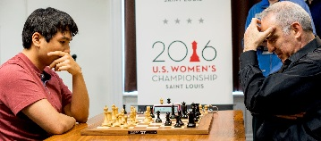
So v Kasparov

Forthcoming events:

Metro Open each Thursday from19 May to June 7. This year the event will be part of the Grand Prix circuit so get your entries in. Contact Gary Taylor 9277 8559 (h).

West Australian Lightning Championship Sunday 22 May at Leeming Primary. Please contact me for information and to submit entry at 0439798607.

South West Open (WA GP event) at Bridgetown Sat 18 & Sun 19 June. Intending players are advised to enter & book accommodation soon. Contact Norbert Muller 0419950619.

West Australian Open Championship (7 round Swiss) July 2 to 23 (dates may change depending on the coming election). Contact Norbert Muller 0419950619.

SOLUTION: 1.Bd5+! Black now had to give up the exchange with 1...Rxd5 seeing 1...Kh8
2.exf! Qxe2 (2...Bxf6 3.Qxe7 wins the queen) 3.fxg7#.

