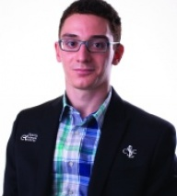
Alex Lenderman – Fabiano Caruana
(US Ch 2016):
Black hoped for 1.Qxf5.
Can you see why (2 moves)?
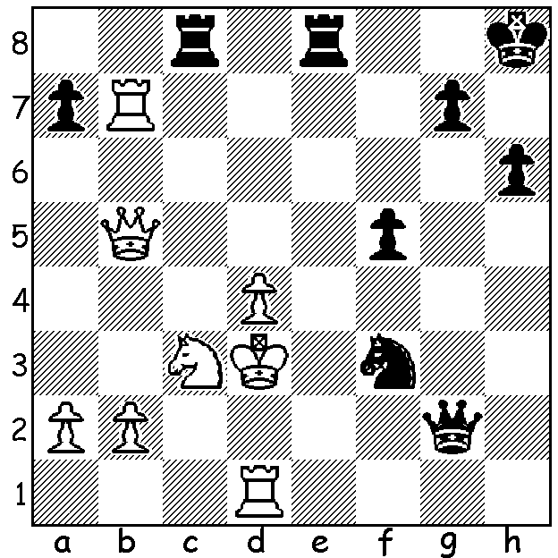

Fabiano Caruana
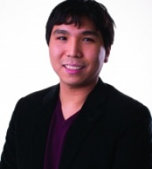
The United States have benefited greatly over the years in chess, as in many other fields, in the influx of immigrants to the country. Perhaps the most famous in chess was Samuel Reshevsky from Poland, one of the leading players in the 1930s to 1950s. Reshevsky was US champion eight times, gained =3rd place in the 1948 World Championship and was =2nd in the 1953 Candidates.

In this year's US Championship 8 of the 12 contestants were immigrants, including the winner Fabiano Caruana (from Italy) and runners-up Hikaru Nakamura (Japan) and Wesley So (Philippines).
Moreover two others, both juniors, Akshat Chandra and Jeffrey Xiong, are from immigrant families. Wesley So

The event was a selection tournament for the coming Olympiad, while the top three players would be invited to play in the St Louis Blitz with the legendary Gary Kasparov (see last week's article).

Leading scores: Caruana 8.5, Nakamura & So 7.5, Ray Robson 7.

The winner of the Womens Championship, in which the players were also almost all immigrants, was Nazi Paikidze (8.5) who overtook leader Tatev Abrahamyan (8), who unexpectedly lost in the last round.

Wesley So defeats five times US champion Gata Kamsky, who played Anatoly Karpov in 1996 for the FIDE World Championship and who GataKamsky
emigrated from Russia to the States in 1989:


WESLEY SO - GATA KAMSKY
2016 US Chanpionship, Rd 1
Ruy Lopez, Breyer Defence
1.e4 e5 2.Nf3 Nc6
3.Bb5 a6 4.Ba4 Nf6
5.0-0 Be7 6.Re1 b5
7.Bb3 d6 8.c3 0-0
9.h3 Nb8 10.d4 Nbd7
11.Nbd2 Bb7 12.Bc2 Re8
13.Nf1 Bf8 14.Ng3 g6
15.Bg5(a) h6 16.Bd2 Bg7
17.a4 c6(b) 18.axb(c) axb
19.Rxa8 Qxa8 20.Nh4 Qd8 Hikaru Nakamura
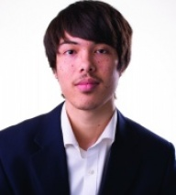
21.Qc1 Kh7(d) 22.Nhf5! gxf5
23.Nxf5 Re6 24.Bxh6 Ne8
25.Bg5 Bf6 26.Bxf6 Qxf6(e)
27.d5 Re7 28.g4 resigns

a) Tempting Black to attack with his h pawn which can become a target.
b) This has been criticised as too passive with 17...c5 suggested as better.
c) A new move prepared by So.
d) A better defence was 21...Nh7 when 22.Nhf5 gxf5 23.Nxf5 Re6 24.Bxh6 Bxh6 25.Nxh6+ Kf8 26.Nf5 when White has compensation for the sacrifice but no clear win.
e) Little better is 26...Rxf6 27.Qg5 Nf8 28.Re3 Ng6 29.Rg3 Kg8 Ray Robson
30.h5 winning.

WA OPEN LIGHTNING CHAMPIONSHIP 1pm Sunday 22 May at Leeming Primary. Details & entry cawa.org.au or 0439798607.

METRO OPEN (WA GP event, 7 Rd Swiss) starting Thursday 19 May at 7.30 & continuing each Thursday to 30 June. Contacts & entries kelvinandmavis@gmail.com and Garry Taylor 92778559(h).

AUSTRALIAN OLYMPIAD OPEN TEAM in Board order is 1.David Smerdon, 2.Zong-Yuan Zhoa, 3.Moulthon Ly 4.Anton Smirnov 5.Max Illingworth. The chess community of Australia is asked to help the teams (Open & Women) financially as there is no government assistance. The Olympiad Appeal is on acfappeal.aunz.org.

SOLUTION: If 1.Qxf5 Qd2+!! (a brilliant deflection/obstruction sacrifice) 2.Rxd2 Ne1#.

