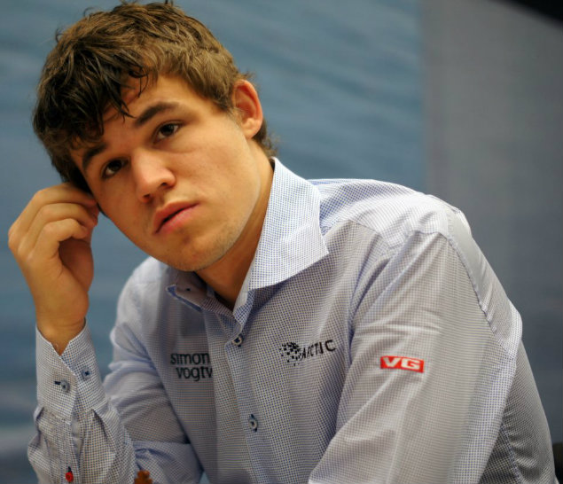
Naiditsch – Carlsen 2006:
despite a considerable material deficit
Black has conjured up a winning attack (4 moves):
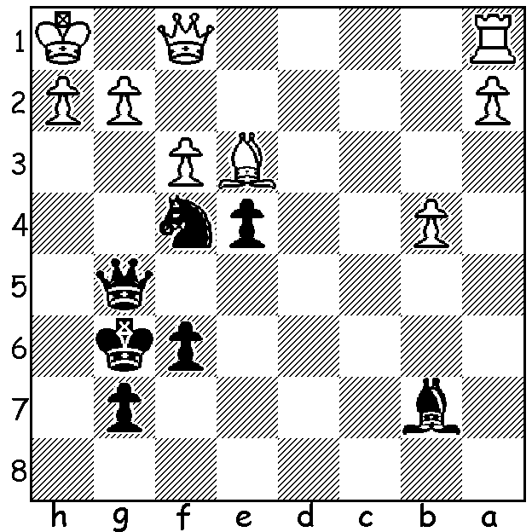

World champion Magnus Carlsen

The 4th Norway Chess Tournament, played in April, was won by world champion Magnus Carlsen, despite losing to Levon Aronian. This was Carlsen's first win in the four years the event has been held. Leading scores: Carlsen 6, Aronian, Maxine Vachier-Lagrave, Veselin Topalov 5.5, Vladimir Kramnik 5.


Levon Aronian - Pavel Eljanov
2016 Norway Chess Tournament, Rd 7
English Opening
1.c4 e6 2.g3 d5
3.Bg2 dxc 4.Qa4+ Nd7
5.Qxc4 c5 6.Nc3 Ngf6
7.d3 Be7 8.Nf3 b6
9.Ng5 Rb8 10.0-0 Bb7
11.Bf4 Bxg2 12.Kxg2 Rb7
13.Nf3 0-0 14.e4 Qa8
15.a4 Rd8 16.Nb5 Qc8
17.Rac1 Nf8 18.d4 Ng6
19.Bg5?! a6(a) 20.Nc3 b5
21.axb axb 22.Qe2 c4
23.Rfd1 h6 24.Bxf6 Bxf6
25.h4 Qb8 26.Ra1 Be7 Levon Aronian
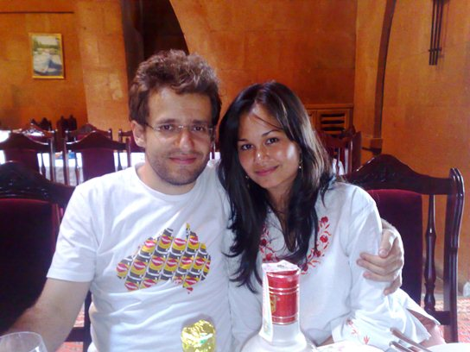
27.h5 Nf8 28.Ne5 Rc8
29.Ra6 Rb6?(b) 30.Rxb6 Qxb6
31.Qf3 f6 32.Ng6 Nxg6(c)
33.hxg6 b4 34.Ne2 Qd6
35.d5 e5 36.g4 Bf8
37.Qf5 Ra8 38.Rc1 Qa6
39.Ng3 Kh8 40.Qe6 Qa2
41.Nf5 c3 42.Rh1 Qa7(d)
43.d6 Qb7 44.d7 Qxe4+ with partner Arianne Caoili
45.f3 resigns

a) After 19...Nxe4 20.Bxe7 Nxe7 21.dxc Nxc5 22.b4 both players missed 22...Nd3!
b) Better 29...b4 30.Na4 Ra7 (31.Nc6? Rxc6! 32.Rxc6 Rxa4.
c) Having an enemy pawn on g6 is worse than a knight, especially as the h file becomes half open: Black should play 32...Bb4 when White would reply with 33.Ne2.
d) Black must prevent 43.Qf7 / 44.Rxh6+!
e) 45...Qe2+ 46.Kg3 Qd2 47.Rxh6+! gxh6 48.Qxf6+ Kg8 49.Qf7+ Kh8 50.Qh7#.

Aronian first connected with Arianne Caoili on the dance floor at the wind-up to the Turin Chess Olympiad in 2006 and they have been in a relationship ever since, becoming engaged last year.
Arianne, who rocketed to fame after the punching of Aronian by the jealous British champion Danny Gormally at Turin and her near victory in Dancing with the Stars, is a dual chess international, having represented the Philippines and then Australia (2004, 06, 08, 10, 12).

The Chess Association website cawa.org.au contains information on past and forthcoming events, including the South West Open in Bridgetown 18/19 June and the WA Open Championship starting June 26. There is also information on the 2016 Olympiad Appeal to assist Australia's Open and Women's teams at Baku, Azerbaijan. As no government assistance is given, the players and the chess community must come up with the finance so Australia can compete in one the the world's largest sporting events. So please help out our teams by giving generous support.

SOLUTION: 1....exf : if 2.gxf Qg4 wins and if 2.g3 f2+.

