Tristan Boyd – Max Illingworth (Doeberl Cup 2016): how does WA's top player gain a winning advantage against a former Australian champion (3 moves)?
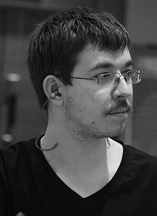
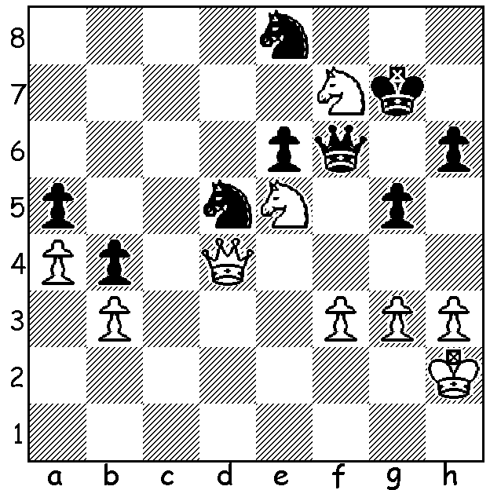
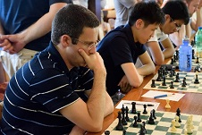

Tristan Boyd Max Illingworth

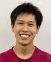
This week we concentrate on local chess, starting with results from WA's three principal clubs. The Metropolitan Club is at present conducting a seven round Open. In the championship played earlier this year the top places were a virtual mirror of last year's Respini Cup which was won by Yita Choong (9/9) followed by David Ellis & Adam Kelly (7). In this year's championship Yita was again the winner with 8/9, suffering his only loss in the final round to Adam Kelly. Second was David Ellis (7) with Adam third (6.5). Other sections: B – Robin Shaw 5.5/7, Natalie Maris & John Lee 4.5: C - Dougal Maclean, Mel Lintern & Sjef de Jong 6.5/9: D - Paul Mosely 8/9, Ben Motu 6, Stewart Hunt 5.5.
Yita Choong

The Perth Club's Championship with 28 competitors resulted in a triple tie between Robert Maris, Stephen Jones and Peter de Yaak (all 5.5/7). With Stephen drawing his final game Peter defeated Robert to catch his two rivals.

The Southern Suburban Club began the year with an Open won by Ihsan Ferozkohi with 7/7 (reported April 29). The Club is now conducting three round robins with the A Division containing a number of WA's top players.

Last year a number of WA players travelled to Canberra for Australia's top annual tournament outside of the national championships, the Doeberl Cup. This year the main event, with 56 entrants and won by Australian James Morris with 7.5/9 followed by GMs Surya Ganguly (India) & Hrant Melkumyan (Armenia) on 7, had only two of the state's players competing. Our top rated player Tristan Boyd faced extremely tough opposition, finishing =18th with 5/9 (+3 =4 -2). Adam Kelly had a tournament to forget scoring 1.5, although he performed well in the Blitz (won by ex-Australian champion Bobby Cheng with 8.5/9), scoring 6/9. Here is a fine game from another ex-Australian champion:
Trevor Tao - Eliot Soo-Burrows
2016 Doeberl Cup, Rd 1
Trampowsky Attack
1.d4 Nf6 2.Bg5 d5
3.Bxf6 gxf6 4.Nf3 c5
5.c3 e6 6.e3 Qb6
7.Qb3 Nc6 8.Nbd2 cxd
9.exd Qc7 10.Bd3 Be7
11.0-0 0-0 12.Kh1 Kh8
13.Rae1 Bd7 14.Ng1!(a) b5
15.Qd1 b4(b) 16.Bxh7! Qf4(c)
17.Re3 e5(d) 18.Bb1 Bg4
19.Qc2 e4 20.Nxe4! Bf5(e)
21.Qd2 Qh4(f) 22.Nc5 Bd6
23.Nf3 Qh7 24.Bxf5 Qxf5
25.Nh4 resigns

a) This and the next are brilliant undeveloping moves.
b) Black, unaware of White's plan, fails to play the blocking 15...f5.
c) If 16...Kxh7 17.Qh5+ / 18.Qg4+ / 19.Re3.
d) If 17...Kxh7 18.Rh3+ / 19.Qh5.
e) If 20...dxe4 21.Rxe4 Qf5 22.Rxg4!
f) If Black captures the knight 22.Rh3+ wins the queen.

The SW OPEN (WA GP event)will be played at Bridgetown on Sat 18 & Sun 19 June. Info & entry at cawa.org.au or Norbert Muller 0419950619.

SOLUTION: 1.Nxh6 wins a pawn, an advantage White was able to convert to a win (if 1...Kxh6 2.Ng4+ or 1...Qxh6 again 2.Ng4+ with Black losing his queen).

