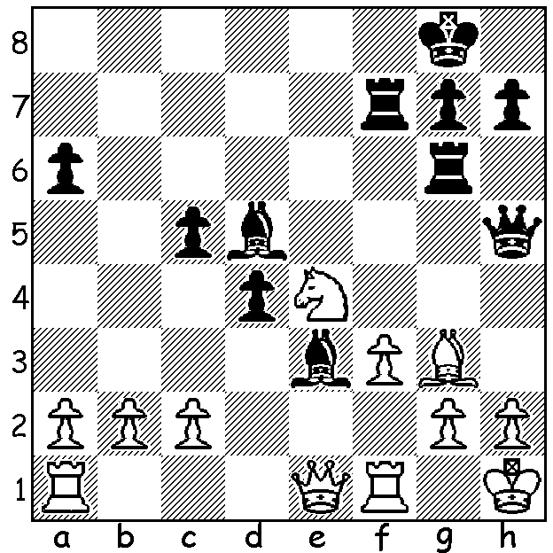

Ten year old R. Praggnanandhaa
(Black v Kharchenko, Aeroflot Open 2016).
has skilfully concentrated every piece against White's king.
To avoid the loss of a piece (1...Bxe4 2.fxe4 Rxf1+ 3.Qxf1 Rxg3)
White plays 1.Nxc5 but loses to a sacrificial attack (3/4 moves):

R. Praggnanandhaa from India has recently become the youngest ever International Master at the age of 10 years and 10 months after obtaining his third norm with a score of 7/10 in the KiiT Chess Festival in India. I have been unable to discover what the R in his name stands for despite consulting a host of web sites. He has previously won the gold medal at the Under 12 Asian Youth Championships, the 2013 Asian Under 8 Championship and the 2015 World Under 12 Championship. By comparison the previous youngest player to become an IM was Sergey Karjakin (Russia) at 11 years 11 months. Karjakin then took only another eight months to become the youngest ever Grandmaster at twelve years seven months. World champion Magnus Carlsen, who defends his title later this year against Karjakin, became a GM aged 13 years 4 months.

L di Nicolantonia – R Pragganandhaa
2016 Cannes Open
Scotch Game
1.e4 e5 2.Nf3 Nc6
3.d4 exd 4.Nxd4 Bc5
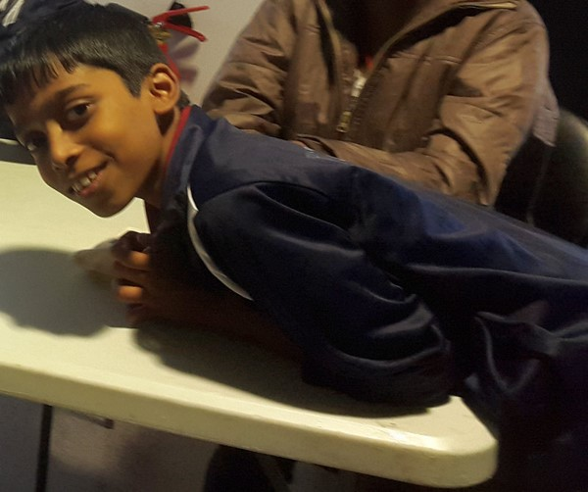
5.Nb3 Bb6 6.Nc3 Nge7
7.Qe2 0-0 8.Be3 d6
9.0-0-0 f5 10.f4 fxe
11.g3 Nf5 12.Bxb6 axb6
13.Bg2 e3 14.Kb1 Kh8
15.Be4 Nh6 16.Qxe3 Ng4
17.Qd2 Nf6 18.Bg2 Be6
19.h3 Na5 20.Nd4 Bg8
21.Rhe1(a) Nc4 22.Qd3 c6
23.Ne6 Bxe6 24.Rxe6 d5
25.b3 Na3+ 26.Kb2 b5
27.Qd4 Qa5 28.Bf1 c5!(b)
29.Qxc5 Rfc8 30.Qd4 Ne4(c)
31.b4 Nc4+ 32.Bxc4 Qa3+
33.Ka1 Nxc3 White resigns (d)

a) There seems little chance of meaningful pressure on the e file. Better would be a kingside pawn advance.
b) An imaginative pawn sacrifice to open lines against the White king.
c) Both attacking and defending against 31.Rxf6! Possible was 30...Nxc2! (31.Kxc2 Qxa2+ 32.Kd3 Qxb3 etc).
d) If 34.Bb3 Qxa2+! 35.Bxa2 Rxa2#.

Check on cawa.org.au for information on the South West Open in Bridgetown 18/19 June.

The WA Lightning Championship held on May 22 at Leeming finished with a tie between Ihsan Ferozkohi and teenager Patrick Gong who each scored 9/11 and then won one game each in a play-off. Other prize winners: Under 1900 - 1. George Carolin-Unkovich 7.5, 2-3.Lorenzo Escalante & Colin Koehler 6: Under 1700 – Stewart Long from Dunsborough who defeated the Dharmapuri brothers Sri Krishnan & Kundan after all finished on 5 pts. Kathryn Hardegeen was the Women's champion and Lorenzo the Senior champion.

The death was announced earlier this week of the great Viktor Korchnoi aged 84. Korchnoi, a Soviet dissident who took up residence in Switzerland, is best remembered for his epic 24 game match for the world championship against Anatoly Karpov in 1985 which he lost by one point.

SOLUTION: 1.Nxc5 Rxf3!! and if 2.gxf3 Qxf3+!! 3.Rxf3 Bxf3#: White played 2.Rxf3 but after 2...Qxf3! 3.Qf1 resigned after 3...Qxg3! (4.hxg3 Rh6#). This final round win gained Praggnanandhaa his second IM norm.

