Korchnoi – Teschner 1962: Korchnoi (Hastings 1955/56)
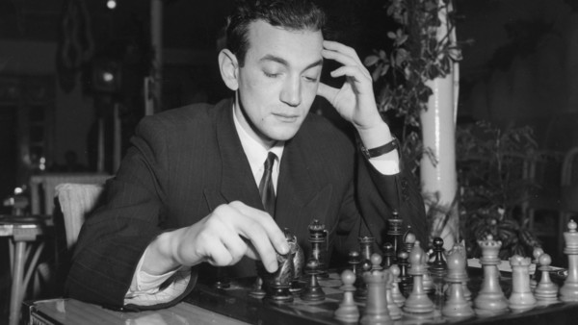
White to play and win (4 moves):
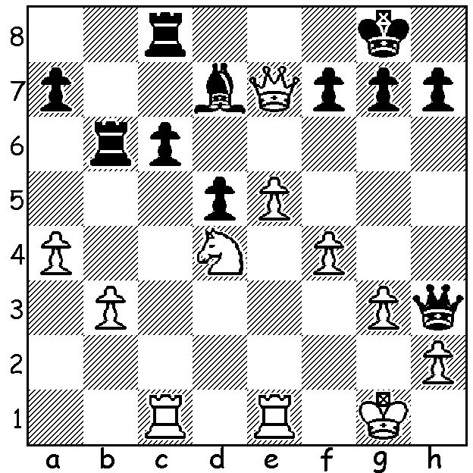

As reported last week great Viktor Korchnoi has died in Switzerland aged 84. He will be remembered as one of the greatest players of all time and one of the great fighters on the chess board. To quote from Golembek's Encyclopedia of Chess, 'Korchnoi's chess style is very attractive for the onlookers, for he fights hard for a win in every game and is frequently in desperate time trouble. He has the reputation of possessing immense reserves of determination and powers of concentration. At his most dangerous when launching a counter-attack, Korchnoi is perhaps one of the greatest defensive players of modern times.' Korchnoi was born in Leningrad in 1931 from a poor background and survived the siege of the city. He played in the USSR championship for the first time in 1952, coming 6th. He became an IM in 1954 and a GM in 1956. He won the Soviet championship on four occasions and a host of international events, many with enormous scores.
He was a representative for the USSR in six Olympiads, scoring an impressive +50 =31 -3. More next week.
Here is a fighting win against the future world champion Bobby Fischer:


Bobby Fischer - Viktor Korchnoi
1962 Candidates: Pirc Defence
1.e4 d6 2.d4 Nf6
3.Nc3 g6 4.f4 Bg7
5.Nf3 0-0 6.Be2 c5
7.dxc Qa5 8.0-0 Qxc5+
9.Kh1 Nc6 10.Nd2(a) a5!
11.Nb3(b) Qb6 12.a4 Nb4
13.g4?(c) Bxg4! 14.Bxg4 Nxg4
15.Qxg4 Nxc2 16.Nb5 Nxa1
17.Nxa1 Qc6 18.f5 Qc4 19.Qf3 Qxa4
20.Nc7 Qxa1 21.Nd5(d) Rae8 22.Bg5(e) Qxb2
23.Bxe7 Be5 24.Rf2(f) Qc1+ 25. Rf1 Qh6
26.h3 gxf 27.Bxf8 Rxf8 28.Ne7+ Kh8
29.Nxf5 Qe6 30.Rg1 a4 31.Rg4 Qb3
32.Qf1 a3 White resigns

a) Better 10.Bd3 or 10.Qe1.
b) After this Black is better: 11.Nc4 should be played.
c) An error brilliantly exploited by Black but if 13.f5 d5 14.e5 Ne4 leaves White in trouble: the retreat 13.Nd2 seems best.
d) Banking everything on a kingside attack but the obvious 21.Nxa8 would leave White with good chances of saving the game – 21...Rxa8 22.fxg fxg 23.Qb3!+ (better than 23.Qf7+ Kh8 24.Qxe7 Qb1! 25.Qxb7 Re8 26.Re1 Qd3) 23...Kh8 24.Qxb7 (24...Rf8 25.Rxf8+ Bxf8 26.Qc8 or 24...Rg8 25.Qb3 Qb1 26.Qc4).
e) If 22.Bh6 Qxb2 23.Nxe7+! Rxe7 24.Bxg7 f6! wins.
f) If 24.Qh3 Qe2.

The WA OPEN CHAMPIONSHIP (7 Rd Swiss) will be played on weekends from July 2 to 23 at N Woodvale Primary. Details cawa.org.au & enquiries N Muller 94099579 (A/H).

SOLUTION: 1.e6! Bxe6 2.f5 and if 2...Bxf5 3.Qe8+ Rxe8 5.Rxe8#.

