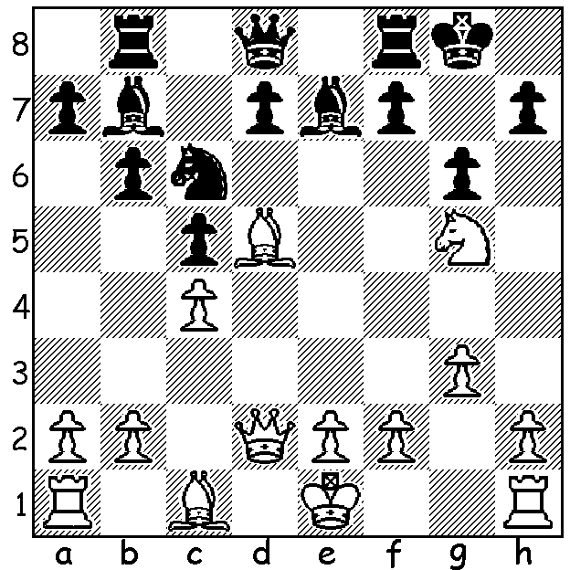

Korchnoi – Karpov (Candidates Final 1974):
Black's last move ...Rb8 is a blunder resulting
in a quickly lost position:

Continuing our short series on Viktor Korchnoi, we come to the period 1974 – 81 which was dominated by his rivalry with world champion Anatoly Karpov. Korchnoi was not popular with the Soviet chess authorities who favoured the younger generation headed by Spassky and Karpov.
Korchnoi at 47 was 20 years older than Karpov when they played the Candidates final in 1974 to determine a challenger to Bobby Fischer in a 24 game match. Karpov led 10-7 (+3 =14) but only just held off a Korchnoi comeback to win 12.5-11.5 and was then installed as world champion when Fischer refused to defend his title.
Korchnoi had been forbidden by the Soviet authorities from competing abroad but when this ban was set aside (partly through support from Karpov after he was proclaimed world champion) Korchnoi, while playing in Amsterdam, took the opportunity to gain political asylum.
Here is a game, played after Korchnoi left the Soviet Union, against one of the leading players from the West, Jan Timman from the Netherlands, who was to face Karpov in a World Championship match after FIDE refused to accept London as the venue for champion Gary Kasparov's defence against Nigel Short. The game shows Korchnoi's love of counter-attack and his endgame skill:
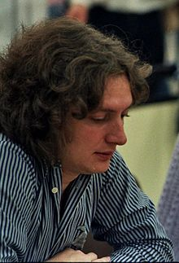
Jan Timman - Viktor Korchnoi
1976 Match, Game 3
French Winawer
1.e4 e6 2.d4 d5
3.Nc3 Bb4 4.e5 c5
5.a3 Bxc3+ 6.bxc3 Ne7
7.a4 Nbc6 8.Nf3 Qa5
9.Bd2 Bd7 10.Be2 f6(a)
11.c4 Qc7 12.cxd Nxd5
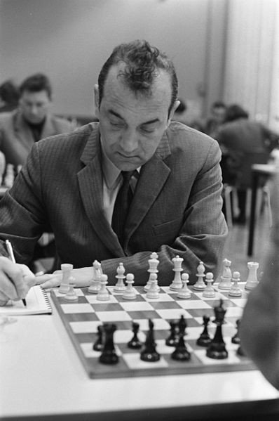
13.c4 Nde7 14.exf gxf
15.dxc 0-0-0 16.Bc3 e5
17.Qd6(b) Nf5 18.Qxc7+(c) Kxc7
19.0-0 Nfd4 20.Nxd4 Nxd4
21.Bd1(d) Kc6(e) 22.Bxd4(f) exd4
23.Bf3+(g) Kxc5 24.Bxb7 Bf5!
25.Bf3 Rhe8 26.Ra2 Rb8
27.Rd2 Rb1 28.g4 Ree1
29.Rxe1 Rxe1+ 30.Kg2 Be4
31.Bxe4 Rxe4 32.Kf3(h) Re5
33.h4 Kxc4 34.Rc2+ Kb3
35.Rc7 d3 36.Rxh7 Rd5
37.Rb7+ Kc2 38.Rc7+ Kb1
39.Rb7+ Ka1 40.Rb5 Rd8
White resigns(i)

a) A novelty – 10...c4 or 10...Qc7 were usual.
b) A pawn up, with two bishops and not wanting to face an attack on the g file after castling, what was more natural than exchanging queens?
c) Not 18.Qxf6 Rdf8 19.Qg5 Rhg8 20.Qd2 Rxg2.
d) Safer was 21.Bxd4 exd4 22.Bd3 (blockade).
e)The king can be an attacking piece in the endgame.
f) Now a mistake to give Black a passed pawn. A reasonable defence was the double pawn sacrifice 22.f4! Kxc5 23.fxe fxe 28.Re1 Kxc4 29.Rc1.
g) Better 23.Rb1.
h) Trying to free the king by 32.f3 fails to 32...Re3 33.Kf2 Ra3 /34...Rxa4.
i) Korchnoi won the match 5.5 – 2.5. Kasparov in My Great Predecessors states: 'This confident (match) victory … became the start of the highest ascent in Korchnoi's chess career. It was in the period 1976 – 80 that his brilliant competitive results were combined with an amazing richness of creative ideas.... And yet he was nearly 50 years old!'

WA CHAMPIONSHIP: due to the Election on June 2 Round 1 has been put forward to this Sunday, 26 June, starting at 1pm at N Woodvale Primary.

SOLUTION: 1.Nxh7! & if 1...Kxh7 2.Qh6+ Kg8 3.Qxg6+ with mate to follow. Black played 1...Re8 but resigned on his 19th move.

