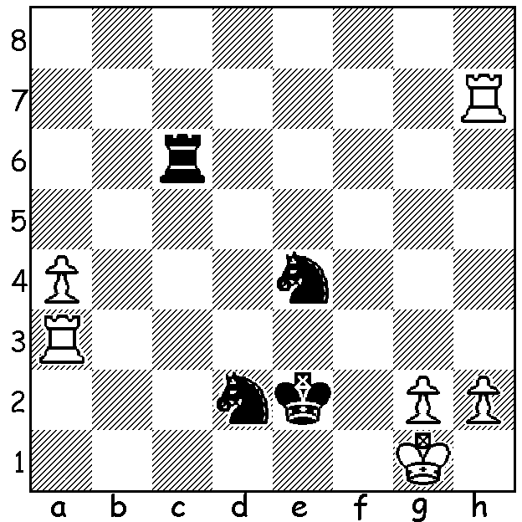

Korchnoi – Karpov, Game 17, 1978:
Faced with the threat of 1...Rc1#
White plays the natural 1.Ra1.
How does Black now win (3 moves)?

In 1977the Russian defector Viktor Korchnoi won the right to challenge world champion Anatoly Karpov by winning three Candidates matches, 6.5 – 5.5 v ex-world champion Tigran Petrosian , 8.5 - 4.5 v LevPolugayevsky and 10.5 -7.5 to another ex-world champion Boris Spassky (despite losing 4 games in a row, 11-14). The 1978 match v Karpov was played in Baguio, Philippines, and proved to be the most intensely bitter world championship ever with accusations by Korchnoi that the Soviets were using every possible dirty trick to frustrate him and Karpov's camp making counter accusations. The most contentious claim centred around Korchnoi's claim that a para-psychologist Dr Vladimir Zukhar, who sat near the front in the audience, was trying to hypnotise him. Aged 27 to Korchnoi's 47 and being a much better manager of his clock than the chronically time-troubled Korchnoi, Karpov was the overwhelming favourite. With the title going to the first player to win six games, Karpov built up a 3-1 lead after 14 games and 5-2 after 27. However Korchnoi won Games 28, 29 and 31 to level the score before losing Game 32 and the match 5-6 with 21 draws.
Our game comes from the 3rd Karpov – Korchnoi match in 1981 in Merano, Italy, won by Karpov 6-2, with Korchnoi successfully employing a favourite defence:

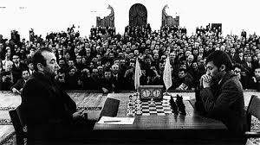
Anatoly Karpov – Viktor Korchnoi
World Championship 1981, Game 6
Ruy Lopez, Open (Tarrasch) Defence
1.e4 e5 2.Nf3 Nc6
3.Bb5 a6 4.Ba4 Nf6
5.0-0 Nxe4 6.d4 b5
7.Bb3 d5 8.dxe Be6
9.c3 Bc5 10.Nbd2 0-0
11.Bc2 Bf5 12.Nb3 Bg6
13.Nfd4 Bxd4 14.cxd4 a5
15.Be3 a4 16.Nc1 a3
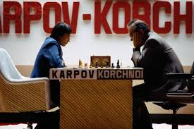
17.b3 f6 18.exf Qxf6
19.Ne2 Nb4 20.Bb1 Qe7(a)
21.Qe1 Rfe8 22.Nf4 Bf7
23.Qc1 c5!(b) 24.dxc Qf6
25.Bxe4 Rxe4(c) 26.Ne2 d4
27.Ng3 Ree8 28.Qd2 Nc6(d)
29.Bg5 Qe5 30.Rac1 d3
31.Rfd1 Bg6 32.Be3 Re6
33.Bf4 Qf6 34.Re1 Rae8
35.Rxe6 Rxe6 36.Rb1(e) h5!(f)
37.h3 h4(g) 38.Bg5 Qd4
39.Be3 Qd5?(h) 40.Nf1?(i) Be4
41.Bf4(j) Bxg2 White resigns(k)

a) Discourages f3 and defends the b4 knight.
b) The pawn sacrifice gives Black a passed d pawn and play on the open c file.
c) Threat 26...Rxf4! 27.Bxf4 Nd3.
d) Not 28...dxe3 29.fxe3 Qh4 30.Rf4 regaining the piece.
e) Defending against 36...Qb2 but a better chance lay in 36.Re1 (36...Rxe1+ 37.Qxe1 Qxf4 38.Qe6+ Kf8 39.Qxc6).
f) With White holding up Black's passed pawn, Black opens up a new front.
g) In time trouble Black misses 37...Nd4 first, giving Black a decisive attack
h) Better 39...Qe5.
i) 40.Ne2! and White's serious problems disappear.
j) If 41.f3 Bxf3! 42.gxf3 Ne5 43.Kh1 Rg6 or 43.Nh2 Nxf3+ 44.Nxf3 Qxf3 45.Qxd3 Qg3+ 46.Kf1 Rxe3 47.Qd5 Kf8! winning.
k) 42.Ne3 Qf3 43.Nxg2 (43.Qxd3 Bxh3) 43...Re2.

SOLUTION: 1...Nf3+! White resigned (2.gxf3 – 2.Kh1 Nf2# -2...Rg6+ 3.Kh1 Nf2#). White needed to play 1.g4! (or 1.g3) - not 1.h4 Rc1+ 2.Kh2 Nf1+ 3.Kh3 Nf2#) when 1...Nf3+ 2.Kg2 Ne1+ 3.Kg1 Rc1 4.Ra2+ Kf3 5.Rf7+=. Taking advantage of Korchnoi's time trouble Karpov had rejected safer moves to pursue an attack with his four pieces and win a game he had been losing.

