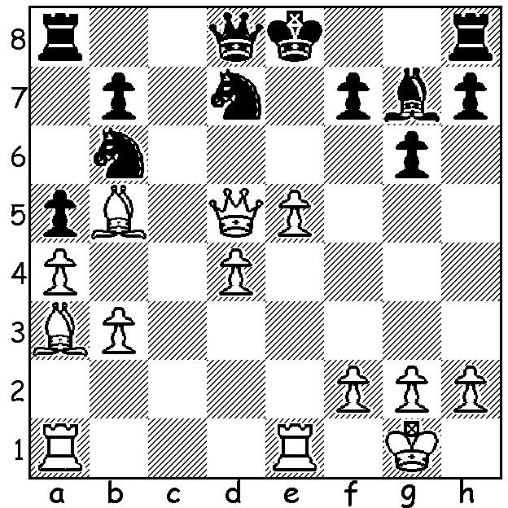

Viktor Korchnoi – Uwe Beinfohr 1986:
a piece sacrifice has given White an imposing
centre and prevented Black from castling:
now White wins quickly:

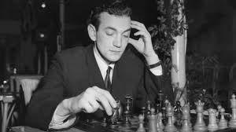
Our third and concluding article on Viktor Korchnoi (1931 – 2016) concentrates on his latter years in which, despite advancing age, he remained a formidable player and feared opponent. In 2007 aged 75 he became the only septuagenarian ever to be rated in the top 100 world players at 85th. He won the world senior championship at 75 with a score of 9/11 and was Swiss champion at 78 and again at 80.

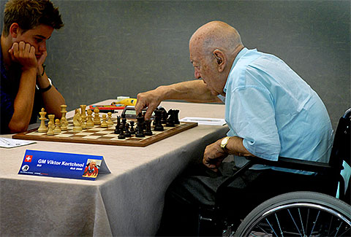
A stroke in 2012, which was to confine him to a wheelchair, failed to prevent his continued participation in international events. He was a prolific writer of books including two annotated books of his games, an autobiography and an overview of Soviet politics' influence on chess. During his life he defeated nine undisputed world champions with plus scores against three of them (Tal, Petrosian, Spassky). 'His often rude and abrasive approach won him few friends. He was never the most loved but one of the greatest respected players ever' ( Financial Times). He would sometimes sweep the pieces off the board in anger but was capable of real acts of sportsmanship. In the 1983 Candidates to find a challenger for world champion Anatoly Karpov he refused to accept a win by forfeit against Gary Kasparov in their semifinal match after the Soviet authorities refused to allow Kasparov to play in the US (the match, won by Kasparov, was relocated to London) and he would not start the clock on being told his opponent, US champion Larry Christiansen, had broken down on the way to their game, again in 1983. Here is a win at the age of 79 against one of the top 10 players in the world:

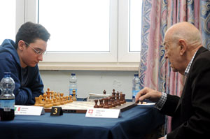
Fabiano Caruana - Viktor Korchnoi
2011 Gibraltar Tradewinds Open
Ruy Lopez
1.e4 e5 2.Nf3 Nc6
3.Bb5 a6 4.Ba4 Nf6
5.d3(a) d6 6.c3 Be7
7.0-0 0-0 8.Re1 Nd7(b)
9.Be3 Nb6 10.Bb3 Kh8
11.Nbd2 f5 12.Bxb6 cxb6
13.Bd5 g5 14.h3(c) g4
15.hxg fxg 16.Nh2 Bg5
17.Nc4 b5 18.Ne3 Bxe3
19.Rxe3 Qf6 20.Qe1 Ne7 21.f3 Nxd5
22.exd5 Rg8 23.Qg3 gxf 24.Qxf3 Bf5(d)
25.Rf1 Rg5 26.Kh1 Qh6 27.Rf2 Rag8
28.Re1(e) Qg6 29.Re3 Bxd3! 30.Kg1(f) e4
31.Qh3 Rxd5 32.Qd7 Rg5 33.g4 Qh6
34.Rf7 R5g7 35.Rxg7 Rxg7 36.Qd8+ Rg8
37.Qb6 Qf6 38.Qxb7 Rf8 39.Qa7 b4
40.Rh3 Qg7 41.Qe3(g) bxc 42.bxc Qxc3
43.Rh5 d5! 44.g5(h) Qa1+ 45.Kg2 Bf1+
46.Kg3 Qe5+ White resigns

a) A quiet continuation which avoids the possibility of the Open Defence 5.0-0 Nxe4, a speciality of Korchnoi, as seen in last week's game.
b) An obscure move played by Maroczy over 100 years ago.
c) White should play 14.Nc4 to enable the other knight to move to d2 rather than be forced to the edge of the board.
d) Black is unconcerned by the self pin.
e) 28.Kg1 was better.
f) If 30.Rxd3 e4: White was unable to prevent this little combination.
g) If 41 Qxg7+ Kxg7 Black would easily win the ending.
h) Not 44.Rxd5?? Qa1+ 45.Kg2 Qxa2+.

SOLUTION: 1.e6! and Black resigns (1...Nxd5 2.exd7# and if 1...Qf6 2.exd7+ Kd8 3.Re8+)

