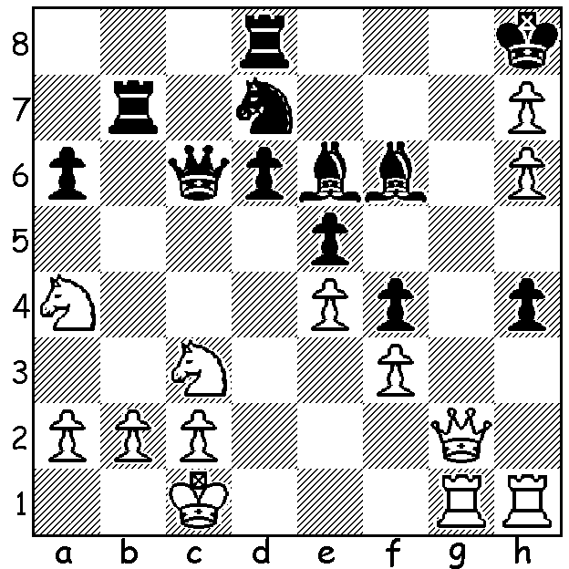

Maxine Vachier-Lagrave – Alberto David 2004:
after sacrificing a piece White now mates in 4 moves
(move 3 is the tricky one):

The Dortmund Sparkassen Chess Meeting began this week with events including an 8-player GM
Round-Robin and a 67-player Open Swiss. The main event includes ex-world champion Vladimir Kramnik and world number 3 Fabiano Caruana as well as the top French player Maxine Vachier-Lagrave who is joint leader after three rounds. MVL's Rd 1 victory over Caruana put him into a elite group of 11 players, headed by world champion Magnus Carlsen and Gary Kasparov and including Caruana and Kramnik, who have all cracked the 2800 rating ceiling. (Interestingly neither Bobby Fischer nor Anatoly Karpov is in the group.)

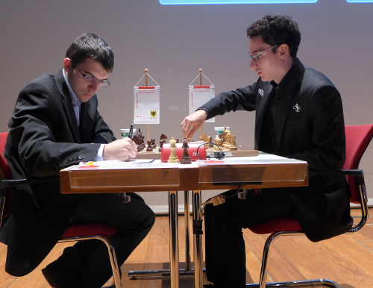
Fabiano Caruana – Maxine Vachier-Lagrave
2016 Dortmund Chess meeting, Rd 1
Sicilian Najdorf
1.e4 c5 2.Nf3 d6
3.d4 cxd 4.Nxd4 Nf6
5.Nc3 a6 6.f3 e5
7.Nb3 Be6 8.Be3 Be7
9.Qd2 0-0 10.0-0-0 Nbd7
11.g4 b5 12.h4 Nb6
13.Qf2 Rb8 14.g5 Nfd7(a)
15.f4 exf 16.Bxf4 Rc8!?
17.Nd5(b) Nxd5 18.exd5 Bg4
19.Be2 Bxe2 20.Qxe2 Re8 Caruana (rt) v MVL
21.Qf3 Qc7 22.Nd4 Nb6
23.Rhe1 Bf8 24.Rxe8 Rxe8 25.Nf5 Qc4
26.b3 Qb4 27.c3 Rc8 28.Rd3 Nxd5!
29.Bd2!(c) Nb6 30.Kb1 Qc5 31.Be3 Qc7
32.Qf4(d) Re8! 33.h5(e) Re6 34.Kc2 Qc6
35.Bxb6(f) Qxb6 36.Rf3 Qb7 37.Ne3 Re4
38.Qg3 Re5 39.Qf4 Rxg5! 40.h6 gxh
41.Rf2 Qd7 42.Nf5 Qe6 White resigns

a) Inferior is 14...Nh5 15.Nc5! & if 15...Bc8 16.Nd3 Qc7 17.Bxb6 Qxb6 18.Qxb6 Rxb6 19.Nd5 Rb7 20.N3b4 with a bind.
b) If 17.Bxd6 Bxd6 18.Rxd6 Qc7 19.Rd1 Ne5 with adequate compensation for the pawn.
c) 29.Rxd5? would be met by 29...Rxc3+.
d) Both players were now in in acute time-trouble.
e) White can draw with 33.Nxd6! Rxe3! 34.Qxe3 Bxd6 35.Qe8+ Bf8 36.Rd8 Qc4 37.b4 and Black must take a perpetual check with 37
...Qf5+.
f) White begins to falter: better 35.Qg4 threatening Nf5/Nh6+.

WA CHAMPIONSHIP: WA top two players Tristan Boyd and Yita Choong, who between them have won the title every year except once since 2007, are the only two of the 18 players with a perfect score after 3 rounds. In 3rd place is Patrick Gong on 2.5 followed by a group of five players including Igor Butsenko and Bunbury primary schoolboy Ramudu Rathnayake who became WA County champion when coming 2nd to Marc Vliestra in the SW Open in Bridgetown last month.
Ramudu provided the biggest upset so far by defeating 2010 champion Tim Hare in Rd 2 while Natalie Maris drew with Patrick Gong in Rd 1.

SOLUTION: 1.Qg7+!! Bxg7 2.hxg+ Kxh7 3.g8=Q+! (clearance sacrifice) 3.R/Bxg8 4.Rxh4#.

