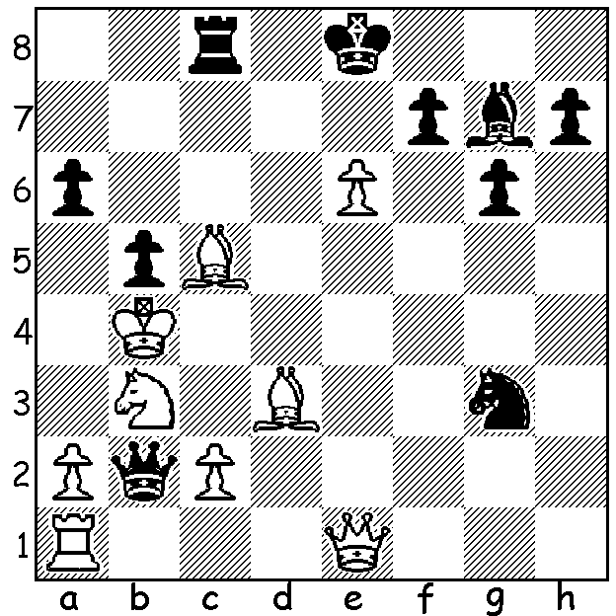

Veselin Topalov – Vladimir Kramnik
1995: Black to play & win (3 moves):

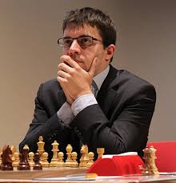
Last week we looked at the start of the Dortmund Sparkassen Chess Meeting and the win by Maxine Vachier-Lagrave over Fabiano Caruana. The Frenchman continued to lead the event and had first place sewn up before the final round. He finished on 5.5/7 (+4 =3), ahead of the Cuban Leiner Dominguez, Vladimir Kramnik and Caruana (all 4) in the 8 man tournament, a result that catapulted him
to number 2 in the world ranking, headed only by world champion Magnus Carlsen.
The game below shows the Russian ex-world champion Vladimir Kramnik in, for him, a rare e4 start play an amazing sacrificial attack against the German Rainer Buhmann:
Maxine Vachier-Lagrave
Vladimir Kramnik - Rainer Buhmann
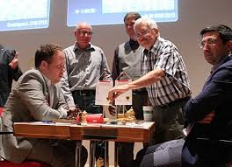
2016 Dortmund Sparkssen, Rd 3
French, Steinitz Variation
1.e4 e6 2.d4 d5
3.Nc3 Nf6 4.e5 Nfd7
5.f4 c5 6.Nf3 Be7
7.Be3 b6 8.Qd2 0-0
9.h4 Nc6 10.Bb5 Qc7
11.0-0-0 a6 12.Bd3 f5(a)
13.g4 c4(b) 14.gxf! cxd3
15.fxe6 Ndb8(c) 16.Nxd5 Qd8
17.Nxe7+ Nxe7(d) 18.Ng5 h6
19.Qxd3(e) hxg5 20.hxg5 Bxe6 The start of this memorable game
21.Qh7+ Kf7 22.d5 Bf5!(f)
23.e6+ Ke8 24.Qxg7 Qc7 25.Rh2(g) Nxd5!
26.Qxf8+?!!(h) Kxf8 27.Rxd5 Bh7 28.b3(i) Ke8(j)
29.g6(k) Bxg6 30.Rh8+ Ke7 31.f5 Bxf5
32.Rxf5 Qc3 33.Bg5+ Kxe6 34.Rf6+ Qxf6(l)
35.Bxf6 Kxf6 36.Rh6+ Kd5 37.Rxb6 and DRAWN after 46 moves.

a) Not 12...c4? 13.Bxh7+! Kxh7 14.Ng5+ Kg8 15.Qe2 g6 16.Qg4 with a winning attack.
b) If 13...fxg 14.Ng5 Bxg5 15.hxg5 g6 16.Qh2 and wins.
c) 15...dxc 16.Rdg1 gives White an extra tempo for his attack.
d) The correct recapture with the knight controlling d5 & f5.
e) The tempting 19.Nf7 Qd5 20.f5 Nxf5 21.Nxh6 Nxh6 22.e7 Re8 23.Bxh6 Rxe7 24.Qxd3 Be6 leaves Black with fewer defensive problems.
f) Black is now down to one minute (+ increments) to reach the 40 move time control but continues to defend superbly: if instead 22...Bxd5 23.e6+! Kxe6 24.Qxg7 Nbc6 25.Rh6+ Kd7 26.Rxd5+ & wins.
g) Not 25.Rd2? Nxd5!
h) An astounding sacrifice with no clear win in sight: objectively 26.Bd4 was best (26...Nc6 27.Bf6 Qxg7 28.Bxg7 Nde7 29.Bxf8 Kxf8 30.Rh8+ Ng8 31.Rd7 Bxe6 32.Rd6 Nd8 and with R + 4p v 2N & B with a draw likely).
i) Cool play, intending c4 freeing the rook from defence.
j) 28...Ra7 is possible – 29.g6 Bxg6 30.Rh8+ Ke7 31.c4 Kxe6 f5+! Bxf5 32.Rh6+ Ke7 33.Bg5+ Kf7 34.Rxf5+ Kg7 35.Bd2 (now who's winning?) but not 28...Kg8 29.g6! Bxg6 30.Rg2 Kh7 31.f5 Bh5 32.f6 Bg6 33.Rdg5 winning.
k) Virtually forcing the draw: he might have tried 29.Kb2!?
l) If instead 34...Ke5 35.Re8+ Kd5 36.Rd8+ Ke5 37.Kb1! and White continues to attack.

WA CHAMPIONSHIP: Defending champion Yita Choong seems almost assured of retaining his title after victories over two of his main rivals Igor Butsenko and past champion Tristan Boyd, WA's top rated player. Yita is on 5/5 with Tristan, Igor and junior Patrick Gong on 3.5. Patrick appears the only player likely to give Yita any trouble with two rounds to play.

SOLUTION: Two deflection sacrifices win for Black: 1...Bc3+! 2.Qxc3 a5+! 3.Kxa5/b5 Qxc3.

