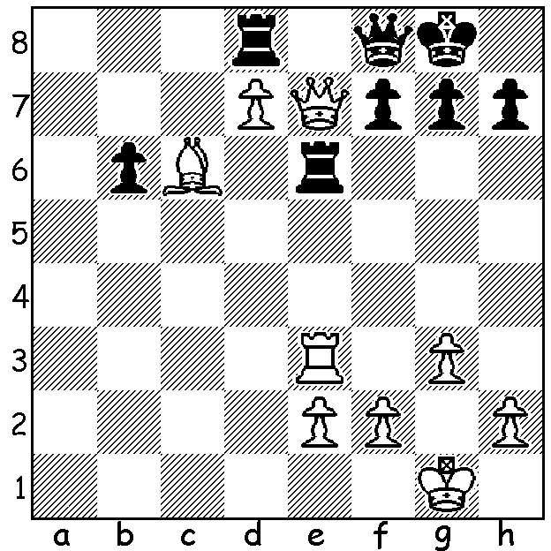

Magnus Carlsen – Zong-Yuan Zhao 2007:
White to play and win (about 8 moves):

World champion Magnus Carlsen has comfortably won the 2016 6 player super-GM Bilboa Masters with 17/30 (3pts a win, 1pt draw) with +4, =5, -1. Second with 12 was the only unbeaten player, Hikaru Nakamura. Other scores: Wei Yi & Wesley So 11, Sergey Karjakin 9, Anish Giri 7. Interest centred on Carlsen with 3 significant results:
Nakamura broke a sequence of 12 losses and 18 draws to the world champion in classic games with his Rd 1 win:
Carlsen had win and draw in his two games against Karjakin, his challenger for the world title later this year:
Carlsen had lost his first classic game to Giri in 2011 and since then their 14 games have been drawn; here is the game that finally broke the hoodoo:

Magnus Carlsen – Anish Giri
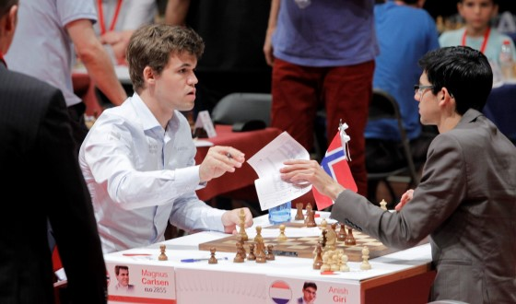
2016 Bilboa Masters, Rd 9
Queens Pawn
1.d4 d5 2.Bf4 Bf5
3.e3 e6 4.Bd3 Bxd3
5.Qxd3 c6 6.Nd2 Nf6
7.Ngf3 Be7 8.0-0 0-0
9.h3 Nbd7 10.a4(a) c5
11.a5 c4 12.Qe2 b5
13.axb6 axb 14.Ne5 Nxe5
15.dxe5 Nd7 16.Qg4 Re8
17.h4 f5 18.Qh3 Rxa1 Giri resigns to Carlsen
19.Rxa1 c3(b) 20.bxc Qc7
21.c4 Nxe5?(c) 22.Qg3 Bd6 23.cxd?(d) exd
24.Nb3(e) Qxc2 25.Nd4 Qc8 26.h5 Qd7
27.Rb1 Bc7(f) 28.f3 Qf7 29.Ra1 Bd6
30.Ra6 Qxh5(g) 31.Rxb6 Nc4 32.Rxd6 Nxd6
33.Bxd6 Rxe3 34.Be5(h) Qg6 35.Qf4 Re1+
36.Kf2 Ra1 37.Qd2(i) Ra8?(j) 38.Nxf5! Qe6(k)
39.Qg5! g6(l) 40.Nh6+ Kf8 41.Ng4 Ke8
42.Nf6+ Kf7 43.Nxh7 Ra4 44.Qd8! Ra2+(m)
45.Kg1 resigns

a) A simple, almost child-like opening, getting away from opening theory.
b) Black elects not to take the proffered pawn - 19...Bxh4 20.Nf3 Be7 21.Nd4 with pressure.
c) A reckless self-pin that should lose quickly.
d) The world champion misses the deflection sacrifice 23.c5! Bxc5 24.Ra6 Rd8 25.Rxd6 Qxd6 26.Bxe5.
e) If 24.Nf3 Nxf3+ 25.Qxf3 Bxf4 26.Qxd5+ Kh8 27.exf4 Qxf4 28.g3 Qe4 29.Qxe4 fxe4 with drawing chances.
f) 27...Nc4 28.Bxd6 Qxd6 29.Qxd6 Nxd6 30.Rxb6 is unpleasant for Black.
g) Computer analysis discovered draw with 30...Qb7! 31.Nxf5 Nxf3+!! 32.gxf3 Bxf4 33.exf4 Rf8 regaining the piece.
h) Avoiding 34.Qf4 Qh6! as Black could draw with no queens on the board.
i) Not 37.Nxf5? Ra2+ 38.Ke1 Qe6.
j) A fatal error (unprotected pieces are often forked): he should play 37...Qa6 with a counter attack (38.Ne2 Qb6+ 39.Bd4 Qa5 or 38.Kg3 Ra2 39.Qg5 Qg6=)
k) If 38...Qxf5? 39.Qxd5+: White now has a winning attack.
l) If 39...Qxe5? 40.Nh6+ wins the queen.
m) 44...Qxe5 loses the queen to 45.Qf8+ Ke6 46.Qe8+ Kd6 47.Qb8+ Ke6 48.Nf8+ Kf6 49.Nd7+.

WA CHAMPIONSHIP: Defending champion Yita Choong has retained the state with 7/7. victories over two of his main rivals and Past champion Tristan Boyd, WA's top rated player, and Igor Butsenko tied 2nd with 5.5.

SOLUTION: 1.Rxe6 fxe6 2.Qxe6+ Kh8 (2...Qf7 3.Qe8+!) 3.Qe8! and Black can only shuffle his rook along the back rank, move his king and pawns (....Rb8 / ...b5 Bxb5!) while White advances his e pawn to the 7th.

