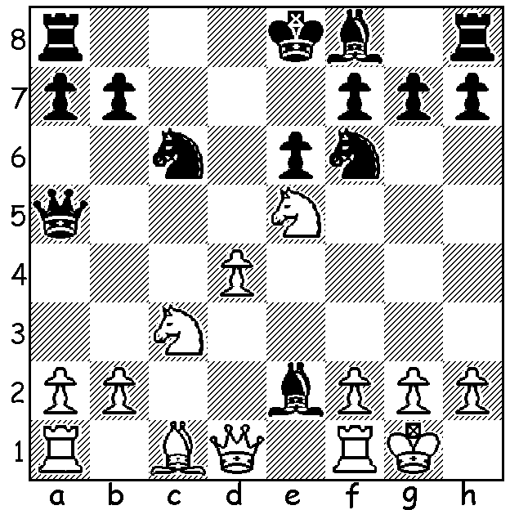

Patrick Gong – Yita Choong (WA Ch Rd 6):
White now plays 1.Nxc6, intending 1...Bxd1 2.Nxa5.
However Black has better:

The Round 4 clash between defending champion Yita Choong and former champion Tristan Boyd was very likely to be the key game in the 2016 WA Championship. These two players had virtually owned the title between them for the past nine years (Choong 2011, 12, 14, 15 & Boyd 2007, 08, 09, 13) with only Tim Hare breaking the duopoly in 2010.


Tristan Boyd - Yita Choong
2016 WA Championship, Rd 4
King's Indian Defence
1.d4 Nf6 2.c4 g6
3.Nc3 Bg7 4.e4 d6
5.h3(a) O-O 6.Be3 e5
7.d5 Na6 8.Nf3 Nc5
9.Qc2 a5 10.Be2 Ne8
11.g4 f5(b) 12.gxf5 gxf5
13.O-O-O Nxe4 14.Nxe4 fxe4
15.Ng5 Nf6 16.Rdg1(c) Kh8
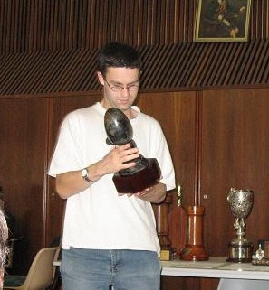
17.Bg4 c6(d) 18.Bxc8 Qxc8 Yita Choong
19.Ne6 Rf7 20.Rxg7 Rxg7
21.Nxg7 Kxg7 22.Rg1+ Kf7
23.Bh6 cxd5(e) 24.Rg7+ Ke6
25.cxd5 Nxd5 26.Rxh7 a4
27.a3 b5 28.Rg7 Kf6
29.Rg4 Qxc2+ 30.Kxc2 Rc8+
31.Kd2 Nb6 32.h4 Nc4+
33.Ke2 Rc7 34.Rxe4 Nxb2
35.f4 Rc2+ 36.Kf1 Kf5
37.Rb4 Nd3 38.Rxb5 Nxf4
39.Bf8 Rd2 40.Ra5 Ke4!(f) Tristan Boyd
41.Rxa4+ Kf3 42.Ke1 Rd5
43.Ra6 Ng2+ White resigns

a) Like the Saemisch Variation (5.f3) this heralds a kingside attack but leaves the square f3 available for the knight.
b) A thematic response to White's aggression on the kingside which provides Black more space to defend despite leaving the king somewhat exposed.
c) The immediate 16.Bg4 seems better when the acceptance of the pawn offer leads to strong attacking chances along the h file.
d) A natural response against a kingside attack, counter-attack in the centre.
e) The saving move providing the king with a safe haven in the centre.
f) The king decisively joins in the attack on the enemy king marooned on the back rank.

CHAMPIONSHIP RESULTS: 1st Yita Choong 7/7, =2nd Tristan Boyd, Igor Butsenko 5.5, 4th Patrick Gong 4.5: Senior champion Alex Janeski: Reserves joint champions Alex Janeski & 13 year old Australind High student Ramadu Rathnayake: Women's champion Natalie Maris.

SOLUTION: After 1.Nxc6 Black plays 1...Qxc3! and White resigns (2.bxc3 Bxd1 or 2.Qxe2 Qxc6 & Black is a piece ahead) - a good example of the Desperado motif in which a doomed piece gives its life as dearly as possible. The game is virtually identical to Perlis – Tartakower (Ostend 1907), Sicilian, Alapin Variation: 1.e4 c5 2.c3 d5 3.exd Qxd5 4.d4 cxd 5.cxd Nc6 6.Nf3 Bg4 7.Be2 e6 8.Nc3 Qa5 9.0-0 Nf6 10.Ne5 Bxe2 11.Nxc6 Qxc3+! White resigns:
Gong – Choong: 1 e4 c5 2. c3 d5 3. exd5 Qxd5 4.d4 Nc6 5.Nf3 Bg4 6.Be2 cxd4 7.cxd4 e6 8.Nc3 Qa5 9.O-O Nf6 10.Ne5 Bxe2 11.Nxc6 Qxc3! White resigns.

