Alex Janceski - Igor Butsenko
(2016 WA Championship Rd 1):
Black to play and win (4 moves):
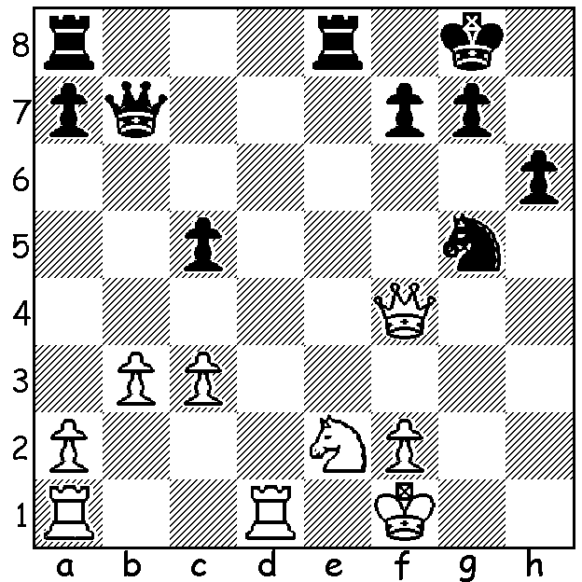

The strength of WA Chess has been improved this year with the arrival of Igor Butsenko from the Ukraine. Igor's first tournament here was the Southern Suburbs Round Robin in which he came =2nd with Ihsan Ferokzhoi with 7/9 (winner Michael Horstmann 8/9). Igor was also joint runner-up in the WA championship with former champion Tristan Boyd with 5.5/7 (draw with Boyd, loss to winner Yita Choong). Here are two of his games, against the 4th and 7th ranked players:

Igor Butsenko - Patrick Gong
2016 WA Championship, Rd 4
Benoni Defence
1.d4 Nf6 2.c4 c5 3.d5 e6
4.Nc3 exd5 5.cxd5 d6 6.e4 g6
7.f3 Bg7 8.Bg5 O-O 9.Qd2 a6
10.a4 Qc7 11.Rc1 Nbd7 12.Nh3 Nh5
13.Be2 Ne5 14.Nf2 f6 15.Be3 f5
16.f4 Ng4 17.Nxg4 fxg4 18.O-O Qe7
19.e5 dxe5 20.d6 Qh4 21.fxe5 Rxf1
22.Rxf1 g3 23.Qd5+ Kh8 24.h3 Bf5
25.Bxh5 Qxh5 26.e6 Bxc3 27.bxc3 Qe2
28.Qe5+ Kg8 29.e7 Kf7 30.d7 resigns

Igor Butsenko - Rob Maris
2016 WA Championship, Rd 7
Queens Indian
1.d4 Nf6 2.c4 e6 3.Nf3 b6
4.g3 Ba6 5.Nbd2 Bb4 6.Qa4 Qe7
7.a3 Bxd2 8.Bxd2 O-O 9.Bg2 Bb7
10.O-O d6 11.Rac1 a5 12.Rfd1 Bc6
13.Qc2 Be4 14.Qc3 Nbd7 15.h3 Rfd8
16.b4 axb4 17.axb4 c5 18.dxc5 dxc5
19.b5 e5 20.Bg5 h6 21.Bxf6 Qxf6
22.Rd2 Qe7 23.Rcd1 Bxf3 24.Qxf3 Nf6
25.Qb7! Qf8 26.Qxb6 Rxd2 27.Rxd2 resigns

THE WILLETTON OPENING (WA Grand Prix) will be played Sat 20 & Sun 21 August at Leeming Primary starting 10.30 each morning. Details cawa.org.au (calendar): entries ellisd19@bigpond.com or 0439798607.

CONGRATULATIONS to Kathryn & Andrew Hardegen on the birth of their daughter Zoe.

SOLUTION: 1...Qh1+ 2.Ng1 Qxg1+! 3.Kxg1 Nh3+ White resigns (4...Nxf4).

