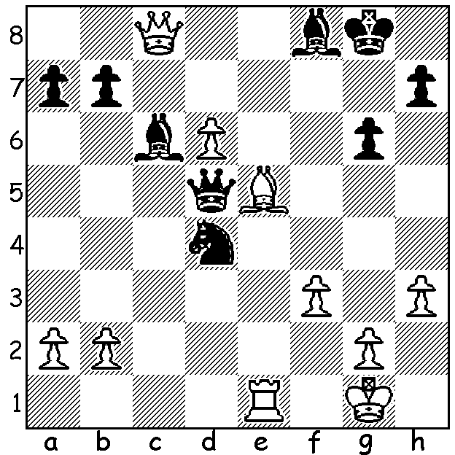

Grigore – L'Ami 2010:
Black to play and win (4 moves)
Need a clue?
Look at note g for tactical theme.

Chisholm College student Patrick Choong is a former Australian Under 16 champion and was the only player to defeat British GM Nigel Short in his 31-board Simultaneous Display in March. Patrick has travelled extensively in the past two years both in Australia and overseas gaining experience and improving his skills. He was ranked 4th in the 2016 WA championship and finished fourth with 4.5/7, beaten only by champion Yita Choong and Igor Butsenko. Here are two of his wins, the first in a difficult struggle in which I am the victim, and the second where he gains an early initiative and ruthlessly exploits his advantage:

David Ellis - Patrick Gong
2016 WA Championship, Rd 7
Reti System
1.Nf3 d5 2.c4 c6 3.b3 Bf5
4.g3 e6 5.Bg2 Nf6 6.O-O h6
7.Bb2 Be7 8.d3 O-O 9.Nbd2 a5
10.a3 Bh7 11.Qc2 Na6 12.Bc3 Nd7
13.Qb2 f6(a) 14.Bh3 Nc7 15.Nd4 f5(b)
16.N4f3 g5 17.Ne5 c5 18.Nxd7 Qxd7
19.Be5 Bd6 20.f4 d4 21.Bxd6 Qxd6
22.Bg2 Rab8 23.Rab1 e5 24.b4(c) axb4
25.axb4 exf4 26.bxc5 Qe5! 27.Nf3 Qe3+
28.Rf2 g4 29.Nxd4 fxg3 30.hxg3 f4
31.Nc2 Qxg3 32.Qe5 Rf7 33.Rb6 Re8
34.Qd6 Ne6 35.Kf1(d) Bf5 36.Bd5(e) Qh3+
37.Bg2(f) Qh4 38.e4?(g) fxe3 39.Nxe3? Bxd3+
40.Qxd3 Qxf2#

a) Rather than the book move 13...Bf6 Black seeks to build a strong centre with ...e5, which White now seeks to prevent.
b) White forces Black into a stonewall formation in order to control e5.
c) An imbalanced position with the two sides attacking on opposite wings.
d) 35.Qe5 Bf5 36.e4 Re7=.
e) White could play 36.Rxb7 Rxb7 37.Bxb7 Qh4= but is in no hurry to capture the pawn.
f) A mistake - 37.Kg1 and White hangs on - 37...g3 38.Rg2=.
g) White had to try 38.Nd4 though 38...f3 should give Black a winning attack: this blunder allows a decisive discovered attack.

Derek Elkington - Patrick Gong
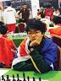
2016 WA Championship, Rd 2
Pirc Defence
1.e4 d6 2.f4 Nf6
3.Nc3 g6 4.d4 Bg7
5.Nf3 O-O 6.Bc4 Nxe4!
7.Nxe4 d5 8.Bd3 dxe4
9.Bxe4 Nd7 10.c3 c5
11.Bc2 cxd4 12.Nxd4 e5
13.Ne2 Qb6 14.Qd3 Nc5
15.Qe3 exf4 16.Qxf4 Re8
17.Rf1 Be6 18.Rf2 Rad8
19.Rf3 Qa6 20.Kf2 Bf5
White resigns Patrick Gong

THE WILLETTON OPENING (WA Grand Prix) will be played tomorrow & Sunday at Leeming Primary starting 10.30 each morning. Details cawa.org.au (calendar): entries ellisd19@bigpond.com or 0439798607.

SOLUTION: 1...Nxf3+!! (clearance sacrifice) 2.gxf3 Qc5+ 3.Kg2 Bxf3+! (discovered attack) 4.Kxf3 Qxc8: if 3.Kh2 Qf2+ 4.Kh1 Bxf3# or 3.Kf1 Bb5+ / 4...Qxc8.

