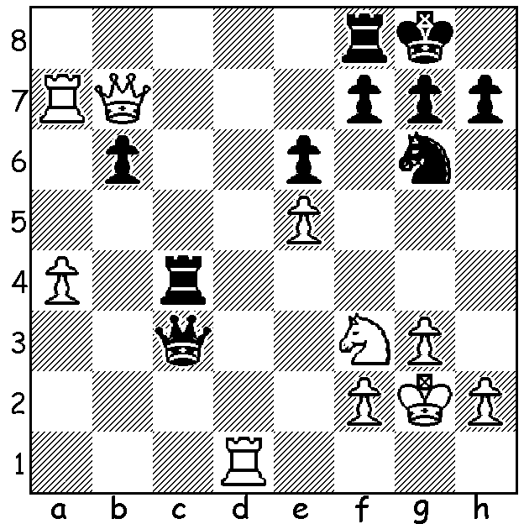

Giri - Anand (2016 Sinquefield Cup):
Black decides against 1...Nxe5.
Can you see why (4 moves)?

The Grand Chess Tour, in which the world's leading GMs participate, this year incorporates two classic events, the London Classic and the Sinquefield Cup as well as two rapid/blitz tournaments. The Sinquefield Cup, played earlier this month in St Louis, Missouri, was a 10 player event with the winner Wesley So scoring 5.5/9 (+2 = 7). Other scores: Viswanathan Anad, Levon Aronian, Fabiano Caruana, Veselin Topalov 5/9, Maxine Vachier-Lagrave, Hikaru Nakamura 4.5, Ding Liren 4, Peter Svidler (who replaced a sick Vladimir Kramnik at the last moment) 3.5, Anish Giri 3. Prizes went from US$75,000 for first to $15,000 for last. Here is a game which saw MVL lose his first game in 2016:

Maxine Vachier-Lagrave - Viswanathan Anand
2016 Sinquefield Cup, Rd 2
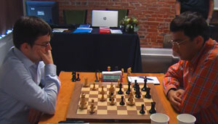
Caro-Kann Defence, 2.Nf3
1.e4 c6 2.Nf3 d5
3.Nc3 Nf6(a) 4.e5 Ne4
5.Ne2 Qb6 6.d4 e6
7.Nfg1 f6(b) 8.f3 Ng5
9.exf gxf 10.f4 Ne4(c)
11.Ng3 Bd7 12.Nxe4 dxe4
13.c3 Na6 14.Qh5+ Kd8
15.Bc4 Kc7 16.a4 c5
17.Ne2(d) Rd8 18.Be3(e) f5
19.0-0 Kb8(f) 20.Qf7 Nc7 MVL v Anand
21.a5 Qc6 22.Qf6 Bd6
23.dxc Bxc5 24.Nd4 Qd6 25.b4 Qe7
26.Qh6 Bd6 27.Rad1(g) Rhf8 28.Bf2 Rf6
29.Qh4 Nd5 30.Nxe6? Bxe6 31.Bxd5 e3!(h)
32.Bxe3 Bxd5 33.Bxa7+ Kxa7 34.Qf2+(i) Bc5!
35.Qxc5+(j) Qxc5 36.bxc5 Rd7 37.Rfe1 h6
38.Kf2 Kb8 39.c4 Bc6 40.Rxd7 Bxd7
41.Rb1 Ra6 42.Rb6 Rxa5 43.Rxh6 Rxc5
44.h4 Rxc4 45.g3 Kc7 46.h5 b5
White resigns

a) 3...Bg4 is a safer alternative.
b) White's retrograde moves aimed to trap the knight. Now 7...h6 would fail to 8.h4.
c) 10...Nf7 was Grischuk – Ding 2016.
d) An good alternative was 17.f5! cxd (17...exf? 18.a5 Qd6 19.Ne2 Kc8 20.0-0 with an excellent position) 18.fxe Bxe6 19.Bxe6 Qxe6 20.Ne2 with strong attacking chances.
e) Again f5.
f) Black has successfully castled by hand and can breathe a little easier.
g) 27.a6 must have been tempting.
h) This clearance pawn sacrifice wins a piece (32.Bg3? e2).
i) If 34.Rxd5 Bxf4! 35.Rxf5 (35.Rxd8 Be3+ 36.Kh1 Qxd8) 35...Be3+ 36.Kh1 Rxf5! wins.
j) 35.bxc5 Bc6 with an easy win.

THE WILLETTON OPENING (WA Grand Prix), played last weekend, resulted in a triple tie between Patrick Gong, ex-WA champion Tim Hare and newcomer Ben Dagza, all on 4.5/6. Junior Sri Krishnan Dharmapuri received the Under 1800 prize and Ramadu Ratnayake (Australind High) and Kee-An Seet (Wesley) the junior awards.

SOLUTION: If 1...Nxe5? Black loses to back row mating threats – 2.Ra8 Qxf3+ (2...Rcc8 3.Rxc8 Rxc8 4.Nxe5 winning a piece or 2...Rc7 3.Rdd8!) 3.Qxf3 Nxf3 4.Rdd8! finishing a rook up. Instead Black played 1...Rcc8 and after 2.Re1 the game continued to a draw.

