Gavin Soutar – Michael Horstmann (2016 Southern Sub RR): Black to play & win (Black intensifies pressure on move 3 and White's clever pinning attempt needs to be refuted - 8 moves):

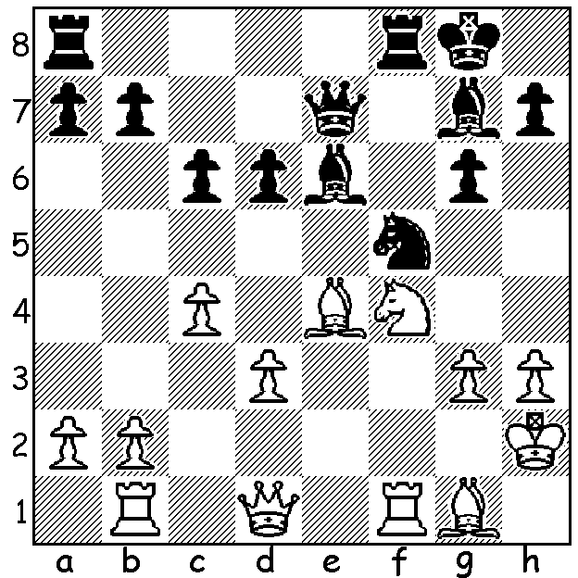

The Southern Suburbs Club, formed last year, has given junior players south of the river the opportunity to participate in play against seniors and a number have acquitted themselves well and benefited from the opportunities. The club also runs chess classes for juniors including beginners before the regular club meeting. One young player I have noticed is Andrey Lugovskoy who came 1st= in the clubs 2016 Division B Round Robin event. Andrey uses his time well, does checks on his analysis before moving, has a good positional sense in formulating plans and carries them out in an economical and logical manner. Here are two of his games from the event:

Andrey Lugovskoy - Jon Prunty
2016 Southern Suburbs Round Robin Div B, Rd 6
Sicilian Defence
1.e4 c5 2.Nf3 d6
3.d4 cxd4 4.Nxd4 Nf6
5.Nc3 a6 6.Bc4 e6
7.Bb3 Nbd7 8.f4 Nc5
9.Qf3 Nxb3 10.axb3 Be7
11.O-O Qc7 12.f5 e5
13.Nde2 Bd7 14.Bg5 Bc6
15.Bxf6 Bxf6 16.Qd3 Rd8
17.Nd5 Bxd5 18.exd5 Rc8
19.c3 Qe7 20.Ng3 O-O
21.Ne4 Rfe8 22.Kh1 Kh8
23.b4 Qd7 24.b3 Be7?
25.f6 gxf6 26.Rxf6! Rg8
27.Rxf7 Rg6 28.Nf6! Bxf6
29.Rxd7 and wins

Andrey Lugovskoy - Colin Koehler,
2016 SS RR Div B, Rd 8
Kings Indian Yugoslav
1. d4 g6 2. c4 Nf6
3. Nf3 Bg7 4. Nc3 d6
5. g3 O-O 6. Bg2 a6
7. O-O Nc6 8. d5 Na5
9. Qd3 c5 10. Rb1 b6
11. e4 Rb8 12. b3 Bd7
13. Bb2 b5 14. Nd2 Ng4
15. Ba1 f5 16. Qe2 f4
17. Nf3 fxg3 18. fxg3 Qb6
19. h3 Ne5 20. cxb5 c4+
21. Kh2 axb5 22. b4 Nb7
23. Qd2 h6 24. Ne2 Nd3
25. Bxg7 Kxg7 26. Qc3+ Kh7
27. Nh4 Qe3 28.Nf4 g5?
29. Nh5 Rg8 30. Rf7+ resigns

Southern Suburbs results: Round Robin Div A – 1st Michael Horstmann 8.5/9, 2^{nd=} Igor Butsenko & Ihsan Ferozkohi: B - 1^{st=} Darrian Low & Andrey Lugovskoy 5/7: C – Ian McAteer 6/6. Michael followed up this victory with a 9/9 in the club's Winter Blitz tournament.

2016 CHESS OLYPIAD takes place in Baku, Azerbaijan, birthplace of Garry Kasparov, 1-14 September with 182 Open teams and 141 women's teams. Over 3000 will be involved (circa 2250 players plus accredited referees, coaches, captains and sports journalists). Multiple web sites will bring daily news and games.

SOLUTION: 1...Nxg3! 2.Kxg3 Qg5+ 3.Kh2 Be5! and the game continued 4.Be3 Bxf4+ 5.Rxf4!? (5.Bxf4 Rxf4 6.Rxf4 Qxf4+ 7.Kg2 Rf8 8.Qe2 d5! 9.cxd cxd 10.Bf3 Bxh3+! - an echo of move 1 – 11.Kxh3 Qxf3+) 5...Rxf4 6.Qd2 Raf8 7.Rf1 Rxf1! 8.Bxg5 R1f2+ White resigns.

