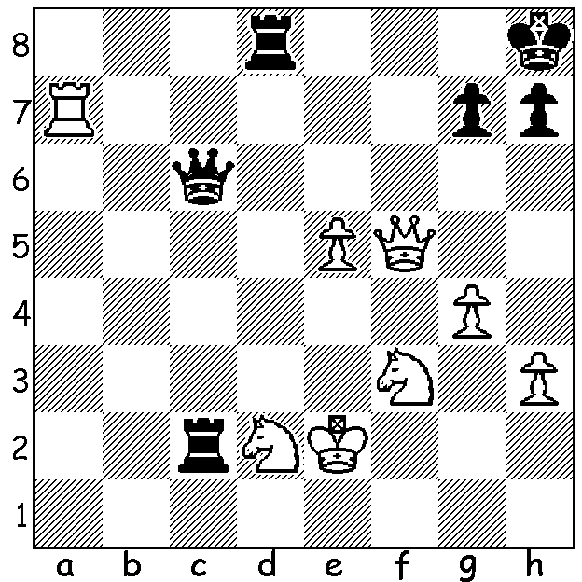

Justin Tan – Mark Hebden (2016 British Championship):
While White has a considerable material advantage, his king
is exposed and Black's three major pieces are all placed
aggressively. White's surprise move follows the maxim
'when winning try to simplify':

The 2016 British Championship was won in convincing style the UK top player Michael Adams 2with 10/11 (+9 =2), equalling the highest winning score gained by Julian Hodgson in 1992. This was only Michael's 5th title win but for many years, as one of the world's top players, he would have been unable to fit in the British. Of interest to us down under was the participation of nineteen year old Australian Justin Tan who came 3rd= with English internationals Gawain Jones and David Howell with 8/11, gaining his second GrandMaster (GM) norm. Justin has been attending school in England and has clearly been able to develop his chess skills there. Here is his only championship loss:


Michael Adams - Justin Tan
2016 British Championship, Rd 6
Ruy Lopez, Breyer Defence
1.e4 e5 2.Nf3 Nc6
3.Bb5 a6 4.Ba4 Nf6
5.0-0 Be7 6.Re1 b5
7.Bb3 d6 8.c3 0-0
9.h3 Nb8 10.d4 Nbd7
11.Nbd2 Bb7 12.Bc2 Re8
13.Nf8 Bf8 14.Ng3 g6
15.a4 Nb6 16.b3 bxa
17.bxa a5 18.Bd3 Qc8
19.Bg5 Bg7 20.Qc1 Bc6
21.Bc2 Nfd7 22.Bb3 d5
23.Nxe5 Nxe5 24.dxe5 Bxe5 Michael Adams
25.f4 Bg7 26.e5 Rb8 27.Qd2 Qd7
28.Qd4 Nc8?(a) 29.Bd1 f6? 30.Bxf6! Bxf6
31.Bg4!(b) Qe7? 32.exf6 Qxe1+ 33.Rxe1 Rxe1+
34.Kf2 Re8 35.Qc5 resigns(c)

a) Better 28...h6 29.Bh4 Nc4!=
b) This Zwischenzug or Intermezzo was clearly missed in Black's calculations; now Black should play 31...Qf7 although he is worse after 32.exf6 Nd6.
c) 35...Rb6 36.Bxc8 Rxc8 37.Qe7.

CHESS CLOCKS: the first use of a sand glass for each player was in the 1861 Anderssen – Kolisch match with a generous time limit of 24 moves in 2 hours. The 1862 London tournament was the first tournament with time limits (20 moves in 2 hours). It was not until the 1880s that the first mechanical double clock was invented with push button clocks replacing the pendulum type between 1895 and 1900. The 1970s saw the appearance of electronic digital clocks.

SOLUTION: 1.Rd7!! (the Black queen and rook on d8 are overworked) 1...Qb5+ (if 1...Rxd7?? 2.Qf8# or 1...Qxd7 2.Qxc2 breaking the attack) 2.Kf2 Qc5+ 3.Kg3 Rf8 4.Ne4! resigns (if 4...Rxf5 5.Nxc5 Rf8 & White wins easily or 4...Qa3 5.Nf6!!gxf6 (5...g6 6.Rxh7# or 5...Rxf6 6.Rd8+) 6.Qxh7# What dynamic play so quickly changing defence into attack!!

