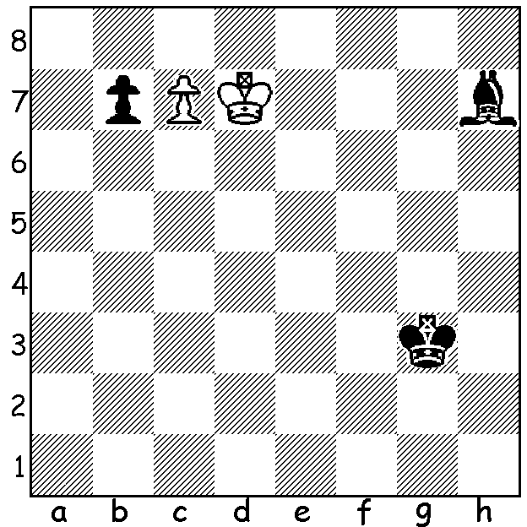

For a few weeks I shall be revisiting
some endgame problems.
Today is White to play and draw
(6 moves):

The World Junior Championships (Under 20, Open & Girls) were played last month in eastern Indiawith 80 players competing in the Open including 8 GMs and 16 IMs. Open winner was 15 year old GM Jefferey Xiong (USA) who finished with 10.5/13 (+8, =5) and winning with a round to spare, the first American to win the title in 19 years. Here is one of his wins from the event, an amazingly complex game with both kings perilously placed with virtually no protection:

Jefferey Xiong - Aravindh Chithambaram
2016 World Junior Championship, Rd 8
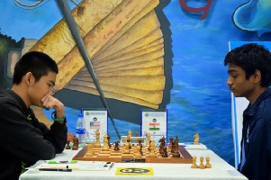
Sicilian, 3.Bb5
1.e4 c5 2.Nf3 Nc6
3.Bb5 g6 4.Bxc6 dxc6
5.d3 Bg7 6.h3 b6
7.Nc3 Nf6 8.Be3 0-0
9.Qd2 Re8 10.Nh2 e5
11.0-0-0 a5 12.Na4 Be6
13.Kb1 Nd7 14.Ng4 Qe7
15.Nh6+ Kh8 16.h4 b5
17.Nc3 f6 18.h5(a) Bxh6
19.Bxh6 g5 20.Rdf1 Qf7
21.g3(b) b4 22.Na4 Bxa2+
23.Ka1 c4 24.f4(c) exf Xiong v Chithambaram
25.gxf cxd 26.fxg dxc
27.gxf Bb1 28.Bg7+ Kg8 29.b3! Nc5!?(d)
30.Nxc5 a4 31 Kb2 axb 32.Nxb3?(e) c1=Q+?(f)
33.Nxc1 Bxe4 34.Rhg1 Ra5 35.Rg5 c5
36.Rfg1 c4 37.Qxb4 c3+ 38.Qxc3 Rb8+
39.Nb3 Rxg5 40.Rxg5 Bd5 41.Bh6+ Kh8
42.Rxd5! Rxb3+(g) 43.Qxb3 resigns

a) Allowing his bishop to be buried.
b) Any attempt to avoid the loss of the a pawn would allow a speedy opening of the queenside.
c) 24.Kxa2?? c3+.
d) Not 29...Qxb3 30.f7+ but best seems 29...Re5.
e) Winning was 32.Nd3! - 32...Ra2+ 33.Kc1 b2+ 34.Nxb2 Ra1 35.Qxb4 Ba2+ 36.Kxc2 c5 37.Qc3 & Black's attack fizzles out.
f) 32...Red8 & if 33.Qg5 Ra2+ 34.Kc1 Rd1+! leads to mate: White had to play 33.Bh6 or 33.Rhg1 and take a perpetual check: the rest is mopping up.
g) 42...Qxd5 43.f7+.

WA CHAMPIONSHIP best games: Championship - Igor Butsenko for his win v Patrick Gong with runner-up champion Yita Choong for his win v Tristan Boyd (both games published in August): Reserves winner Natalie Maris for her draw v Patrick Gong with runner-up Australind junior Ramadu Ratnayake for his win v Derrick Elkington (judged by Michael Horstmann).

SOLUTION: Using the 'switchback' theme White draws with 1.Kc8 b5 2.Kd7!! b4! 3.Ke6 (not 3.c8=Q?? Bf5+) 3...Kf4 4.Kd5 Bf5 5.Kc4 winning the pawn.

