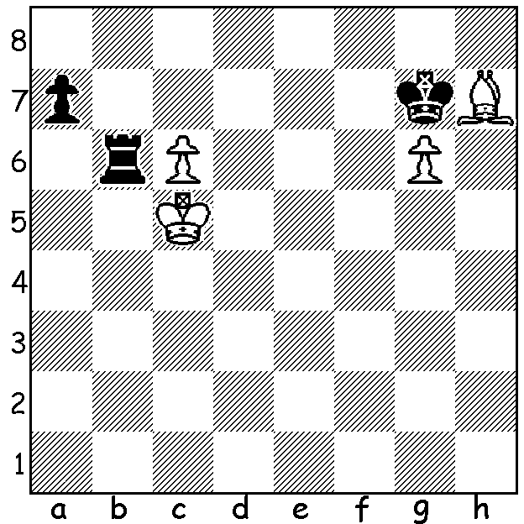

In this week's problem
White wins in 3 or 4 moves.

Like our previous alphabet series opening originator, the American James Moore Hanham, the name Alexander Ilyin-Zhenevsky (1894-1941) is not a familiar name but his influence extended over a variety of fields. He was an ardent communist revolutionary and the second half of his name, Zhenovsky means 'the Genevan' since he joined the party while exiled in Geneva (he became chess champion of Geneva in 1914). He was a political writer and diplomat and was the main person in the Soviet Union responsible for the spreading the idea of chess as a way to teach the basics of scientific and rational thought. As a military organiser he advocated and promoted chess as an educational vehicle for developing tactical and strategic comprehension during military training. He was persecuted during the Stalin era and died either from a German air-raid of Leningrad or was a victim of Stalin's purge of Old Guard revolutionaries. His main chess successes were the winning of the Leningrad (St Petersburg) championship in 1925, 26 & 29 and he had the distinction of defeating world champion Capablanca in their one game. He organised the first Soviet championship in 1920 and his contribution to Opening Theory was the Ilyin-Zhenevsky variation in the Dutch Defence (also called the Fluid System) with pawns on f5, e6 & d6 and bishop on e7.
Here is his most famous win, a masterly defensive triumph :
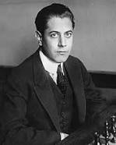
Jose Raul Capablanca - Alexander Ilyin-Zhenevsky
Moscow 1925
Closed Sicilian
1.e4 c5 2.Nc3 Nc6
3.g3 g6 4.Bg2 Bg7
5.Nge2 d6 6.d3 Nf6
7.0-0 0-0 8.h3 a6
9.Be3 Bd7 10.Qd2 Re8
11.Nd1 Rc8 12.c3 Qa5
13.g4 Red8 14.f4 Be8 Capablanca
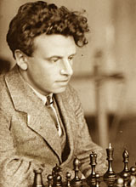
15.g5 Nd7 16.f5 b5
17.Nf4 b4 18.f6 Bf8
19.Nf2 bxc 20.bxc e6
21.h4 Rb8 22.h5 Rb6
23.hxg hxg 24.Nd1 Nde5
25.Qf2 Ng4 26.Qh4 Nce5
27.d4 Nxe3 28.Nxe3 Qxc3
29.dxe5 Qxe3+ 30.Kh1 dxe
31.Rf3 exf4! 32.Rxe3 fxe3
33.Qe1 Rb2 34.Qxe3 Rdd2
35.Bf3 c4 36.a3 Bd6
37.Qa7 c3 White resigns Ilyin-Zhenevsky

SOLUTION: 1.c7 Rb1 (to meet 2.c8=Q? with 2...Rc1+) 2.Bg8! and now if 2...Rc1+ 3.Bc4 or 2...Kxg8 3.c8=Q+.

