In today's endgame problem
White wins in 5 moves:
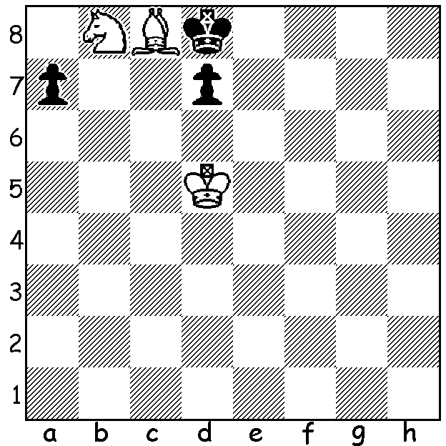

Last week we looked at the life of the Russian communist revolutionary Alexander Ilyin Zhenevsky and his integration of politics and chess. He has left a lasting legacy with his development of the Fluid Variation of the Dutch Defence named after him. Black sets up the formation pf5, pe6, pd6, Nf6, Be7, plays for the liberating ...e5 and a kingside attack. Here is an example:

Alexander Budo - Alexander Ilyin-Zhenevsky
1931 USSR Championship
Dutch Defence, Ilyin Zhenevsky Variation
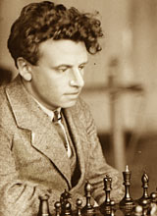
1.d4 e6 2.Nf3 f5
3.g3 Nf6 4.Bg2 Be7
5.0-0 0-0 6.c4 d6
7.b3* Qe8 8.Bb2 Nc6
9.Nbd2 Bd8 10.Qc2 e5
11.dxe dxe 12.e4 f4
13.gxf Nh5! 14.f5 Nf4
15.Kh1 Bf6 16.a3 g6
17.fxg Qxg6 18.Rg1 Kh8
19.Bh3 Qh5 20.Bxc8 Raxc8
21.Rg3 Ne2 22.Rg2 Rg8
23.Rxg8+ Rxg8 24.Qd1 Nf4
25.Qf1 Rd8 26.Rd1 Nd3
27.Bc3 Bh4 28.Nxh4 Qxh4 Ilyin-Zhenevsky 1927
White resigns

* In a game of mine 7.Nc3 was played:
J H Klinskey - David Ellis
1971 Cornish Championship
7.Nc3 Qe8 8.b3 Qh5 9.Ba3 Nc6
10.d5 Nd8 11.Qc2 Rf7(a) 12.Rad1 e5
13.Nb5 Bf8 14.c5 f4 15.cxd cxd
16.gxf Bf5 17.Qb2 Bh3 18.fxe Ng4
19.Nxd6 Bxd6 20.Bxd6 Bxg2 21.Kxg2 Rxf3!
22.Kxf3 Nf7!(b) 23.Ke4 Nxd6+ 24.Kd3(c) Nxe5+
25.Kd4 Nb5+ White resigns(d)

a) Not 11...e5 12.Nxe5!
b) Activating both this knight and the rook and threatening to win a piece with ...Nxe5+ and ...Nxd6.
Best now seems 23.Kg2 but after 23...Qxh2+ 24.Kf3 h5 (threat 25...Ng5#) 25.Ke4 Nxf2+ or 25....Nxd6 26.exd6 Qxd6.
c) White now realises 24...exd6 loses to 24...Qg6+ 25.Kd4 Qf6+ or 25.Kf3/4 Rf8+ 26.Kg2/3 Ne3+ / 27...Qg4#.
d) 26.Ke3 Re8 27.Kd2 Nc4+! 28.bxc4 Rxe2+ wins.

SOLUTION: 1.Bxd7? loses a piece to the fork 1...Kc7. If you tried 1.Ba6 you would have reached a draw with 1...Kc7 2.Kc5 d6+! 3.Kd5 Kxb8 4.Kxd6 Ka8 and White can only stalemate. However White mates with the tempo losing 1.Bb7! Kc7 2.Ba6 Kxb8 3.Kd6 Ka8 4.Kc7 d6/5 5.Bb7#.

