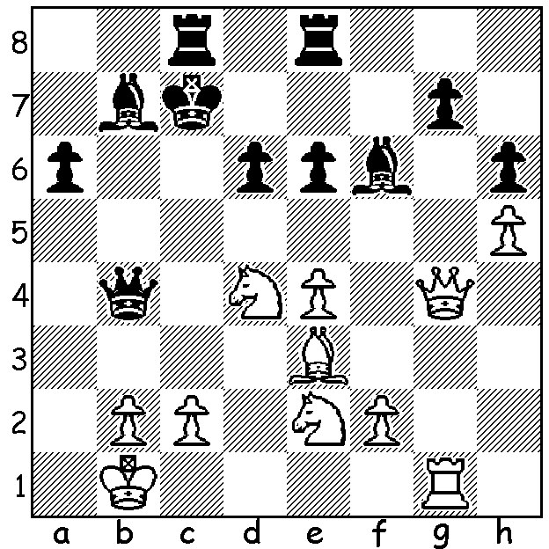

2016 Olympiad
Eric Hansen (Canada) – Andrey Zhigalko (Belarus)
Black's last move was 1...Kd7-c7?.
How does White exploit this blunder?

After a month out of Australia I'll try to catch up with the main chess stories from September. Of most import was the Chess Olympiad, played in Baku, Azabaijan, from 1st to 13th. The Open section was won by USA on countback from Ukraine, both scoring 20 pts from the 11 rounds, with Russia,, the highest rated team, 3rd on 18. It was USA's first top place in 40 years but the win was not unexpected with three players in the top seven world ratings, Fabiano Caruana 3rd, Wesley So 6th, Hikaru Nakamura 7^{th,} , backed up by Sam Shankland and Ray Robson. USA went through undefeated (+9 =2) - as did Greece (+4 =7). The Women's event was won convincingly by China (like USA Open team +9 =2) while Poland (+8 =1 -2) edging out Ukraine (=7 =3 -1) for second place. Next week Australia's results. Here's one of the USA wins:

Nikola Sedlak (Serbia) – Wesley So (USA)
42nd Olympiad, Rd 5
Colle System
1.d4 Nf6 2.Nf3 d5
3.Bf4 c5 4.e3 Nc6
5.Nbd2 e6 6.c3 Bd6
7.Bg3 0-0 8.Bd3 b6
9.Qe2 Bb7 10.Rd1 Re8
11.e4 Be7 12.e5 Nh5
13.a3 g6 14.Nf1 f5
15.exf6 Bxf6 16.Ne3 e5
17.dxe Nxe5 18.Nxe5 Nxg3
19.hxg3 Rxe5 20.Bc4! b5!(a)
21.Bxb5 Qb6 22.0-0 Kg7(b)
23.Bd3 Bg5(c) 24.c4 Rae8(d)
25.cxd5 Rxe3!(e) 26.fxe3 Bxe3+
27.Rf2(f) c4!(g) 28.Bxc4 Rf8
29.Rdf1 Qd4 30.b3 h5
31.d6 h4 32.Kh1(h) Rxf2
33.Rxf2 hxg 34.Rf7+ Kh6
White resigns

a) A pawn sacrifice freeing b6 for the queen with gain of time.
b) Making ...d4 a possible threat with White deprived of the Qc4+ escape from the pin.
c) If 22...d4 23.Nc4!
d) If 24...d4 White again counters with a knight attack 25.Nd5!

e) An exchange sacrifice which ties up White almost completely.
f) Both 27.Kh2 Re5 28.Rde1 Bxd5 and 27.Kh1 Re5 28.g4 Bxd5 leave Black with a strong attack.
g) Another clearance sacrifice opening up the a7-g1 diagonal.
h) If 32.g4 Qf4Threatening ...Qg3 / ...Qxg2#.

SOLUTION: White wins a piece with the clearance sacrifice 2.e5! As 2...dxe5 or ...Bxd5 is met by the discovered attack 3.Nxe6+! winning the queen.

