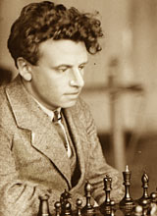
Despite being a rook down & his
pawns can be stopped White can
gain an unlikely draw (5moves):
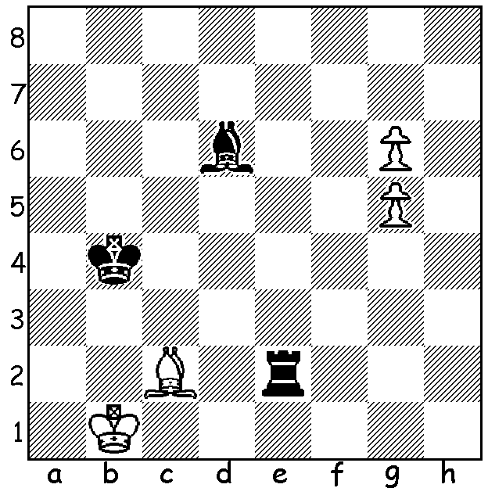

Ilyin-Zhenevsky 1927

(Due to some confusion with the West Australian last week this article was published rather than my intended first article on the 2016 Olympiad which appeared on this website. To get back into sync I'm therefore publishing last week's published West article and will resume Olympiad reports next week)

In concluding our series on Ilyin-Zhenevsky and the Fluid Dutch Defence (4...d6) named after him
I'm repeating a game that is among my favourites, a win by 'The Great Dane' Bent Larsen in which
he makes a positional queen sacrifice and wins 57 moves later:

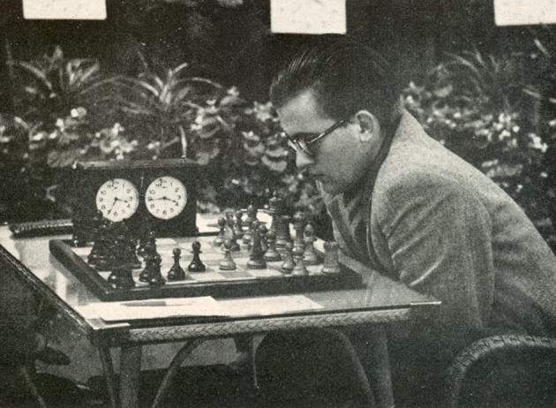
NEIKIRCH - LARSEN
1958 Interzonal, Portoroz
Dutch Defence, Ilyin-Zhenevsky Variation
1.d4 f5 2.g3 Nf6
3.Bg2 e6 4.c4 d6
5.Nf3 Be7 6.0-0 0-0
7.Nc3 Qe8 8.Re1 Qg6
9.e4! Nxe4 10.Nxe4 fxe4
11.Rxe4 Nc6(a) 12.Re1 Nb4
13.a3 Nc2! 14.Nh4 Bxh4
15.Be4 Nxe1 16.Bxg6 Nf3+
17.Kg2 hxg6 18.gxh4 Nxh4+
19.Kg3 Nf5+ 20.Kg2 b6(b)
21.Bg5 Bb7+ 22.Kf1 c5
23.dxc bxc 24.Qa4 a5 Bent Larsen
25.Rc1 Rf7 26.Rc3 Nd4
27.Be3 Bc6 28.Qd1 e5 29.Qb1 Nf5
30.b3(c) Rb8 31.Qd1 Rfb7 32.a4 Kf7
33.Rd3 Rb6(d) 34.Ke2 Be4 35.Rc3 Rh8
36.Qg1 Nd4+ 37.Bxd4 cxd4 38.Rg3 d3+
39.Ke3 Bf5 40.Qe1 Rb4 41.Qh1 Rc8
42.Qd5+ Ke7 43.f4(e) Rc5 44.Qg8 Rxb3
45.Qxg7+ Kd8 46.Rxg6 Bxg6 47.Qxg6 exf+
48.Kxf4 Kc7(f)

a) Not 11.Qxe4? 12.Nh4 winning the queen. Now with the rook threatened White can play 12.Re1,Re3,Nh4 or Qe2.
b) 20...Nh4+ and draw agreed was Mednis – Martin 1957.
c) Bad would be 30.b4 axb 31.axb cxb 32.Qxb4 Rb7.+
d) Preventing 34.Rxd6 Nxd6 35.Qxd6 Bg2+.
e) 43.Qxa5 gives better chances.
f) White's despairing exchange sacrifice gives him a number of nuisance checks and a passed h pawn but Black's passed d pawn is the deciding factor: 49.Qg7+ Kb6 50.Qd4 Kc6 51.Qe4+ Kd7 52.Qh7+ Kc8 53.Qg8+ Kb7 54.Qf7+ Kb6 55.Qd7 Rxc4+ 56.Ke3 Kc5 57.Qf5+ Kb4 58.Qb5+ Kc3 59.Qd5 R4b4 60.Qg2 d5 61.Qd2+ Kc4 62.h4 Rc3 63.h5 R4b3 64.Kf3 d4 65.Qh6 d2+ 66.Ke2 Rd3 67.Qc6+ Kb4 68.Qd6+ Kxa4 69.Qc6+ Ka3 70.Qc5+ Kb2 71.Kd1 a4 72.h6 Ka1
White resigns

SOLUTION: 1.g7 Re1+ (not 1...Re8 2.Bh7) 2.Bd1! (not 2.Ka2 Be5! 3.g8=Q Ra1#) 2...Re8 3.Bg6 Rg8 4.Bf7 Rxg7 5.g6 and Black's rook remains imprisoned and helpless.

