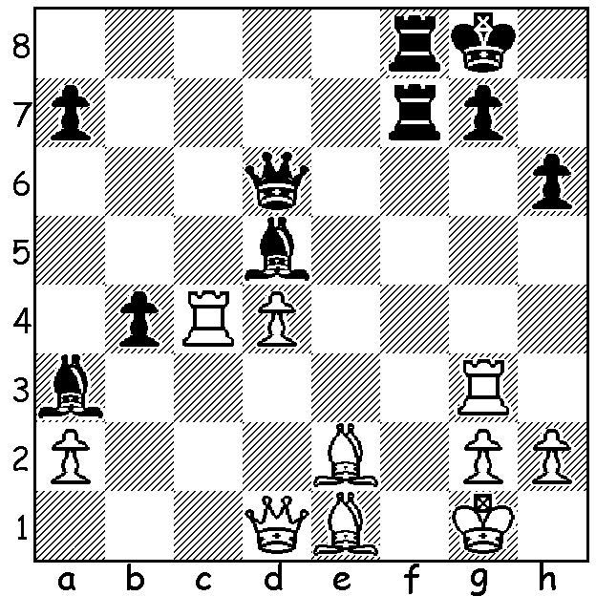

2016 Olympiad:
Bogdan Bozinovic (Croatia) –
Anton Smirnov (Australia)
Australia's prodigy wins material
(Black to play, 3-5 moves):

Australia played well above its ranking in the Olympiad in Baku winning 7 and losing 4 matches to come in a group of 11 nations 24th - 34th (170 teams). Individual scores in board order – David Smerdon +2 =3 -4 3.5/9, Zhao Zong Yuan +3 =1 -3 4.5/9, Moulthon Ly +3 =2 -3 4/8, Anton Smirnov +7 =3 8.5/10, Max Illingworth +4 =3 -1 5.5/8. Undoubtedly the stand-out performance was that of 15 year old Smirnov who is now undefeated in the past two Olympiads. It was a weighty responsibility for Smerdon to play against some of the world's leading GMs and his score included a draw against the world champion:

David Smerdon (Australia) – Magnus Carlsen (Norway)
2016 Olympiad, Rd 4
Sicilian Defence (2.c3)
1.e4 c5 2.c3 d5
3.exd Qxd5 4.d4 Nf6
5.Nf3 e6 6.Na3 Qd8
7.Nc4 Be7 8.Be3 cxd
9.Qxd4 0-0 10.0-0-0 Nd5
11.Qg4 Nxe3 12.fxe3!? Qc7
13.Bd3 Nd7 14.Qf4 Qc5
15.b4!? Qc6 16.Nd4! Qxg2
17.Rhg1 Qh3 18.Rg3 Qh4?!(a)
19.Qxh4 Bxh4 20.Rh3 Bg5
21.Rg1(b) h6 22.Rxg5 hxg5(c)

a) The players looked at 18...Qh5 in their post-mortem – 19.Rdg1 g6 20.Nxe6!! Ne5 (20...fxe6 21.Bxg6! hxg6 22.Rxg6+ with a winning attack) 21.Nxe5 Bxe6 22.Rg5! Bxg5 23.Rxg5 Qh3 24.Rg3 drawing (24...Qxh2?? 25.Rxg6+).
b) Smerdon admitted he would have played on against almost anyone else. Best play seems to be 21.Bh7+ Kh8 22.Bc2+ Bh6 23.Nd6 Ne5 24.Nf3! Nxf3 25.Nxf7+! Kg8 26.Rxf3 Bxe3+ 27.Rxe3 Kxf7=.
c) Draw after 23.Bh7+ Kh8 24.Bd3+ Kg8 25.Bh7+ Kh8 26.Bd3+.

Anton Smirnov (Australia) – Anuar Ismagambetov (Kazakstan)
2016 )Oympiad, Rd 9
Queens Gambit, Slav Defence
1.d4 d5 2.c4 c6
3.Nf3 Nf6 4.Nc3 a6
5.Qc2 dxc 6.e4 b5
7.b3 cxb 8.axb e6
9.Bd3 Bb7 10.0-0 Nbd7
11.e5 Nd5 12.Nxd5 cxd5
13.Bxh7 Rc8 14.Qb1 Bb4
15.Be3 Qe7 16.Bd3 f6
17.Ra2 fxe 18.Bg6+ Kf8
19.dxe d4 20.Bg5 Qc5
21.Be4 Nxe5 22.Nh4 Bxe4
23.Qxe4 Kg8 24.Re2 Nf7
25.Qxe6 Qc6 26.Qg4 Nxg5
27.Qxg5 Qf6 28.Qd5+ Kh7
29.Re5 g6 30.Qxd4 Bc3
31.Qd7+ Kh6 32.Nf5+! Resigns
(32...gxf5 33.Re6)

SOLUTION: As the immediate 1...Bxc4 fails against 2.Bxc4 pinning the rook on f7, Black places the queen on the a6-f1 diagonal attacking the rook a second time with 1...Qa6. Now 2.Rc2 or 2.Rc7 allows 2...Rf1+! (3.Bxf1 Q/Rx f1#). If White protects the rook with 2.Qc2 Kh8 threatening 3...Bxc4 (3.h3 Bxc4 4.Bxc4 4...Rc7!).

