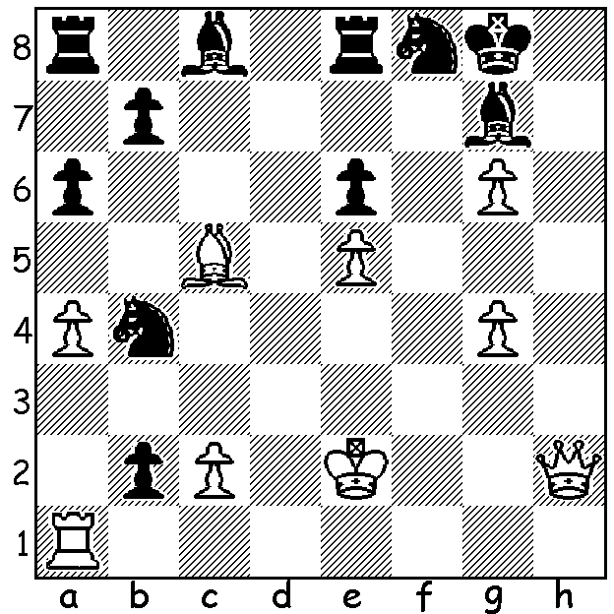

English international Gawain Jones is renowned as an
attacking player, revelling in imbalanced positions and
ever ready to sacrifice for attack. In the position below
(White v Domagoj Dragicevic 2009) he has the one
queen on the board but is badly behind in material. How
does he press on to victory?

One team going into the 42nd Olympiad in Baku hoping for a medal was England. At the end they finished in a group of teams 4th to 10th with 16/22 with 7 wins, 2 draws (to Peru and Iran) and 2 losses (to India and Netherlands). Their outstanding match was the Rd 7 3-1 victory over the 2014 champions China 3-1 with wins to Michael Adams and Nigel Short and draws to David Howell and Gawain Jones. Adams on top board was unbeaten with 6/9 (+3 =6) while Jones 7/9 (+6 =2 -1) and Short 6.5/9 (+5 =3 -2) had excellent results. However their number 2 and 3 players, Howell with 4/10 (+2 =4 -4) and Luke McShane with 3/7 (+2 =2 -3), both failed to achieve plus scores. Their player with the Welsh name, Gawain Jones, played some typically exciting games including this gem:

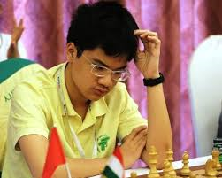
Anh Khoi Nguyen (Vietnam)* – Gawain Jones (England)
42nd Olympiad, Baku 2016
Kings Indian Defence
1.d4 Nf6 2.c4 g6
3.Nc3 Bg7 4.e4 0-0
5.Nf3 d6 6.h3 e5
7.d5 Na6 8.Be3 Nc5(a)
9.Nd2 Nh5(b) 10.b4 Na6
11.a3 Qe8(c) 12.c5 f5
13.cxd cxd 14.Nb5 f4!!(d) Nguyen
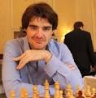
15.Nxd6 fxe3! 16.Nxe8 exf+
17.Ke2 Ng3+ 18.Kd3 Rxe8(e)
19.Kc2 Bd7(f) 20.Bc4 Ba4+
21.Bb3 Bb5 22.Kb2 Be2
23.Qb1 Bh6 24.Nf3 Kh8(g)
25.Ka2 Rac8 26.Qb2 Nxe4!
27.Raf1 Bxf1 28.Rxf1 Nc3+
29.Ka1 e4 30.Qxf2 exf3
31.Qxf3 Bg7 32.d6 Re2
White resigns(h) Jones

a) White is ill-advised to give up his better bishop for the knight with Bxc5.
b) The natural course of the Kings Indian now pits White's queenside attack against Black's kingside attack. Black wastes no time in preparing his attack but safer is 10...a5 slowing White's advance.
c) To give protection to the h5 knight which is attacked by the white queen (...f5 exf gxf).
d) Protecting the d pawn with the queen allows 15.exf winning a pawn. White could now avoid the following complications with 15.Bxa7.
e) Computers give the position as advantageous to White but he has a difficult defensive game. If now 19.Rh2 Bh6 20.Qf3 Nxf1 21.Nxf1 Bd7 22.Kc3 (22.Qxf2 Rac8 and White's king is trapped) 22...Rf8 23.Qe2 Rac8 24.Kb2 and White might well survive the attack and win.
f) Black bravely ignores the h1 rook for the next 8 moves, a decision justified by the finish (note h).
g) Prophylaxis, guarding against the possibility d6+ / d7 (after ...Rac8).
h) 33.d7 Nb5+34.Kb1 Nxa3# - an amazing game!
*Anh Khoi Nguyen won the World Under 12 Championship in 2014 and at present is ranked 4th world Under 14 with a rating of 2459.

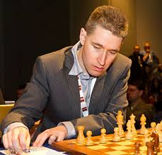
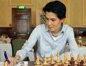

Adams Howell
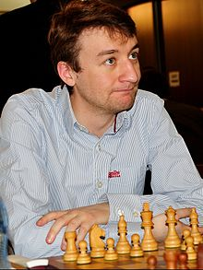
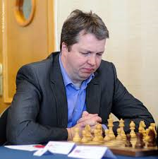
McShane Short

SOLUTION: 1.Bxf8!! and all Black's captures lose - 1...R/Bxf8 2.Qh7#, 1...Kxf8 2.Qf4+ Ke7 (2...Kg8 3.Qf7+ Kh8 4.Rh1+ mating) 3.Qxb4+ Kd8 4.Qb6+ Kd/e7 5.Qd6# and 1...bxa1=Q is met by 2.Bxg7! and mate follows despite Black's enormous material advantage.

