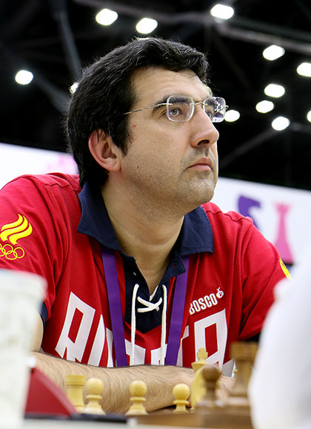
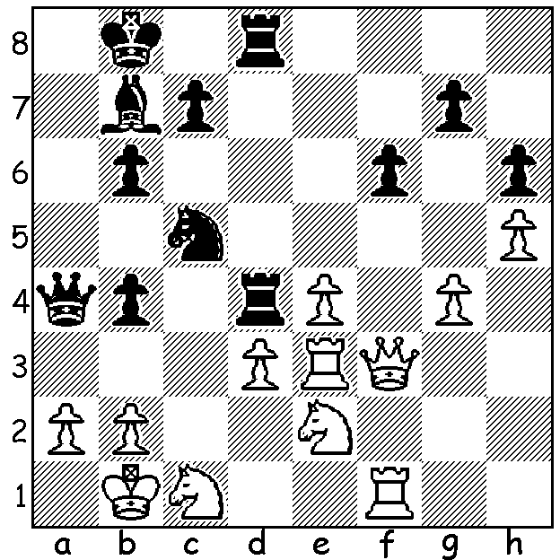

2016 Olympiad: Atabayev – Kramnik:
A brilliant attack by the former world
champion utilising all his pieces
Black to play – White resigns after 5 moves Kramnik at Baku Olympiad

In our last look at the Baku Olympiad we concentrate on Russia which had the highest ranked team and was co-favourites with the USA. As he is due to play Magnus Carlsen for the world title later this month Sergey Karjakin was selected as Bd 1 even though he has a lower rating than ex-world champion Vladimir Kramnik. Russian scores: Karjakin +4 =4 -1 6/9, Kramnik +5 =3 6.5/8, Evgeny Tomashevsky +2 =4 -1 4/7, Ian Nepomniachtch +7 =2 -1 8/10, Alaexander Grischuk +6 =3 -1 7.5/10. Russia's score of 18/22 with +8 =2 (to USA & India) -1 (to UK) was only good enough to secure third place behind USA and Ukraine. Russia has now gone seven Olympiads since its last top place in 2002 when it gained its sixth title in a row following the break up of the USSR which had won almost all the previous Olympiads dating back to 1952. Here's one of the outstanding games from Russia's star player who gained the Board 2 gold medal and regained world no 2 ranking:

Vladimir Kramnik (Russia) – Daniele Vocaturo (Italy)
2016 Olympiad, Rd 4
Kings Indian Defence
1.d4 Nf6 2.Nf3 g6 3.g3 Bg7
4.Bg2 0-0 5.0-0 d6 6.b3 e5
7.dxe dxe 8.Ba3 Qxd1 9.Rxd1 Re8
10.c4 e4 11.Nd4 c6 12.Nc3 Na6
13.e3 Bg4 14.Rd2 Rad8 15.h3 Bc8
16.Rad1 h5 17.Be7!(a) Rxd4 18.Rxd4 Rxe7
19.Rd8+ Ne8 20.Nxe4 Be6 21.Ra8 Be5
22.Rdd8 Kf8 23.Rxa7 Bc7(b) 24.Rda8! Bb6
25.Rxa6 bxa6 26.Nf6! Bd7 27.b4! c5(c)
28.Nd5 Bc6 29.Rxa6 Bxd5 30.Bxd5 Bd8
31.b5 Rd7 32.b6 Ke7 33.b7 Bc7
.Ra8 Nf6 35.Rc8 Bd6 36.Bc6 Rd8
37.a4 Nd7 38.a5 Bb8 39.a6 Ne5
40.Rxb8! Rxb8 41.Bd5 resigns

a) A most imaginative move in what may appear to be a balanced almost sterile position. White gives up two minor pieces for a rook but his rooks will tie up Black and pawns will be shed.
b) Black should play 23...Bf5 before ...Bc7. This gives White the chance for a further sacrifice.
c) Black is lost but this hastens the end leaving d5 unprotected.

The Harris/Edwardes Inter-Club competition brought together the three principal WA clubs over two Sundays last month. Southern Suburbs retained the Division I title, defeating Metro in the final, and also won Division II, coming ahead of Perth who won Division III.

SOLUTION: 1...Rxd3! 2.Nxd3 Rxd3 3.Ng3 (3.Nc1 Rd4 or 3.Rxd3 Bxe4 4.Qe3 Bxd3+ 5.Ka1 Nb3# or 5.Kc1 Qc2#) 3...Ba6 4.b3 (4.Rfe1 Rd2 5.Rb3 Bd3+ 6.Kc1 Nxb3+ 7.axb3 Rc2+ 8.Kb1 Qxb3 wins) 3...Qa3 4.Rd1 Na4! White resigns (5.bxa4 Rxe3 /6...Rxg3).

