Mikhail Tal (1936-92), born in Riga, Latvia, was arguably the greatest attacking player of all time with so many of his games abounding in sacrifices for attack. He wrested the world championship from Mickhail Botvinnik in 1960 (12.5 – 8.5) but, suffering from poor health, lost the return (8 -13). Due to his continuing health problems his subsequent results were inconsistent but he did equal Botvinnik's record of six USSR championship wins among his many tournament successes..
Can you find his win as White v Koblenz 1957:

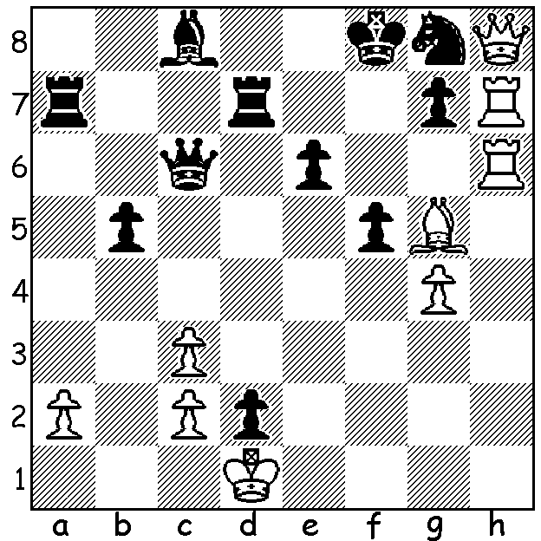
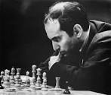
The 10th Tal Memorial was played from Sept 26 to 6 October at a leading private museum in Moscow, the Museum of Russian Impressionism, with 10 of the world's top players competing. Winner was Ian Nepomaiachtchi with 6/9 (+3 =6) followed by Anish Giri on 5.5. Equal 3rd were Levon Aronian and Vishy Anand on 5 while Vladimir Kramnik and Peter Svidler were among those 5th-8th with 4.5. An out of form Boris Gelfand was the tailender with 2. Here is a short game with an amazing endgame finish which gained Aronian his only win and Giri his only loss:

Levon Aronian – Anish Giri
2016 Tal Memorial, Rd 6
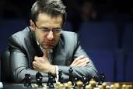
English Opening (Reversed Dragon)
1.c4 e5 2.g3 Nf6
3.Bg2 d5 4.cxd Nxd5
5.Nf3 Nc6 6.0-0 Nb6
7.d3 Be7 8.Be3 0-0
9.Nbd2 Be6(a) 10.Rc1 Qd7
11.a3 Bh3 12.Bxh3 Qxh3(b)
13.b4 Bd6 14.Qb3 Ne7
15.d4 exd 16.Bxd4 Nc6(c) Aronian
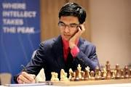
17.Ne4 Nxd4 18.Nxd4 Qd7
19.Rfd1 Be5 20.Nc6 Qe8
21.Na5 Rb8(d) 22.Nc5 Qc8
23.Qf3 c6 24.b5 Bb2
25.bxc6! Bxc1 26.Rxc1 Qc7(e)
27.cxb7 Na4 28.Ncb3 Qe7
29.Nd4 Qg5 30.Qf4! Qxa5
31.Qxb8 Rxb8 32.Rc8+ Qd8
33.Rxd8 Rxd8 34.Nc6 resigns(f) Giri

a) 9...f5 could be met with 10.Rc1 f4 11.Bxb6 axb6 12.Qb3+ Kh8 13.Rxc6 bxc6 14.Nxe5.
b) Black has removed White's fianchettoed bishop but this fails to halt White's queenside attack, with Black's queen out of play despite its threatening position.
c) The attempt to mate with 16...Nbd5 17.e4 Nf4 18.gxf4 Bxf4 fails to 19.Kh1.
d) 21...Bf4 leaves White on top after 22.e3!
e) 26...bxc is better - 27.Nxc6 Re8 28.Nxb8 Qxb8: if 27...Rb7 28.Nxb7 Qxb7 29.a4! and if 29...Nxa4? 30.Qa3 Nb6 31.Ne7+ Kh8 32.Ng6+ wins.
f) If 34...Re8 35.Ne7+ Kf8 36.Nc8 queens or 34...Rd1+ 35.Kg2 Rb1 36.Nb4. Black can only play 34.Rb8! but after 35.Nxb8 Nc5 36.Nc6 Nxb7 37.Nxa6 he is two pawns down and without hope.

The 12 game World Championship match between defending champion Magnus Carlsen and challenger Sergey Karjakin begins today in Manhattan, NY.

The WA Allegro Championship (9 Rd, 15 min) will be played Sunday 27 Nov at Leeming Primary. Check details on cawa.org.au

SOLUTION: 1.Rf6+! (deflection & clearance sac) 1...gxf6 (1...Rf7 2.Qxg7+) 2.Bh6+ wins.

