Hou Yifan – Fabiano Caruana (Isle of Man 2017): how does BLACK win (4-5 moves)

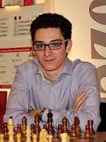
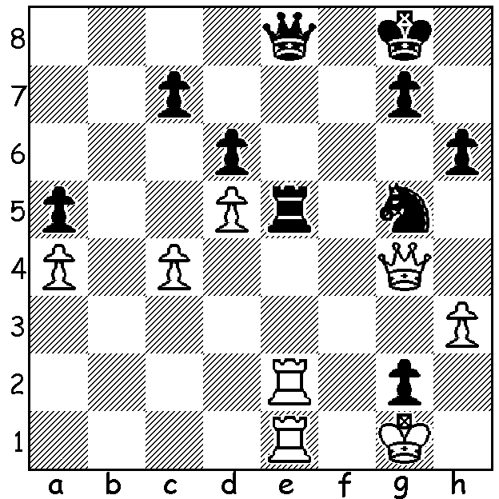

The 2016 Isle of Man Open, played last month, had a number of the world's leading players among the 131 competitors. Winner was Pavel Elijanov (Ukraine) on countback after he and Fabiano Caruana tied on 7.5/9. Third was Arkadij Naiditsch on 7 followed by Alexi Shirov, Salem Saleh, David Howell & Wesley So on 6.5 with Hikaru Nakamura & Michael Adams among those on 6.
Australia had three players competing, John Paul Wallace, who with 5.5 clinched his GM title, Max Illingworth 4.5 & Emma Guo 2.5.

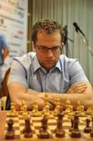


Pavel Elijanov John Paul Wallace

In June I reported on a young Indian becoming an International master at the age of 10. If he continues to improve he could well become the youngest GM ever (a record currently held by Sergey Karjakin when aged 12). Here's his quick win in the Isle of Man with Black against a GM:

English Axel Bachman – Rameshbabu Praggnandhaa
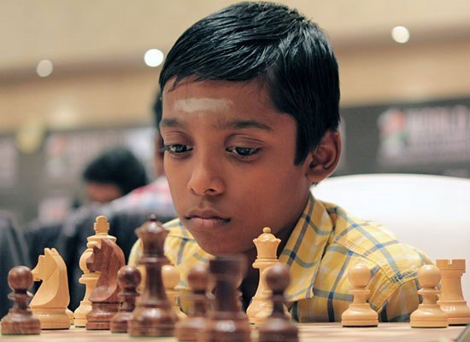
2016 Isle of Man Open, Rd 9
1.d4 Nf6 2.Bf4 g6
3.Nc3 d5 4.Qd2 Bg7
5.Bh6 0-0 6.Bxg7 Kxg7
7.0-0-0 c5 8.e3 Nc6
9.f3 c4 10.e4 b5
11.exd Nb4 12.Nxb5 Nxa2+
13.Kb1 Qxd5! 14.Na3(a) c3
15.bxc3 Rb8+ 16.Ka1 Qa5!
17.Kxa2 Nd5 18.Ne2 Be6
White resigns(b)

a) If 14.Nb7 12...Qb7 15.Nxa8 c3 wins.
b) If 19.c4 Nb4+ 20.Kb2 Nd3+ 21.Ka2 Bxc4+ 22.Ka1 Qxa3#.

A former Australian champion loses to a fierce attack:
Sergei Movsesian – Max Illingworth
2016 Isle of Man Open, Rd 8
Two Knights Defence

1.e4 e5 2.Nf3 Nc6
3.Bc4 Nf6 4.d3 Be7
5.0-0 0-0 6.Re1 d6
7.a4 Kh8 8.h3 Ng8
9.Nc3 f5 10.Nd5 fxe
11.dxe Nf6 12.Ng5! Nxd5
13.Nxh7! Nb6?(a) 14.Nxf8 Nxc4
15.Ng6+ Kh7 16.Qh5+ Kg8
17.f4 Nb6?(b) 18.Rf1 exf
19.Bxf4 Bf6 20.Bg5 Nd7
21.e5! Ndxe5 22.Bxf6 gxf6
23.Qh8+ Kf7 24.Qh7+ Ke8
25.Qg8+ Kd7 26.Nf8+ Ke7 Max Illingworth
27.Qg7+ Ke8 28.Nh7 resigns

a) 13...Rf4 guards h5 (14.Qh5 Rh4 or 14.Bxf4 Nxf4).
b) Again an error – 17...exf 18.Qd5+ Kh7 19.Nxe7 Qxe7 20.Qxc4 Qh4 and Black is still in the game.
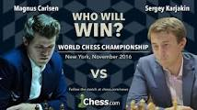
The 12 game World Championship match between
defending champion Magnus Carlsen and challenger
Sergey Karjakin being played in Manhattan, NY, has
started with three draws. All three have seen queens
exchanged early but in the 3rd game Carlsen won a pawn
and later a bishop for a pawn but agreed draw when he
would be left with rook & knight v rook (78 moves) .

The WA Allegro Championship (9 Rd, 15 min) will be played Sunday 27 Nov at Leeming Primary. Check details on cawa.org.au

SOLUTION: 1...Rxe2 2.Rxe2 Qxe2!! 3.Qxe2 Nxh3+ 4.Kh2 (if 4.Kxg2 Nf4+ wins) 4...g1=Q+ 5.Kxh3 Kh7 and Black wins the queen ending.

