WORLD CHAMPIONSHIP

After seven draws Game 8 in the 12 game World Championship in New York produced the first decisive result. Magnus Carlsen, as in Game 1, when he played the Trompowsky (1.d4 Nf6 2 Bg5), again essayed an unusual Queens Pawn Opening, the Zukertort (1.d4 Nf6 2.Nf3 d5 3.e3 e6 4.Bd3 c5 5.b3). He obtained a slight advantage but a risky pawn sacrifice put him in danger of losing to challenger Sergey Karjakin. Here is the position after 52.h4. Despite being a pawn down Black holds all the aces with an advanced passed pawn and a centralised knight against an ineffective bishop (the e pawn is a handicap obstructing the h1-a8 diagonal). How does Black now win?
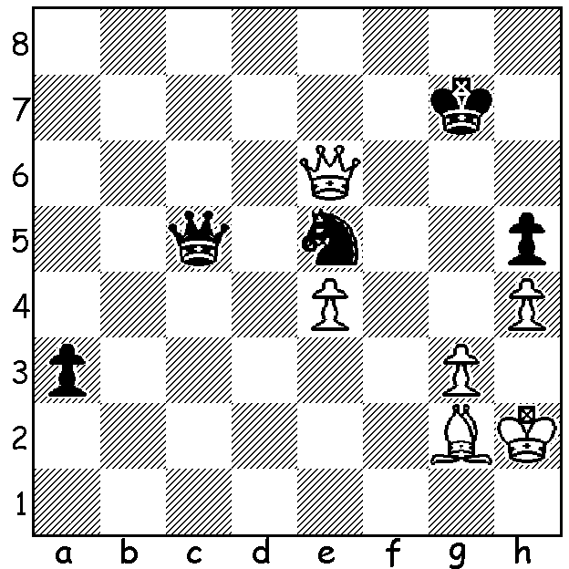
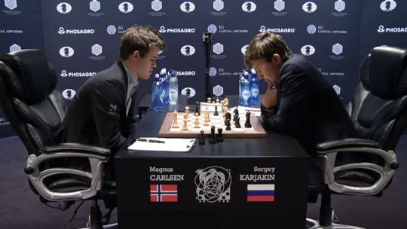

The following game is thought by chessgames.com to be the best game of 2016.
What do you think?

Wesley So – Varuzhan Akopian
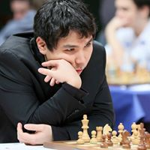
2016 US Championship
French Defence, Rubinstein Variation
1.e4 e6 2.d4 d5
3.Nc3 dxe 4.Nxe4 Nd7
5.Nf3 Ngf6 6.Nxf6+ Nxf6
7.c3 c5 8.Be3 cxd
9/Bxd4 Be7 10.Bd3 0-0
11.Qc2 h6 12.0-0-0 Qa5
13.Kb1 Rd8 14.Ne5 Bd7
15.Qe2 Bc6 16.Rhe1 Bd5(a)
17.c4 Bxg2 18.Bc3 Qb6(b)
19.Rg1 Bc6(c) 20.Nxf7! Kxf7
21.Rxg7+! Kxg7 22.Qxe6 Qxf2(d)
23.Qxe7+ Kg8 24.Bh7+ resigns Wesley So

a) Be8 is a much safer move, defending the vulnerable f7.
b) 18...Bb4 seeking exchanges to lessen White's attack - 19.Nxf7 Rxd3 20.Nxh6+ Kh8 21.Rxd3 gxh6 22.Rg1 Rg8 is only better for White.
c) 19...Bh3 20.Qd2 Rxd3 21.Nxd3 Kf8.
d) 22...Re8 is a necessary defensive resource - 23.Qf5 Kf8 24.Bxf6 Bd7 25.Bxe7+ Kxe7 26.Qh7+ Kf8 27.Bg6 Qf6 28.Rxd7 Re1+ 29.Kc2 Qxf2+ 30.Rd2 Qf6 31.Qxh6+ Ke7 32.Bf7! Qg7 33.Qh5 Qg5 34.Qh7 Qf5+ 35.Qxf5 Rxf5 36.Bd5 Rd8.

The WA Allegro Championship will be played this coming Sunday 27 Nov at N. Woodvale Primary (NOT Leeming Primary) from 11am to 5pm. Entries to andrewhardegen@iinet.net.au or 0407421084.

The 2016 Australian Schools Championship will take place at Wesley College on Sat 3 & Sun 4 Dec with WA represented by Regent College (Primary) and Wesley College (Secondary). Spectators are welcome.

Following these championships the 2016 Christmas Open (WA Grand Prix event) will be held again at Wesley (Mon 5 & Tues 6 Dec). It is hoped many of the eastern state juniors together with their coaches and supporters will be able to play and WA players will come out in numbers to make this the biggest event of the year.

Check cawa.org.au for details of all these events.

SOLUTION: 52...a2! (a deflection sacrifice to avoid the possibility of White escaping with a perpetual check). White resigns – 53.Qxa2 Ng4+ 54.Kh3 Qg1 with mate or the win of the queen. Carlsen seemed to play as if it were Game 12 and he was a point down, taking undue risks. However both players were playing moves in time trouble to reach move 40 (100 min to move 40, 50 min moves 41 -60, then 15 min to end of game, all moves with 30 sec increments. This leaves Carlsen with the onerous task of having to win at least one of the final four games to even reach a play-off of Rapid Chess.

