Phiona Mutesi – Amen Miladi (2016 Womens Olympiad): White has been badly overrun on the queenside yet it's her opponent who resigns after just 4 more moves:
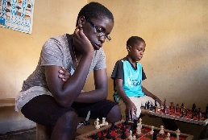
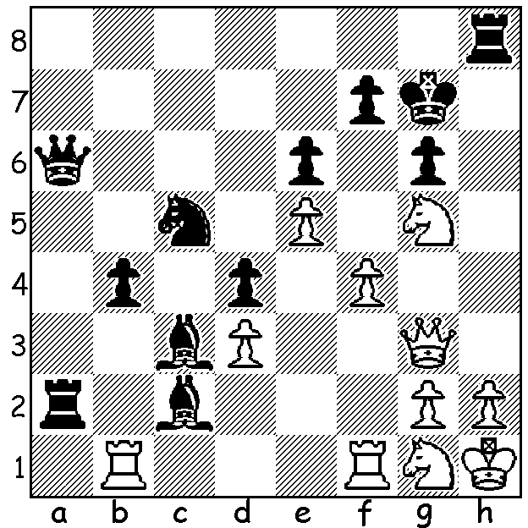

On Monday, together with a number of other players and partners, I attended the preview showing of Queen of Katwe. The Disney film, which can also be seen at many mainstream and alternative cinema venues, details the early years of the Ugandan girl Phiona Mutesi, born in 1996, who came from an impoverished slum family brought up by a widowed mother. I wrote an article about Phiona on Dec 27, 2013 which can be seen on cawa.org.au and I have attached the more pertinent parts of that below. The Currambine Grand Theatre had provided complimentary tickets and will also provide a trophy and prizes when it hosts a Lightning tournament on Sat 10th Dec from 1 – 4 pm. The tournament is open to the public with a number of prizes with juniors particularly welcome. Please contact Norbert Muller (9409 9579 or norbert.muller@iinet.net.au) to ensure participation. Here are two of Phiona's games, both with sparkling finishes:

Yeon Lee Cho vs Phiona Mutesi
2012 Womens Olympiad
Scotch Gambit
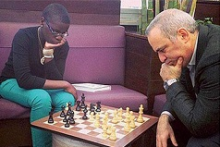
1.e4 e5 2.Nf3 Nc6
3.d4 exd 4.Bc4 Nf6
5.e5 d5 6.Bb5 Ne4
7.Nxd4 Bc5 8.Nxc6(a) Bxf2+
9.Kf1 Qh4 10.Be2(b) bxc6
11.Nc3 Nxc3 12.bxc3 Bd4??(c)
13.cxd4? 0-0 14.Be3 f6
15.exf6?(d) Rxf6+ 16.Kg1 Bf5
17.Qd2 Be4 18.h3 Qg3
19.Bf1 Raf8 20.Re1 Bxc2!
21.Rc1 Be4 22.Qe2(e) Rf3! Phiona playing Gary Kasparov
23.Re1 Rxe3!! 24.Qxe3 Rxf1+!
25.Kxf1 Qxg2#

a) 8.Be3 avoids Black's coming attack.
b) If 10.Nd4+ c6 11.Nf3 Ng3+! 12.Kxf2 Ne4+ 13.Ke2 Qf2+ 14.Kd3 Bf5!
c) A gross blunder: after 13.Qxd4 Black has nothing for the piece.
d)15.e6 would avoid the opening of the f file.
e) Better 22.Re1.

Phiona Mutesi vs Amen Miladi
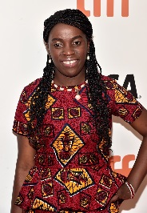
2014 Womens Olympiad
Sicilian Closed
1.e4 c5 2.Nc3 g6
3.g3 Nc6 4.Bg2 Nf6
5.d3 d6 6.Nge2 Bg7
7.h3 Rb8 8.Be3 0-0
9.0-0 b5 10.Qd2 b4
11.Nd1 Nd7 12.f4 a5
13.Rb1 Nd4 14.g4 Nxe2
15.Qxe2 Bd4 16.Bxd4 cxd4
17.Qf2 Qb6 18.f5 Ne5
19.Qh4 e6?(a) 20.f6 Kh8
21.Qh6 Rg8 22.Rf4 Nd7(b)
23.Qxh7+! resigns

a) Black should not allow the unimpeded advance f6.
b) To defend h7 from f8 but a move too late.

The 2016 Australian Schools Championship will take place at Wesley College on tomorrow, Sat 3 & Sun 4 Dec with WA represented by Regent College (Primary) and Wesley College (Secondary). Spectators are welcome.

Following these championships the 2016 Christmas Open (WA Grand Prix event) will be held again at Wesley (Mon 5 & Tues 6 Dec). It is hoped many of the eastern state juniors together with their coaches and supporters will be able to play and WA players will come out in numbers to make this the biggest event of the year.

Check cawa.org.au for details of all events.

World Championship: After Karjakin's win in Game 8, Carlsen equalised the score with victory in Game 10. Games 11 & 12 were drawn and, with a tied match 6-6, the championship will be decided by 4 Rapidplay games.

SOLUTION: 1.f5! Bxb1 2.fxe Nxe6 3.Rxf7+ Kg8 4.Rf6 resigns (1...exf5 2.Rxf5! gxf5 3.Ne6+ or 2...Rf8 3.Qh4).

PHIONA MUTESI

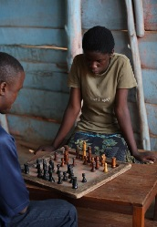
I recently had passed to me by Norbert Muller an article on a teenage chess player, one whose play has not reached great heights but whose story is nevertheless one of such incredible achievement that Disney has bought the movie rights to a book written about her. Phiona Mutesi was born in Uganda in 1996 in extreme poverty. Her father died of AIDS leaving her mother to try to support her three children and a niece in three-by-three room. Phiona had to stop attending school at the age of nine because of the cost and the need to care for the other children. One day she followed her brother Brian to a church hall hoping there might be a free meal. Instead she saw youngsters playing chess, a game she had never seen but which fascinated her. She was invited to enter by the organizer and learn the moves. She would walk 6km every day to play and her enthusiasm won her coaching from the better players. Her mentor then took her to local boarding schools to mix with and play privileged children and her progress was such that she was chosen at 14 to play Board 2 for Uganda in the Women’s Olympiad in Russia. The snow and cold, the luxury of the hotel and the plentiful food were mind-boggling contrasts to her life in Africa. After her return she was given a scholarship by Sports Outreach to attend school, became the first female Ugandan junior champion, was runner-up in the Uganda Women’s championship and was chosen to play in the 2012 Olympiad in Turkey where she achieved a 50% score. She is rated 1668, the second highest female in Uganda and 16th overall.
(from article 27 Dec 2013)

