WORLD CHAMPIONSHIP

Carlsen – Karjakin (World Championship Play-off Game 4):
with Black threatening mate, White pulls off a spectacular finish:

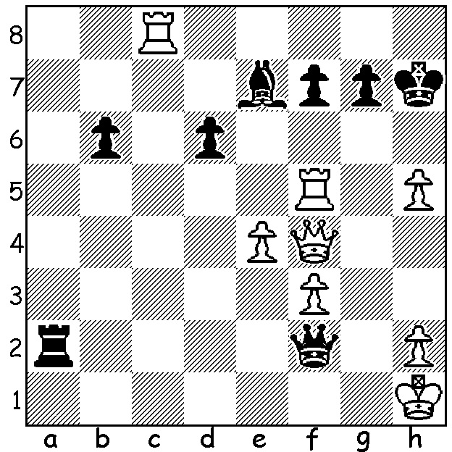
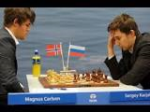
After securing a lead by winning game 8, Sergey Karjakin missed a drawing line in the middle game in Game 10 allowing Magnus Carlsen to grind out a long endgame win. With the last two games drawn, a rapid-play play-off of 4 games became necessary (all on one day, 25 min each with 10 sec increments). Carlsen failed to find the win in Game 2 with 2 bishops & 2 kingside pawns vs rook & 3 kingside pawns, but won Game 3 when Karjakin blundered when short of time and in an inferior position. In the final game Karjakin played the only Sicilian of the match (1.e4 c5) but again lost (see diagram). This left the result Games 1-12 6-6 (one win each), Play-off Games 13-16 (Carlsen 2 wins, 2 draws).

Sergey Karjakin vs Magnus Carlsen
2016 World Championship, Play-off Game 3
Ruy Lopez
1.e4 e5 2.Nf3 Nc6
3.Bb5 a6 4.Ba4 Nf6
5.0-0 Be7 6.d3 b5
7.Bb3 d6 8.a3 0-0
9.Nc3 Na5 10.Ba2 Be6
11.b4 Nc6 12.Nd5 Nd4
13.Ng5 Bxd5 14.exd5 Nd7
15.Ne4 f5(a) 16.Nd2(b) f4
17.c3 Nf5 18.Ne4 Qe8
19.Bb3 Qg6 20.f3(c) Bh4
21.a4 Nf6 22.Qe2 a5!(d)
23.axb axb 24.Bd2 bxc
25.Bxc3 Ne3 26.Rfc1 Rxa1
27.Rxa1 Qe8 28.Bc4 Kh8
29.Nxf6 Bxf6 30.Ra3 e4!(e)
31.dxe Bxc3 32.Rxc3 Qe5
33.Rc1 Ra8 34.h3 h6
35.Kh2 Qd4 36.Qe1 Qb2(f)
37.Bf1 Ra2 38.Rxc7??(g) Ra1
White resigns

a) The position starts to favour Black with an aggressive pawn push on the kingside & White saddled with a bad white-square bishop.
b) Better is 16.c3 fxe4 17.cxd4 exd3 18.dxe5 Nxe5 19.Bb1.
c) Preventing a future ...f3 but creating a hole on e3.
d) With the more aggressively placed pieces Black opens up the position.
e) A fine pawn sacrifice, securing the knight outpost and opening the a1-h8 diagonal for the queen.
f) If 36....Nxc4 37.Qb4 regains the piece.
g) 38.Rb1 keeps White in the game - just.

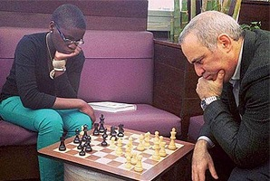
The Currambine Grand Theatre is
one of many cinemas showing the film
Queen of Katwe about the early years
of Ugandan female international Phiona
Mutesi who came from an impoverished
slum family. The cinema will provide a
trophy and prizes when it hosts a
Lightning tournament tomorrow from
1 – 4 pm. The tournament is open to the
public with a number of prizes and with
juniors particularly welcome. Please
contact Norbert Muller (9409 9579 or
norbert.muller@iinet.net.au) to ensure Phiona playing Gary Kasparov
participation.

The Christmas Lightning (9 rounds) takes place on Sunday at Leeming Primary from 1pm to 4pm. Contact DOP Gordon Dunlop (g-dunlop64@bigpond.com or 93686412.) Details cawa.org.au

SOLUTION: 1.Qh6+!! Black resigns (1...Kxh6 Rh8# or 1...gxh6 2.Rxf7#). What a brilliant finish to the world championship, and on Carlsen's 26th birthday too!

