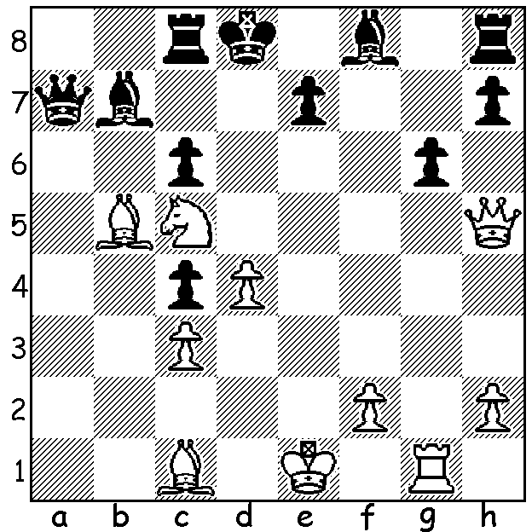

Richard Rapport – Niclas Huschebeth 2010:
a stunning sacrifice leads to a quick mate if
accepted while declining leads to a slower death:

I recently published a game dubbed Game of the Year. Today a game containing what chessvibes commentator Robert Hess dubbed Move of the Year. I imagine the criteria for such a judgement must be: a) soundness of sacrifice, b) level of surprise, c) number of moves necessary to prove the strength of the move with opponent finding the best defence. The winner, 20 year old Richard Rapport from Hungary, became a GM just before his 14th birthday, the youngest Hungarian to gain the title, beating the record of Peter Leko. He is well-known for his liking for off-beat openings including counter-gambits. His opponent, 34 year old Armenian, Levon Aronian, is one of the top GMs and was ranked world number 2 in 2014.

Levon Aronian - Richard Rapport
2016 European Club Cup, Rd 3
Queens Gambit, Tchigorin Defence
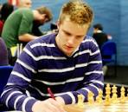
1.d4 d5 2.c4 Nc6
3.Nc3 Nf6 4.cxd Nxd5
5.Nf3 e5 6.dxe Bb4
7.Bd2 Nxc3 8.bxc3 Ba5
9.e3 0-0 10.Qa4 Bb6
11.Qf4 Qe7 12.h4(a) f6
13.exf Rxf6 14.Qc4+ Kh8
15.Bd3 Bf5 16.Bxf5 Rxf5
17.Ng5 Ne5 18.Qe4 Qd7
19.0-0 Re8 20.Qc2 h6 Richard Rapport
21.Ne4 Rh5 22.Ng3 Rxh4
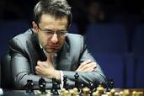
23.Rad1 Rf8 24.Bc1 Qg4
25.Rd5 Qg5 26.Qe2 c6
27.Rd4(b) Rh1+!! 28.Kxh1(c) Bxd4
29.f3(d) Bb6 30.Ne4 Qh5+
31.Kg1 Bc7 32.Kf2 Qh2
33.Ke1 Rd8 34.Bd2 Nd3+
35.Kd1 Qe5 36.g4 Qb5
37.Qg2 Nb2+ 38.Kc2(e) Nc4
39.Bc1 Rd5 40.g5 Na5
41.Bd2 Qd3+ White resigns(f) Levon Aronian

a) A significant weakening of the kingside, where White is likely to castle. b) Black cannot play 27...Bxd4? as 28.exd wins bishop & knight for rook. However Black now unleashes a totally surprising deflection sacrifice. c) If 28.Nxh1 Nf3+ wins.
d) Now 29.exd4 loses to 29...Qh4+ 30.Kg1 Ng4 31.Re1 Qh2+ 32.Kf1 Qxg3.
e) White's king has sought safety on the weakened queenside but Back is able to switch his forces there very quickly
f) 42.Kc1 Rb5.

SOLUTION: 1.Qd5+!! and if 1...cxd5 2.Ne6#. If 1...Ke1 2.Qd7+ Kf7 3.Bc4+ Kg7 4.Qe6! leads to mate or if 1...Kc7 2.Bf4+ Kb6 3.Nd7+ Ka5 4.Bxc6+ Ka6 5.Qb5#.

