Topalov – Anand (London Chess Classic 2016) : Black wins quickly:
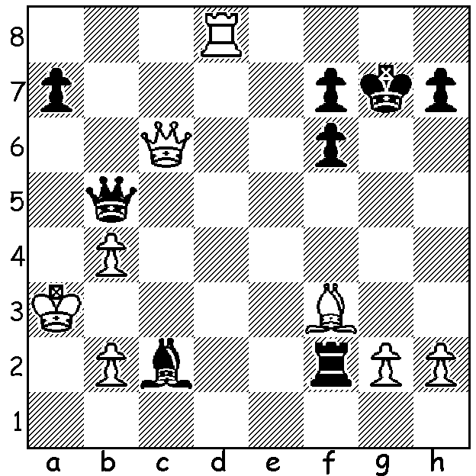
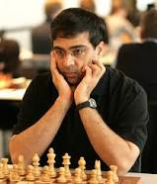
The final event of the year involving the top GMs was the London Chess Classic played 7 – 19 December. The main tournament had five long established players, ex-world champions Vishy Anand (aged 47) and Vladimir Kramnik (41), Veselin Topalov (41) Levon Aronian (34), top UK player Michael Adams (45), and five younger players, Hikaru Nakamura (29), Fabiano Caruana (24), Wesley So (23), Anish Giri (22), Maxime Vachier-Lagrave (26). It was the younger brigade coming out on top with So (6/9) in first place and Caruana runner-up (5.5). Other scores: Anand, Kramnik, Nakamura all 5, Giri (4.5, all draws), MVL, Aronian and Adams 4, Topalov, who was badly off form, winning only his final game, 2.5. The tournament was the 4th and final leg of the Grand Chess Tour (a Grand Prix competition), also won by So. Other events at the Classic included the Open with 247 players, the Super Rapid with 475 players, won by Russian female Valentina Gunina with 9/11, and the final of the British Knock-Out won by Nigel Short, defeating David Howell 3.5-2.5 (+2 =3 -1). As in the problem we concentrate on the play of Anand who remains one of the world's best:

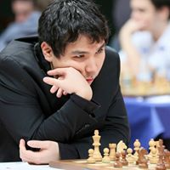
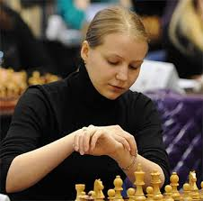
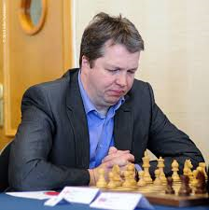
Wesley So Valentina Gunina Nigel Short

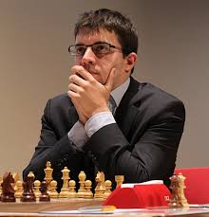
Viswanathan Anand v Maxime Vachier-Lagrave
2016 London Classic, Rd 2
Sicilian Najdorf
1.e4 c5 2.Nf3 d6
3.d4 cxd 4.Nxd4 Nf6
5.Nc3 a6 6.h3 e5
7..Nb3 Be6 8.f4 Nbd7
9.g4 Rc8 10.f5 Bxb3
11.axb3 d5 12.exd Bb4
13.Bg2 Qb6(a) 14.Bd2 e4
15.Qe2 0-0 16.0-0-0 Nc5
17.Kb1 Rfd8 18.Rhe1 a5 MVL
19.Qf2(b) Qc7 20.Bf4 Qb6
21.Be5 a4 22.bxa(c) Bxc3 23.Bxc3 Nxd5
24.Rxd5(d) Rxd5 25.Bxe4 Rd6 26.a5 Qb5
27.Qe2 Qxe2 28.Rxe2 Rd1+ 29.Ka2 Re8
30.Bf3 Rxe2 31.Bxe2 Rc1(e) 32.Bf3 Rxc
33.Bxb7! resigns(f)

a) A little better was 13...Rxc3 14.bxc3 Bxc3+ 15.Bd2 Bxa1 16.Qxa1 0-0.
b) A complicated continuation is 19.Nxe4 Ncxe4 20.Bxe4 Re8 21.Qd3 Bxd2 22.Rxd2 Nxd5! 23.Qxd5 Rcd8 24.Qxb7 Qxb7 25.Rxd8! Qe7 26.Rxe8 Qxe8 27.Rd1 h5 28.Bf3 and White would hope to win.
c) White could try 22.Bxf6 gxf6 23.Nxa4!? Nxa4 24.Qxb6 Nxb6 25.c3 with three pawns for the piece.
d) An excellent exchange sacrifice gaining 2 pawns and breaking Black's attack.
e) Black doesn't see the impending danger.
f) White's a pawn wins a piece as 33...Nxb7 34.a6 and promotes: 33...g6 34.gxf hxg 35.a6 Nxa6 36.Bxa6 leaves White with an easy win.

The Australian Open Championship starts on Jan 2 in Brisbane. WA's top three players, FMs Tristan Boyd, Yita Choong and Patrick Gong will all be competing.

The World Rapid-Play and Blitz Championships have begun in Doha, Qatar, with world champion Magnus Carlsen defending his Rapid-Play title and Alexander Grischuk his Blitz title.

SOLUTION: 1...Rxf3+! (combined deflection / removing the guard sacrifice): White resigns (2.Qxf3 Qa4# or 2.gxf3 Qxc6).

