WORLD RAPIDPLAY CHAMPIONSHIP

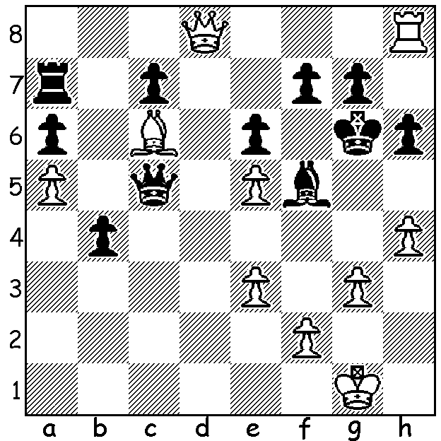
English International David Howell (White)
brings off a spectacular win in the 2016 World
Rapidplay Championship (v Das Debashis):
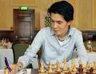

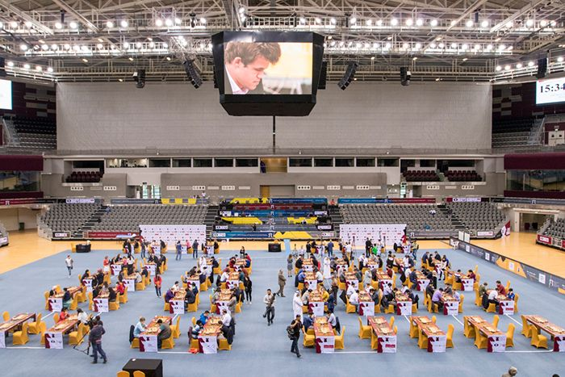
The 2016 year in Chess concluded with the World Rapidplay and Blitz Championships in Doha, Qatar. The Rapidplay, played over three days with a time limit of 15 mins + 10 sec increments, had 106 competitors, led by world champion and defending Rapidplay champion Magnus Carlsen. Carlsen started badly with a draw and a loss. A further two losses saw him drop behind but by winning his final games he caught leader, Vassily Ivanchuk, at the post. Alexander Grischuk also finished with three wins to come 1st= but on countback the title went to Ivanchuk (+9 =4 -2), who had beaten Carlsen conclusively in their game, with Grischuk (+9 =4 -2) second and Carlsen (+10 =2 -3) third. Ivanchuk, aged 47, from Ukrainewas ranked world number 2 in 1991, 1992 and 2007. Some other scores: Levon Aronian 9.5, Vishy Anand and Sergey Karjakin 9, Maxime Vachier-Lagrave and Hikaru Nakamura 8.5.

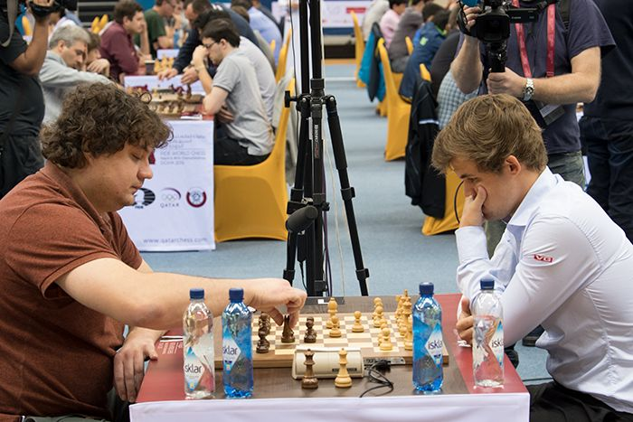
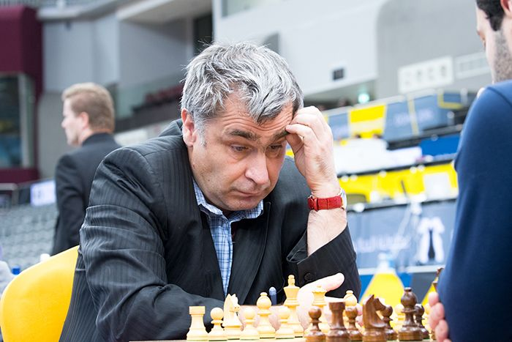

Carlsen v Anton Korobov who led with 5/5
Vassily Ivanchuk after Day 1 and defeated Carlsen

TeimourRadjabov vs Olexandr Bortnyk
2016 World Rapidplay
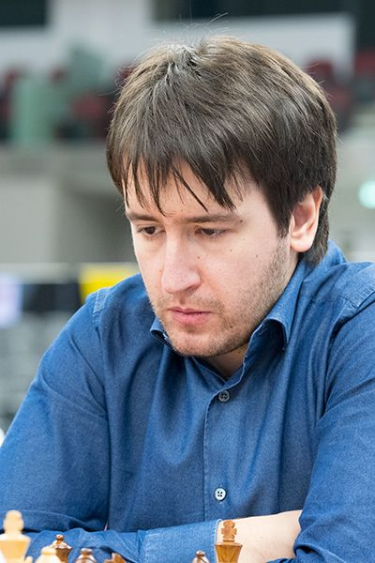
Kings Indian Defence
1.Nf3 d6 2.d4 Nf6
3.g3 g6 4.Bg2 Bg7
5.b3 0-0 6.Bb2 Bf5
7.c4 Qc8 8.h3 c5
9.Nc3 Nc6 10.Rc1 Bh6
11.d5 Bxc1 12.Qxc1 Nd4
13.g4 Bd7 14.Qh6 Nxf3+
15.Bxf3 Ne8 16.Ne4 f6
17.h4 Bxg4 18.h5! gxh
19.Ng5! fxg 20.Qxg5+ Kf7
21.Qxh5+!!(a) Bxh5 22.Bxh5+ Kg8
23.Rg1+ Ng7 24.Rxg7+ Kh8
25.Rxe7+ Rf6(b) 26.Bxf6+ Kg8
27.Rg7+ Kf8 28.Rxh7 Qf5
29.Rh8# Teimour Radjabov

a) Not 21.Rxh5 Qf5!
b) Saves the queen but not the king.

Benjamin Bok vs Radoslaw Wojtaszek
2016 World Rapidplay
Sicilian Defence, Rossolimo Attack
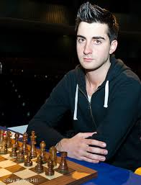
1.e4 c5 2.Nf3 d6
3.Bb5+ Nd7 4.d4 cxd
5.Qxd4 a6 6.Bxd7 Bxd7
7.0-0 Nf6 8.Bg5 e6
9.Nbd2 Bc6 10.Nc4 b5
11.Nb6 Rb8 12.Nd5 exd5
13.exd Bb7 14.Rfe1+ Kd7
15.a4 Be7 16.axb axb
17.Qd3 Qc7 18.Nd4 Qc4?(a)
19.Qh3+(b) Kd8 20.Nf5 Re8
21.Nxg7 Rg8 22.Rxe7! Kxe7
23.Bxf6+ Kxf6 24.Qh6+ Ke5
25.Re1+ Kxd5 26.Rd1+ Qd4
27.Qg5+ Kc4 28.b3+ Kc3
29.Qg3+ resigns Benjamin Bok

a) 18...Qc5 is playable although White is better after 19.Nc6! Qxd5 20.Bxf6! Kxc6 (20...Qxd3 21.Nxb8+ or 20...Qxc6 21.Qh3+) 21.Bxe7.
b) Better 1 9.Qf5 followed by 20.Rxe7.

SOLUTION: 1.Qg5+!! resigns (1...hxg5 2.h5#): a sensational deflection sacrifice!

