WORLD BLITZ CHAMPIONSHIP

The World Blitz Championship followed on from the Rapidplay Championship which had been won by 47 year old Vassily Ivanchuk on countback from Alexander Grischuk and world champion Magnus Carlsen. The Blitz, with a time limit of 3 min for all a player's moves + 2 sec increments, proved to be a two-horse race between Carlsen and his most recent challenger Sergey Karjakin. In their individual game Carlsen blundered allowing a knight fork of queen and rook, forcing him to sacrifice queen for rook. He held out for over 70 more moves getting down to rook v queen before resigning. Carlsen was in the lead with a round to go but could only draw his final game allowing Karjakin to equal his score of 16.5/21 and win the title on countback, earning US$40,000 of the prize fund of $200,000. This left Carlsen equal first in both events but with neither title (perhaps play-offs would have been appropriate). The position comes from the Hikaru Nakamura – Alexander Grischuk game (both players finished =3rd). Moving virtually instantaneously the two players produced an amazingly topsy-turvy exciting finish. How could Black win quickly? See Solution for the final moves:

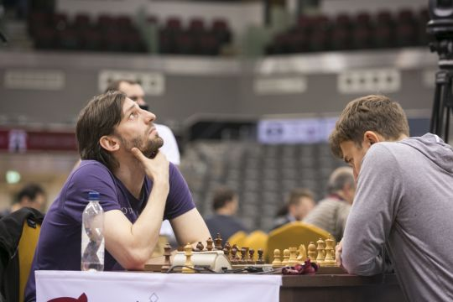
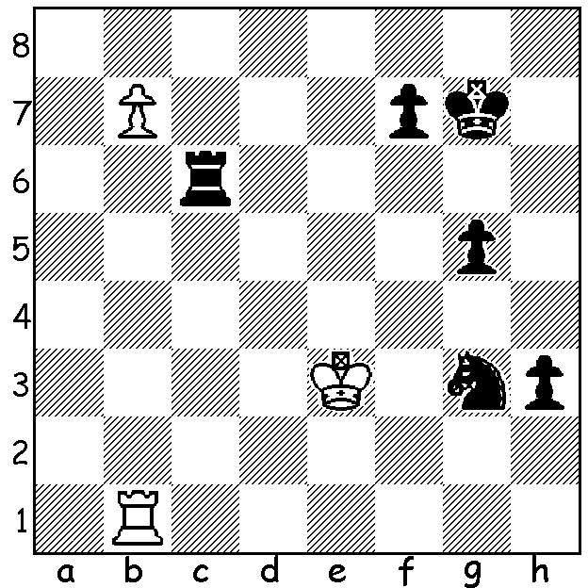
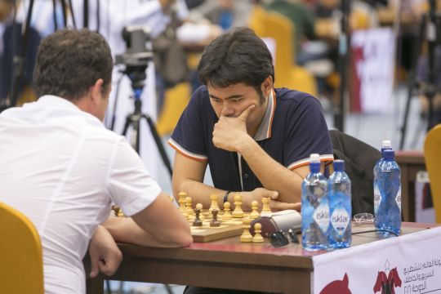
Nakamura at Blitz Grischuk at Blitz

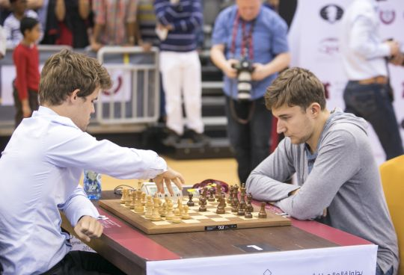
SERGEY KARJAKIN vs PETER LEKO
2016 World Blitz Championship
Giuoco Pianissimo
1.e4 e5 2.Nf3 Nc6
3.Bc4 Bc5 4.0-0 Nf6
5.d3 d6 6.a4 a6
7.c3 0-0 8.h3 Ba7
9.Nbd2 Ne7 10.Re1 c6
11.b4 Ng6 12.d4 exd
13.cxd d5 14.exd Nxd5 Carlsen v Karjakin at Blitz
15.Qb3 Be6 16.b5 axb
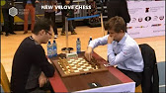
17.axb Ndf4 18.Bxe6 Nxe6
19.Ba3 Nxd4 20.Nxd4 Bxd4
21.Rad1 Re8 22.Ne4 Qb6
23.Nd6! Rxe1+ 24.Rxe1 Bxf2+
25.Kh1 Bxe1 26.Qxf7+ Kh8
27.Bb2 Rg8 28.Nf5 resigns

Karjakin said he would have been pleased to have
played such a game with normal time limits. Leko v Carlsen at Blitz
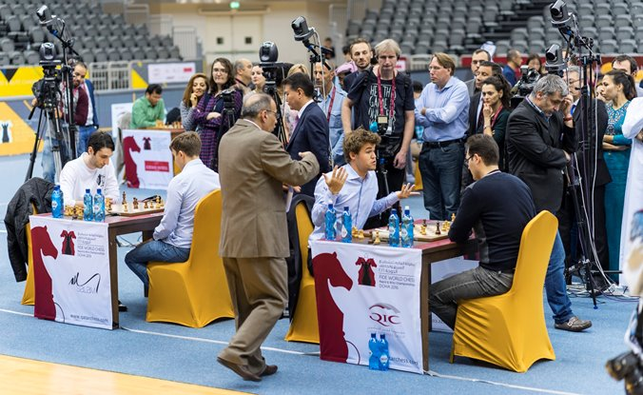
The final round (from left) Jabova is losing to Karjakin while Carlsen has to concede draw with Leko

AUSTRALIAN OPEN: 2014 winner Max Illingworth leads in Brisbane with 7/8. WA's three top players have been among the leaders although losses in Rd 8 have left Yita Chong (5) and Patrick Gong (4.5) some way off the pace while Tristan Boyd, with only one loss, has 5.5.

SOLUTION: Black could win with 55...Nf1+! (deflection or obstruction sacrifice) if 56.Rxf1 Rb6 or 56.Kf2 h2 57.Kg2 Rc2+). Instead the game continued 55...Rc3+? 56.Kf2 Ne4+ 57.Kg1? (57.Ke2) 57...Rg3+? (57...Rc2 58.b8=Q Rg2+ 59.Kf1 Ng3+ 60.Ke1 h2 winning) 58.Kh2 (now White is winning) 58...g4 59.Rb2! Re3 60.b8=Q Ng5 61.Rb3? (61.Rb1 was necessary) 61...g3+! 62.Qxg3 (the only move to avoid loss) 62...Rxg3 63.Kxg3 Kg6 64.Rb4 f6 65.Rb6 Kf5 66.Rb5+ Kg6 67.Kg4?? h2! 68.Rb1 Ne4! 69.Rf1 h1=Q! White resigns (70.Rxh1 Nf2+ 71.Kg3 Nxh1 72.Kg2 and despite losing his knight Black wins by advancing his king in front of his pawn to ensure promotion).

