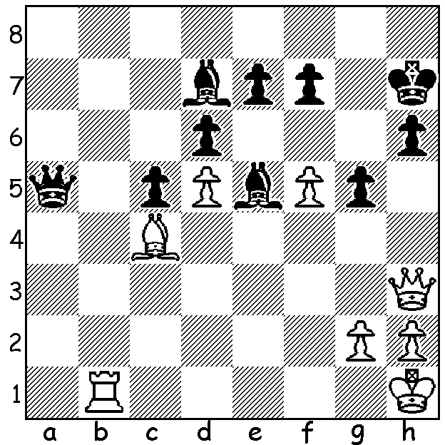

The 79th Tata Steel tournament began this
week in Wijk aan Zee with world champion
Magnus Carlsen defending his title. One
opponent will be exciting young Hungarian
Richard Rapport. Here (White vs Arthur
Pipers 2011) he wins quickly starting
with a sensarional move:

The Australian Open, played earlier this month in Brisbane, resulted in a quadruple tie for first place between Temur Kuybokarov (Uzbekistan), Max Illingworth (Australia, winner of 2014 Australian Championship), Kanan Izzat (Azerbaijan, aged 20, presently studying at Latrobe University Melbourne and winner of the 2016 Australian Championship) and Liu Yi (19 year old Australian), all on 8.5/11. Yi defeated leader Kuybokarov in the final round to produce the tie, although Kuybokarov was declared champion on countback. WA's top players all performed well with Tristan Boyd and Patrick Gong coming =13th on 7 and Yita Choong =29th on 6 (103 competitors). Tristan's only loss was a 60+ move game with Izzat and he came close to defeating Australian Olympiad player and GM Moulthon Ly:

TRISTAN BOYD vs MOULTHON LY
2017 Australian Open, Rd 4
Modern Defence
1.d4 g6 2.e4 Bg7
3.Nc3 d6 4.Be3 a6
5.Qd2 Nd7 6.Nf3 b5
7.a4 b4 8.Ne2 a5
9.h3 Bb7 10.Ng3 Ngf6
11.Bd3 0-0 12.Bh6 e5
13.0-0 exd 14.Nxd4 Nc5
15.Rfe1 Bxh6 16.Qxh6 Kh8
17.Qf4 Nxd3 18.cxd3 Nd7
19.Nf3 Nc5 20.Qh6 f6
21.d4 Ne6 22.b3 Qe7
23.Qe3 Rae8 24.Qd3 c6
25.Nf1 Qd8 26.N1d2 f5
27.exf Rxf5 28.Re3 Nf4
29.Qc2 Ref8 30.Rae1 R5f7
31.Kh2 Kg8 32.Ne4 Nd5
33.R3e2(a) Rf5 34.Ng3 Rxf3(b)
35.gxf3 Nf4(c) 36.Re7 Qc8
37.Nf5!!(d) Ba6 38.Nh6+(e) Kh8
39.Nf7+ Kg8 40.Nh6+ Kh8
41.Nf7(f) Drawn by threefold repetition.

a) Better 33.Rd3 defending the knight although best is 33.Neg5! (33...Nxe3 34.Rxe3 Re7 35.Ne6 Qe8 36.Nxf8=). The text allows the dangerous sacrifice 33...Rxf3! (34.gxf3 Nf4 35.Rg1 d5 36.Ng5 Nxe2 37.Qxe2 Bc8 38.Rg3 h6 39.Ne6 Qe8 40.Nf4 Qxe2 41.Nxe2 with Black better.
b) Now the sacrifice is less effective with 34...R5f7 preferable.
c) 35...Qd7 is stronger (36.Re4 Nf4 37.Rxf4 Rxf4 38.Qe2 c5 39.dxc dxc 40.Rd1 Qc7 41.Qe8+ Rf8 42.Rd7!).
d) Brilliant defence which turns the tables (37...Rxf5 38.Re8+ or 37...Qxf5 38.Qxf5 Rxf5 39.Rxb7 or 37.gxf5 38.Rg1+ Kh1 39.Rgg7).
e) Now White can win with 38.Rg7+ Kh8 39.Ree7! Rxf5 40.Rxh7+ Kg8 41.Reg7+ Kf8 42.Rc7.
f) 41.Ng4 would give White continuing chances.

CAWA AGM will be held at Southern Suburbs Chess Club, Leeming Primary, Meharry Rd on Tuesday 31 Jan at 7.30 Members are urged to attend when committee positions come up for election with positions of president and secretary becoming vacant.

SOLUTION: 1.f6!!! Bxh3 2.Bd3+ Kg/h8 3.Rb8+.

