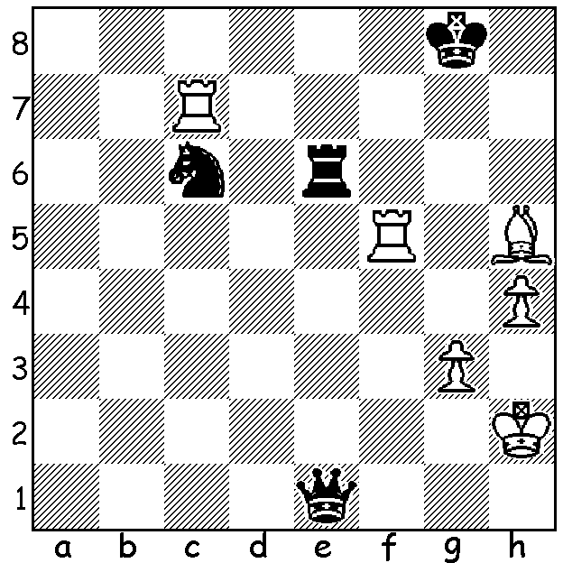

Find the win that world champion
Magnus Carlsen missed in the current
79th Tata Steel tournament in Wijk aan Zee,
Netherlands (White v Anish Giri):

Following the Australian Open in Brisbane two of WA's contestants, Yita Choong and Patrick Gong, travelled to NZ to compete in the Oceania Zone Championships, preliminary tournaments for the World Championship. They were joined by strong WA country player Gyula Plaganyi and WA Womens's Champion Kathryn Hardegen. Kathryn, in particular, had an excellent tournament coming second to 15 year old New Zealander WFM Layla Timergazi in the women's event. Kathryn, in scoring 6.5/9 (+5 =3 -1), half a point behind the winner, whom she beat, earned the Womens FIDE Master title (WFM).
Kathryn bulds up pressure on the queenside against ultimate winner:

Layla Timergazi vs Kathryn Hardegen
2017 Womens Oceania Zonal, Rd 5
Queens Gambit, Slav Defence
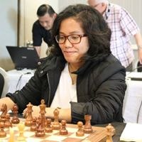
1.d4 d5 2.c4 c6
3.Nc3 Nf6 4.e3 a6
5.Nf3 b5 6.cxd cxd
7.Be2 Bg4 8.Ne5 Bxe2
9.Qxe2 e6 10.0-0 Bd6
11.Nd3 Nbd7 12.f3 Qb6
13.Rd1 0-0 14.Qf2 b4
15.Na5 Qb5 16.b3 Rac8
17.Bb2 Rc6 18.Ne5 Rc7
19.Rac1 Rfc8 20.Nxd7 Nxd7
21.Qd2 f5 22.Rxc7 Rxc7
23.Rc1 Rxc1 24.Bxc1 Qc6
25.Nb2 a5 26.Nd3 a4
27.bxa Qxa4 28.Nf2 Qc6
29.g4 Nb6 30.gxf exf
31.Nd3 Na4 32.Bb2 Qc4 Kathryn Hardegen
33.Ba1 Nc3 34.a3? Nb1
35.Qd1 Nxa3 36.Bb2 b3 37.Nc5 Nc2
38.e4 fxe 39.fxe Bxc5 40.dxc5 Qxc5+
41.Kh1 d4 42.Qg4 Qc6 43.Qf4 Qb7
44.Qe5 h6 45.Qe8+ Kh7 46.h4 g6
47.Kg1 Kg7 48.Qe5+ Kf7 49.Qf4+ Ke8
50.e5 Ne3 51.Qg3 Qe4 52.Bxd4 Qxd4
and Black wins.

Facing a dangerous kingside attack Katherine calmly breaks open the centre to expose her opponent's uncastled king, gaining a winning endgame and 2nd place:

Nicole Shu Yu Qin vs Kathryn Hardegen
2017 Womens Oceania Zonal, Rd 9
Queens Gambit, Slav Defence
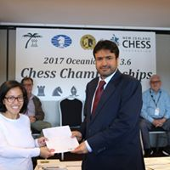
1.d4 d5 2.c4 c6
3.Nf3 Nf6 4.cxd cxd
5.Nc3 Nc6 6.Bf4 Ne4
7.e3 Nxc3 8.bxc3 g6
9.h3 Bg7 10.Bd3 0-0
11.g4 Na5 12.g5 f6
13.h4 Bg4 14.Be2 Nc4
15.Ng1 Bxe2 16. Qxe2 Qa5
17.Rc1 e5 18.gxf Bxf6
19.dxe Nxe5 20.h5 Qa3
21.Rc2 Qe7 22.Bxe5 Bxe5
23.hxg hxg 24.Qd3 Qf7
25.Nh3 Rad8 26.Rg1 Rd6
27.f4 Bg7 28.Rcg2 Re8
29.Kd1 Rc8 30.Rxg6 Rxg6
31.Rxg6 Rxc3 32.Qxc3 Qxg6 Katherine at Prize Presentation
33.Qc8+ Bf8 34.Ng5 Qd3+
35.Kc1 Qxe3+ 36.Kb1 Qb6+ 37.Ka1 Qd4+
38.Kb1 Qb6+ 39.Ka1 Qc6 40.Qxc6 bxc6
41.Kb2 Bd6 42.Nh3 Kf7 43.Kc3 Ke6
44.Kd3 Kf5 45.Ke3 c5 White resigns

CAWA AGM: Members are urged to attend the AGM at Southern Suburbs CC, Leeming Primary, Meharry Rd, Tues 31 Jan. Executive positions are up for election with both current President and Secretary not seeking re-election.

SOLUTION: 1.Rc8+ Kg7 2.Rf7+ Kh6 3.Rh8#. Carlsen with ample time played an almost instantaneous 1.Bf7+ and the game continued 1...Kh8 2.Rh5+ Kg7 3.Bxe6+ Kf6 4.Rh6+ Ke5 5.Bh3 Qd2+ 6.Bg2 Qxh6 7.Rxc6 but with R, B & 2p for Q he was unable to win, the game finishing in stalemate 60 moves later (123 moves each in total).

