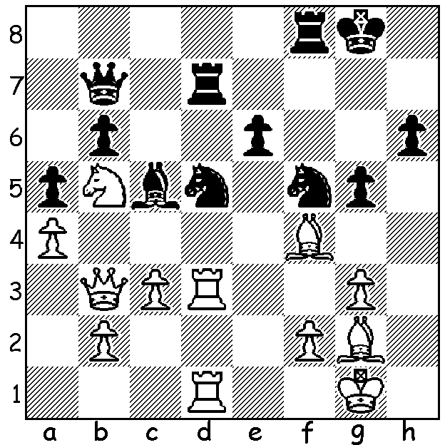

Another position from the current Tata Steel at
Wijk aan Zee, this time from the Challengers,
Eric Hansen – Jeffrey Xiong. Black has
played the aggressive 1...g5 and if 2.Be5 Bxf2+!
3.Kxf2? Nd4+ wins the queen. However White
also has a trick up his sleeve. What does he play?

Continuing our report on the Oceania Zonal in New Zealand we come to the Open section which was won by Australia's talented international, 15 year old IM Anton Smirnov with 7.5/9. =2nd were Max Illingworth, who tied for 1st place in the recent Australian Open, Anthony Kerr (NZ) and 18 year old Ari Dale, who shared first place with Tristan Boyd at the 2016 WA Christmas Open, all on 7. WA had 3 players competing, Yita Choong (6.5, =5th), Patrick Gong (6, =11th) and country player Gyula Plaganyi (4.5, =50th/116). I jumped the gun on Dec 30 in saying WA had 3 FMs competing in the Australian Open. While Patrick and Tristan Boyd had been awarded the title previously it was only in the NZ event that Yita gained the title (Kathryn Hardegen also gained the WFM there after coming 2nd in the Women's event). The first game below is a fine example of breaking open a seemingly strong centre with ...f5 & ...d5, the second a hard fought game with both players needing the full point:
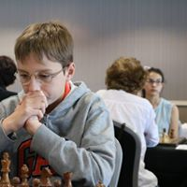
Allen Chi Zhou Fan vs Yita Choong
2017 Oceania Zonal, Rd 2
English Opening, Hedgehog Defence
1.Nf3 Nf6 2.c4 c5
3.g3 b6 4.Bg2 Bb7
5.0-0 e6 6.Nc3 Be7
7.Re1 d6 8.e4 a6
9.d4 cxd 10.Nxd4 Qc7
11.Be3 Nbd7 12.f4 0-0
13.Rc1 Rfe8 14.g4 Nf8
15.b4 Rac8 16.g5 N6d7 Anton Smirnov at Zonal
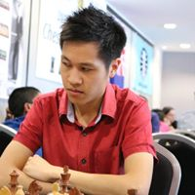
17.Na4 Qb8 18.Qd3 Qa8
19.a3 Bd8 20.Nb3 Bc6
21.Nb2 Bc7 22.Rc2 Ng6
23.Nd4 Bb7 24.Ne2 Nh4
25.Bh1 f5! 26.Nc3 fxe
27.Nxe4 d5 28.cxd exd
29.Bf2 Ng6 30.f5 dxe
31.Qxd7 Bxh2+! 32.Kxh2 Rxc2
33.Kg1 Ne5 34.Qd4 e3
35.Bxb7 exf2+ 36.Qxf2 Rxf2
37.Bxa8 Rxb2 38.Bc6 Nf3+
White resigns Yita Choong at Zonal

Yita Choong vs Max Illingworth

2017 Oceania Zonal, Rd 9
Owens Defence
1.d4 Nf6 2.c4 b6
3.f3 Nc6 4.e4 e5
5.Ne2 Nxd4 6.Nxd4 exd4
7.Qxd4 Bc5 8.Qd3 0-0
9.Bg5 h6 10.Bh4 g5
11.Ng3 Nh5 12.Nc3 d6
13.0-0-0 Be6 14.Nd5 c6
15.Ne3 Nxg3 16.hxg3 Qf6
17.Be2 Rab8 18.Qd2 b5
19.cxb Rfc8 20.Kb1 a6
21.f4 gxf 22.Nc2 axb Max Illingworth
23.Qxf4 Qg7 24.Qxh6 b4
25.Qxg7+ Kxg7 26.Nd4 Kf6 27.Rh6+ Ke5
28.Rh5+ Kxe4 29.Nc2 Bxa2+! 30.Ka1 f5
31.Bd3+ Ke5 32.Re1+ Kf6 33.Rxf5+ Kg7
34.Re7+ Kg8 35.Kxa2 b3+ 36.Kb1 bxc2+
38.b3 Re8 37.Kxc2 Bd4 39.Rc7 Rbc8
40.Rg5+ Kf8 41.Rh7 Re3 42.Rf5+ Kg8
43.Rg5+ and drawn after repetitions.

SOLUTION: 2.Rxd5! exd5 3.Rxd5! Rdf7 4.Rxc5 Qe7 5.Rxf5 winning.

