Wei Yi – Ian Nepomaniachtchi (Tata Steel 2017): a clever move wins the exchange for White


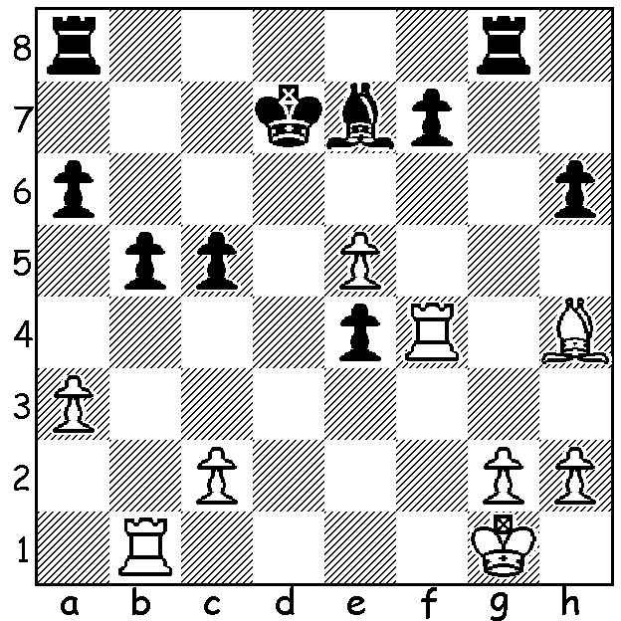

Wei Yi

The 79th Tata Steel tournament in Wijk aan Zee concluded last week with the winner Wesley So (9/13, +5 =8) a point ahead of runner-up, world champion Magnus Carlsen. So has now gone 56 games without defeat during which time he has won the Sinquefield Cup, gained gold medals at the Olympiad being member of victorious USA team and best score on Bd 1, won the London Classic and now the Tata Steel. He has also become world number 2, overtaking Fabiano Caruana after Caruana's loss to Nigel Short in Gibraltar. One other player to feel happy with his performance in the Netherlands was Indian Baskaran Adhiban who came equal 3rd on 7.5 after gaining entry via his top place in last year's Challengers.
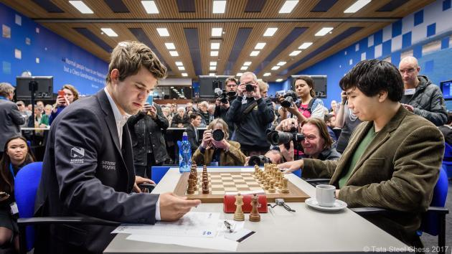
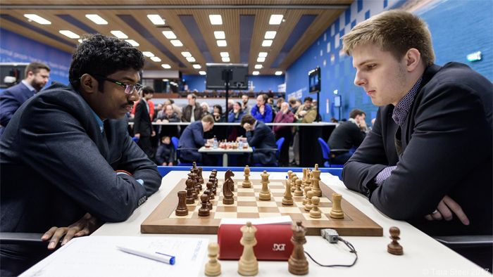
So (R) v Carlsen Adhiban v Rapport (who beat Carlsen)

Baskaran Adhiban - Dmitry Andreikin
2017 Tata Steel, Rd 8
Vienna Game (transposing to Closed Sicilian)
1.e4 e5 2.Nc3 Nc6 3.g3 g6
4.Bg2 Bg7 5.d3 d6 6.f4 Nge7
7.Nf3 Nd4 8.0-0 Bg4 9.Be3 c5
10.Qd2 0-0 11.Nh4 exf 12.Bxf4 Qd7
13.Rf2 Rae8 14.Bh6 Bxh6 15.Qxh6 b5
16.h3 Be6 17.Raf1 Qd8 18.Nb1 d5
19.Nd2! dxe(a) 20.Nxe4 Nef5 21.Rxf5! Nxf5
22.Rxf5! Qd4+(b) 23.Rf2 f5 24.Ng5 Qg7
25.Qxg7+ Kxg7 26.Bc6! h6(c) 27.Nxe6+ Rxe6
28.Bxb5 Rb8 29.a4 a6 30.Bc4 Re1+
31.Kg2 Rxb2 32.Bxa6 Rc1 34.Rxc2 Rxc2+
33.Bc4 Rcxc2 35.Kf3 Kf6 36.a5 g5
37.a6+! Rc1 38.Ng2 Ke5 39.Ne3 h5
40.Nc2! g4+ 41.Ke3 gxh 42.a7 h2
43.a8=Q h1=Q 44.Qb8+ Kf6 45.Qf8+ Kg6
46.Bf7+ resigns(d)

a) 19...Nxc2? loses to 20.exd Bxd5 21.Bxd5 Nxd5 22.Ne4 Nce3 23.Ng5.
b) If 22...Bxf5 23.Nxf5 gxf5 24.Nf6+.
c) If 26...Re7 White wins with 27.Re2 Kf6 28.Rxe6+! Rxe6 29.Nxh7+ Ke7 Nxf8 Kxf8 31.Bxb5.
d) If 46...Kh7 47.Qg8+ mates while 46...Kf6 loses the queen to 47.Bd5+.

WA JUNIORS: Five WA juniors competed in the 2017 Australian Junior Championships: Under 16 Ignatius Yap (5.5/9, =6th), Under 14 Ramadu Rathnayake (5.5/9, =6th), Under 12 Alex Pimenov 5.5/9, =14th), Ethan Richards (5/9, =24th), Under 8 Jamie Richards 3/9, =29th). Unfortunately our top junior Patrick Gong was not able to compete because of the clash of dates with the Oceania Zonal. Ignatius Yap also played in the 2nd Singapore Amateur Championship (Under 2000) in December coming =21st with 6/9.

SOLUTION: 1.e6! (an obstruction sacrifice depriving Black's king of the e6 square) 1...fxe6 (1..Kxe6 2.Rxe4+ wins the bishop) 2.Rf7 (now if 2...Re8 3.Rd1+ wins). Black played 2...Rg5! but lost a long endgame.

